**PROJECT OVERVIEW-ARCHITECTURE:**

Data source used in the project is On-premise SQL Server Database. We need to migrate multiple tables from on premise SQL server data base to cloud. So, for that we will use ADF. ADF used for data ingestion. ADF used to connect to on-premise SQL server data base to copy all tables from on premise SQL server data base and move all tables to the cloud. Now this tables will be stored in ADLS gen2.

**Role of ADF:** ADF will connect on to on-premise SQL database and put all data in ADLS gen2 account.

Once data come in to ADLS gen2 account, using ADB it will transform raw data into most curated layer. ADB is a bigdata analytics tool which is mainly useful for high end data analytics workloads.

**DATA LAKE HOUSE ARCHITECTURE:** ADF connect onto on-premise and keeps data first into bronze layer which means bronze layer has exact copy of what data looks in the data source(on-premise SQL server data base). In bronze layer, we are not going to change anything inside bronze layer. Adv of bronze layer is if anything goes wrong in silver/gold layer we can go back to bronze layer and can get the actual data same as which is present in the data source. Once data copied into bronze layer by ADF, we then use ADB to connect onto bronze layer, do some transformation and load transform data into silver layer. In bronze to silver layer ,transformation might be changing the column names, changing data types because lot of times on-premise kind of data types and cloud data types is not really compatible so we may need to change few things based on how it is going to support it in the cloud. So those kind of minimal transformation will be done in the silver layer. Once data has been transformed using azure data bricks and final data has been loaded to silver layer, we will do another set of transformation using same azure data bricks and this data will be loaded finally to this gold layer. This gold layer is the final cleanest form of data .once data is loaded into gold layer, we will use another tool Azure Synapse Analytics. Data in gold layer will now be loaded into tables which we created in azure synapse analytics. Now data has been completely migrated . Now we can analyze the data using reporting tool power bi . Power BI will get all data that has been loaded into azure synapse analytics and we can create different kind of reports like charts, pie charts etc. we also use security and governance tools like Azure Active Directory which is an identity access management tool so all security related things and creating service principal can be done by Azure AD. Azure Key vault used to store all secrets. For example, username and password can be stored in azure key vault and it can be used to safely retrieve this information Basically data analyst is the one who will be creating reports in power bi. Role of azure DE is to clean raw data into most curated data ,all data transformation will be done by data engineers using azure data bricks.

**ADF 🡪 used for data ingestion**

**ADB 🡪 used for data transformation**

**ASA 🡪 used for loading data to tables**

**PBI 🡪 reporting tool, used to visualize and analyze data.**

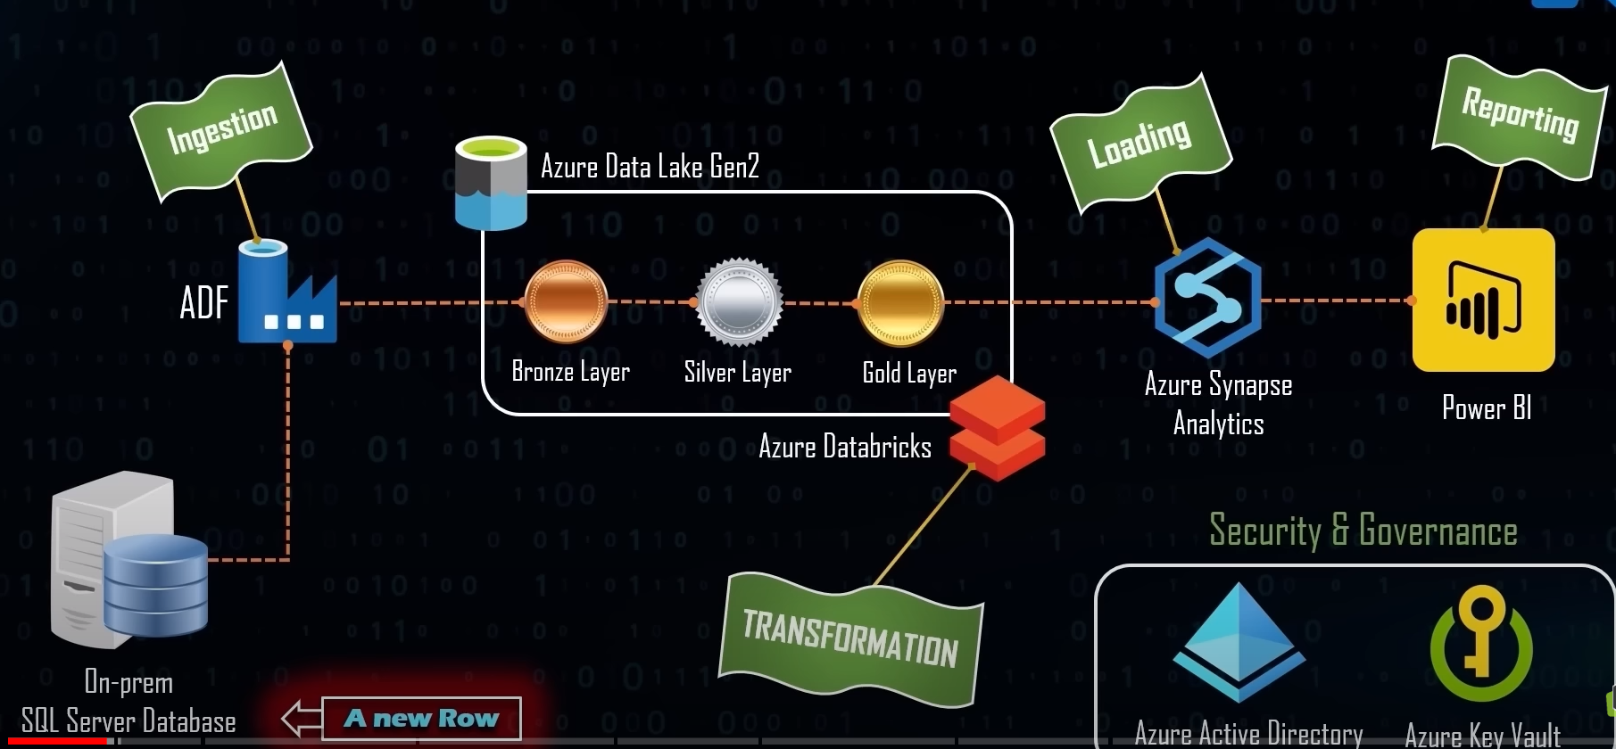

Note: Azure Active Directory is not a resource, it will create by azure only when we create azure account. When we create azure account, azure active directory will be created for us. All identity access management which we need to done with azure active directory can be done over here.

----

After installing Microsoft SQL server in local PC, we need username and password to connect onto database.

CREATE LOGIN mrk WITH PASSWORD = ‘’ ;

create user mrk for login mrk

now login username and password got created. If we want to read tables within database, we need access so, we will get user access as shown below, security 🡪 users 🡪 right click on user 🡪 Membership 🡪db data reader.

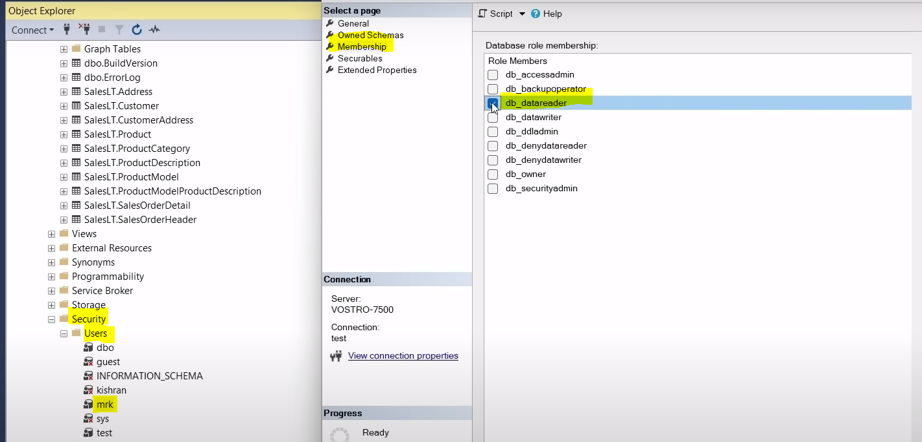

Now we have read access and we can read all tables that is available in database. Now if we want to connect this local SQL server data base to azure, using login and password we can connect. This login name and password we will store as secrets in azure key vault.

Now we will create Azure Key Vault service. After creating AKV, we will create secrets as shown below,

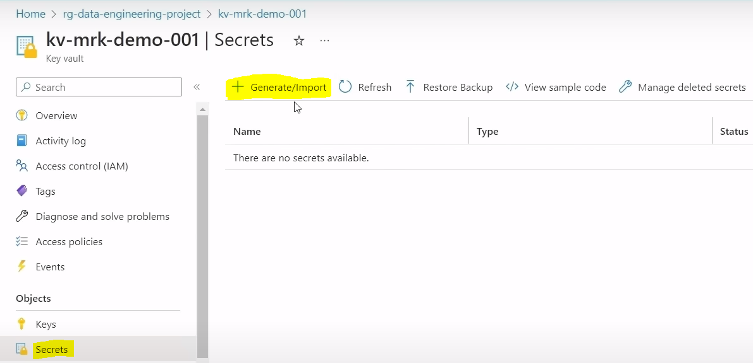

We will create secret for username as shown below. Secret value for username is mrk

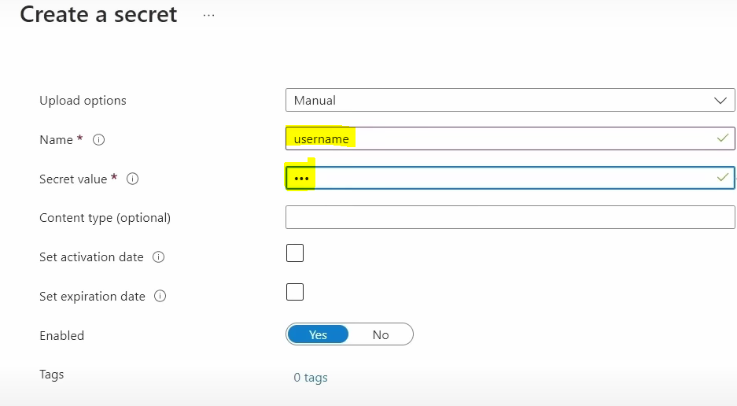

--

We will create one more secret for password as shown below.

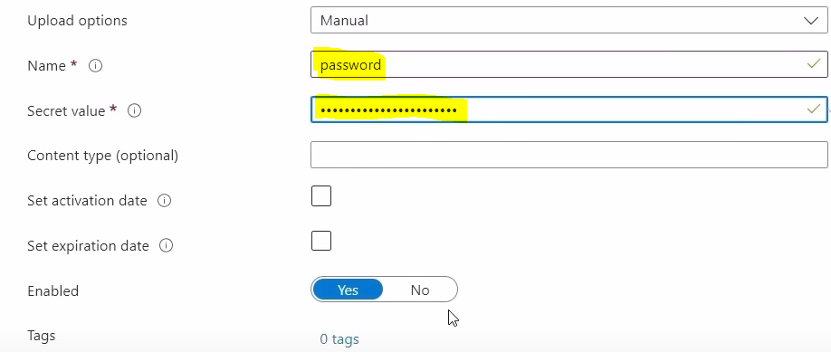

--

Now this 2 values are encrypted in secret value field and saved in key vault .

If we want to connect ASA to on premise SQL server, instead of using credentials directly, we can use this encrypted data which we are creating in key vault secrets as shown above.

In order to establish connection between ADF and on-premise data sources, we need to install self-hosted integration run time. We need to install self-hosted integration run time on the device where actual data base is located. If SQL server management studio is on my machine, we will install self-hosted integration run time on my machine on my laptop.

Auto Resolve Integration Runtime used to connect to any cloud-based resources. For E.g., we are using ADF to connect to source ADLS Gen2, ADLS is cloud based resources so we can use this auto resolve integration run time.

Auto Resolve Integration Run Time : In order to connect to all cloud-based resources , we will use AR IRT.

Self-Hosted Integration Run Time: In order to connect on-premise data sources to azure, we will use self-hosted integration run time. Self-Hosted is for to connect files to private network

We will create self-hosted integration run time from below path.

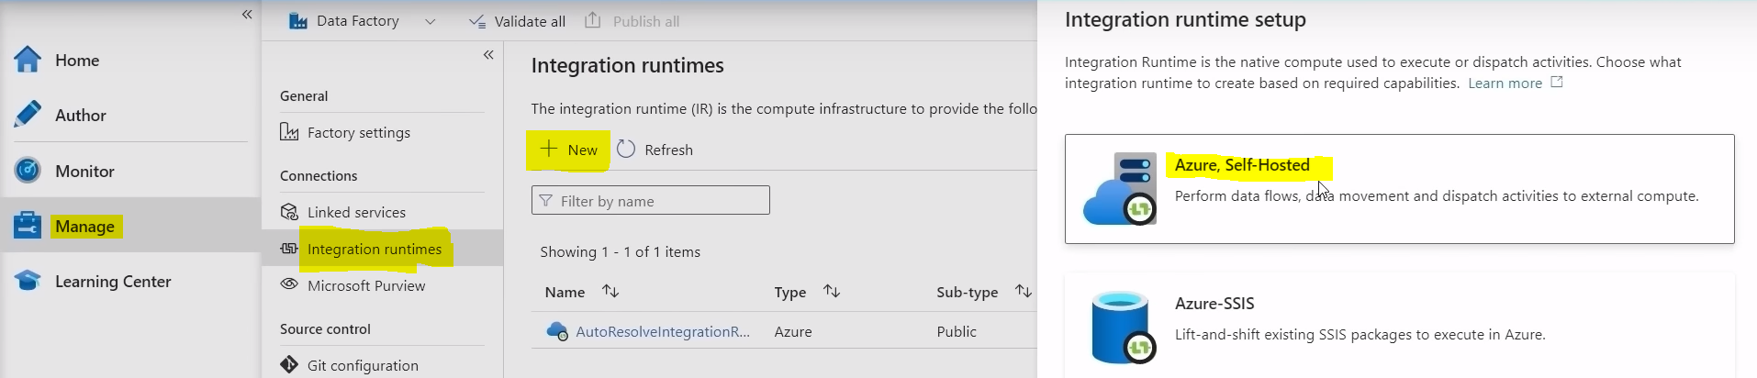

-----

Now we will select Self-Hosted and click on continue as shown below.

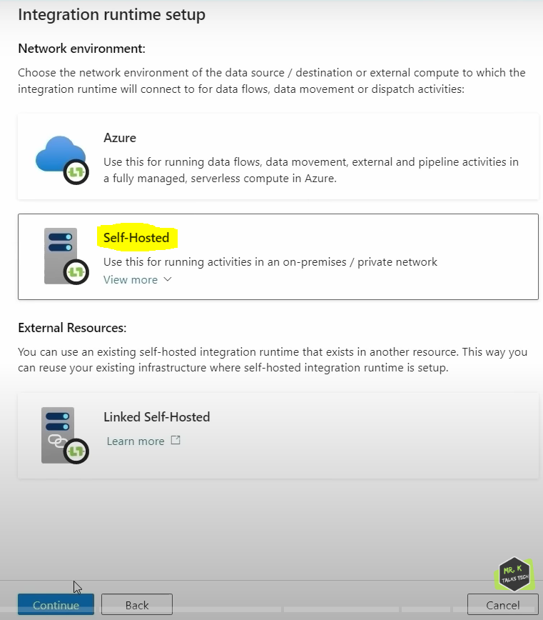

After selecting self-hosted and click on continue, its asking to give name for Integration runtime setup as shown below.

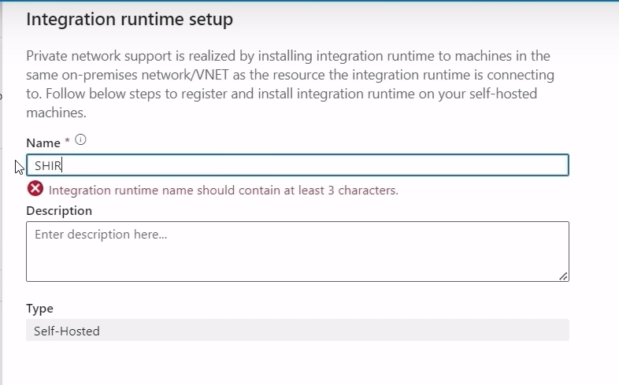

Name : SHIR

Description : used to connect SQL Server

After entering Name and Description , we will click on create button.

Now runtime setup is completed and below screen shot will be visible.

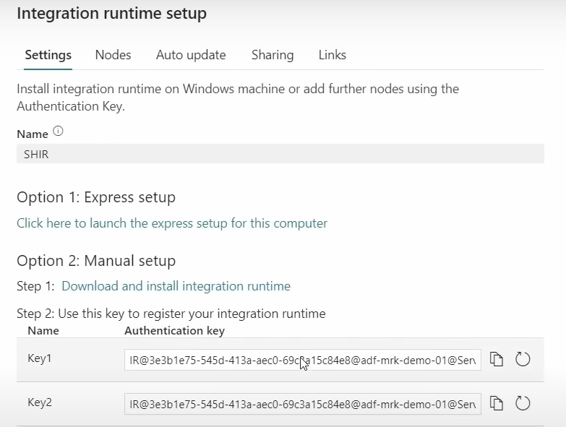

Here we have 2 options to set up self-hosted integration run time. 1st option is Express setup and 2nd option is Manual setup. In Manual setup we can click on link as shown above to download an application and when you install that application, we need to enter any one of this keys to register SHIR with the machine that we are trying to install. Whereas in express setup, we can click on link to install SHIR with out actually specifying the key.

**WHEN TO PREFER MANUAL SET UP AND EXPRESS SET UP?**

If we are installing SHIR on different machine then we can probably go with the manual setup, where we will be going to manually register the SHIR with the key copied from ADF. If we want to install SHIR on same machine, then we can go with express set up.

**WHAT IS MAIN USE OF INTEGRATION RUN TIME?**

To perform any operations, we need to have 2 things, one is compute power and other is infrastructure to execute that operation. Integration Run Time is giving us both in terms of ADF to do any sort of operations like data integration or data movement. In simple terms , integration run time also called as compute infrastructure in ADF.

**Express setup:**

We will click on link as shown in above screenshot.

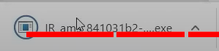 This exe file got downloaded and we will open exe file so that it will install SHIR on the machine without specifying keys.

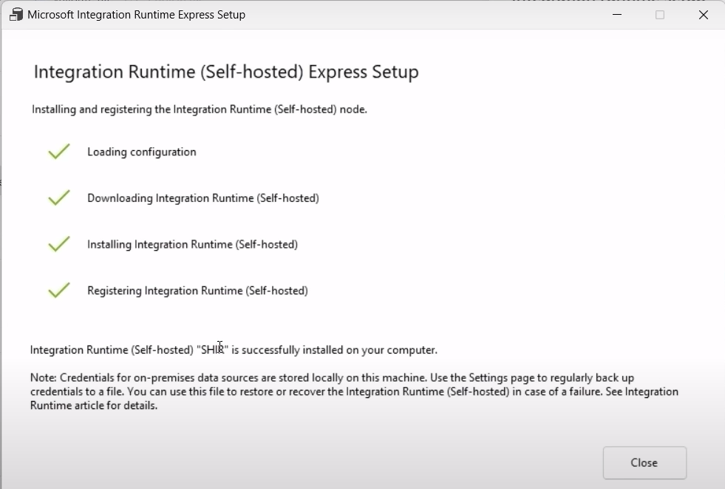

Now SHIR is installed and configured now and click on close.

SHIR is created as shown below.

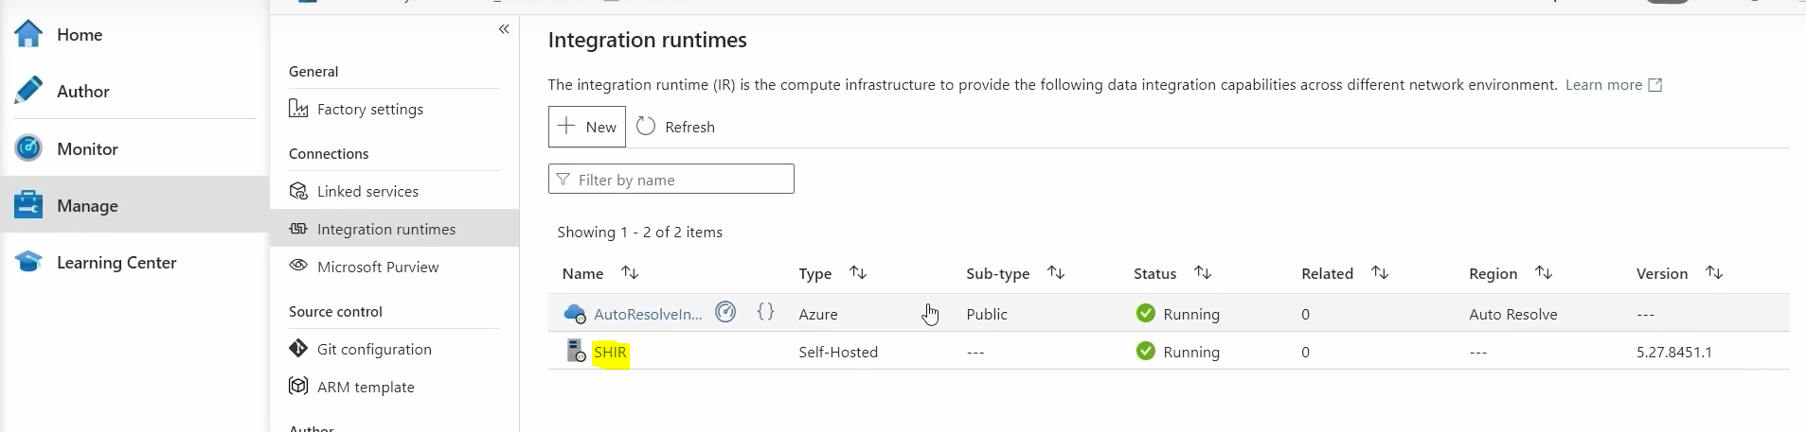

SHIR that we have created is running which means that we have established connection between ADF and my local machine. So, if we want to test integration run time created or not, in search bar we can type integration run time and we can search.

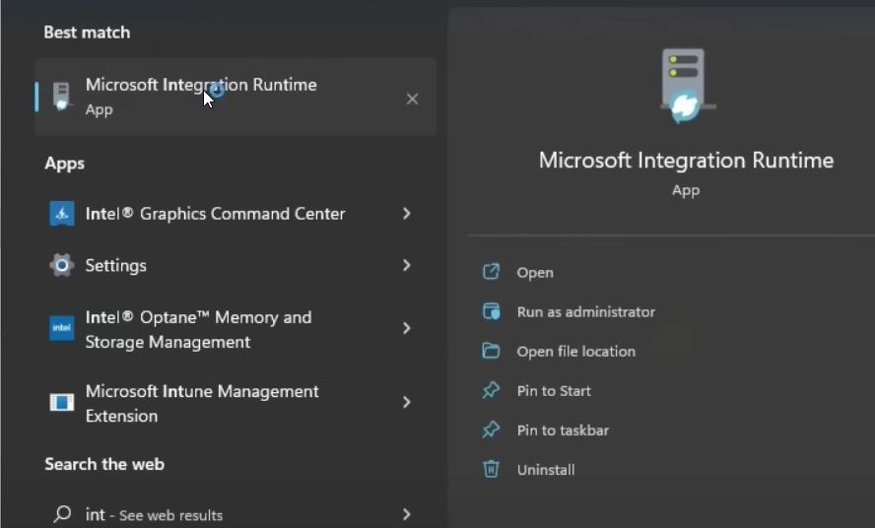

If we click on open, we will get below screen.

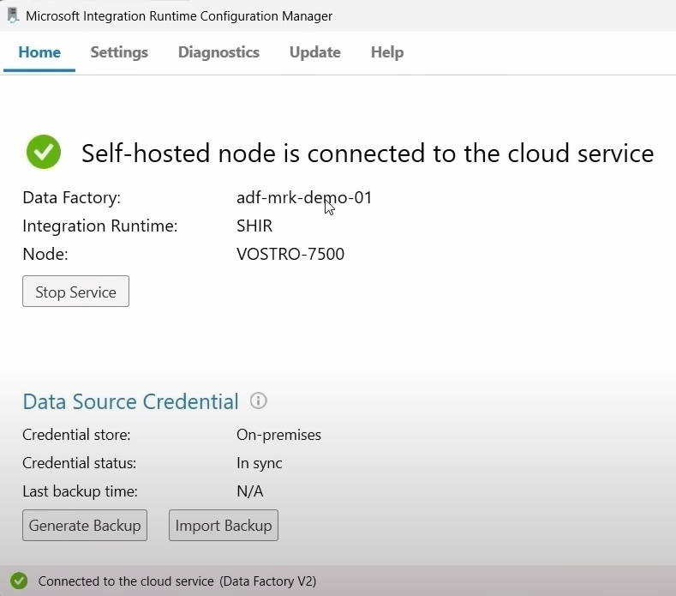

Now ADF can easily integrate with on-premises.

DATA INGESTION PROCESS:

Author 🡪 click on + 🡪 Pipeline 🡪 pipeline , now we can change pipeline name in the right side in properties . pipeline name will tells us what all this about.

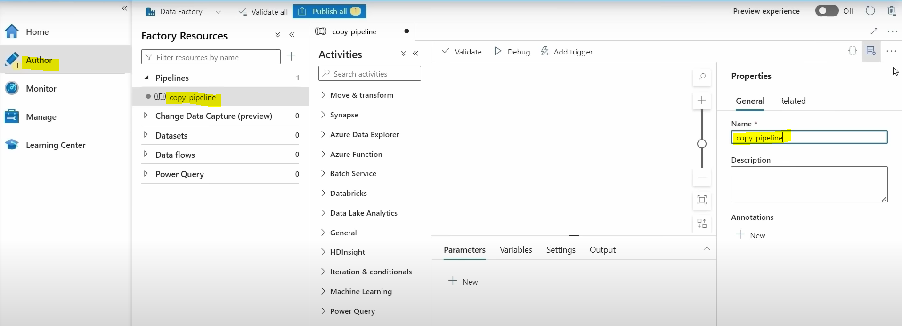

Now we will search copy data activity and drag copy data activity to canvas. Copy data activity used to copy one table from data base. If we want to change copy data activity name, we will do it in General tab as shown below.

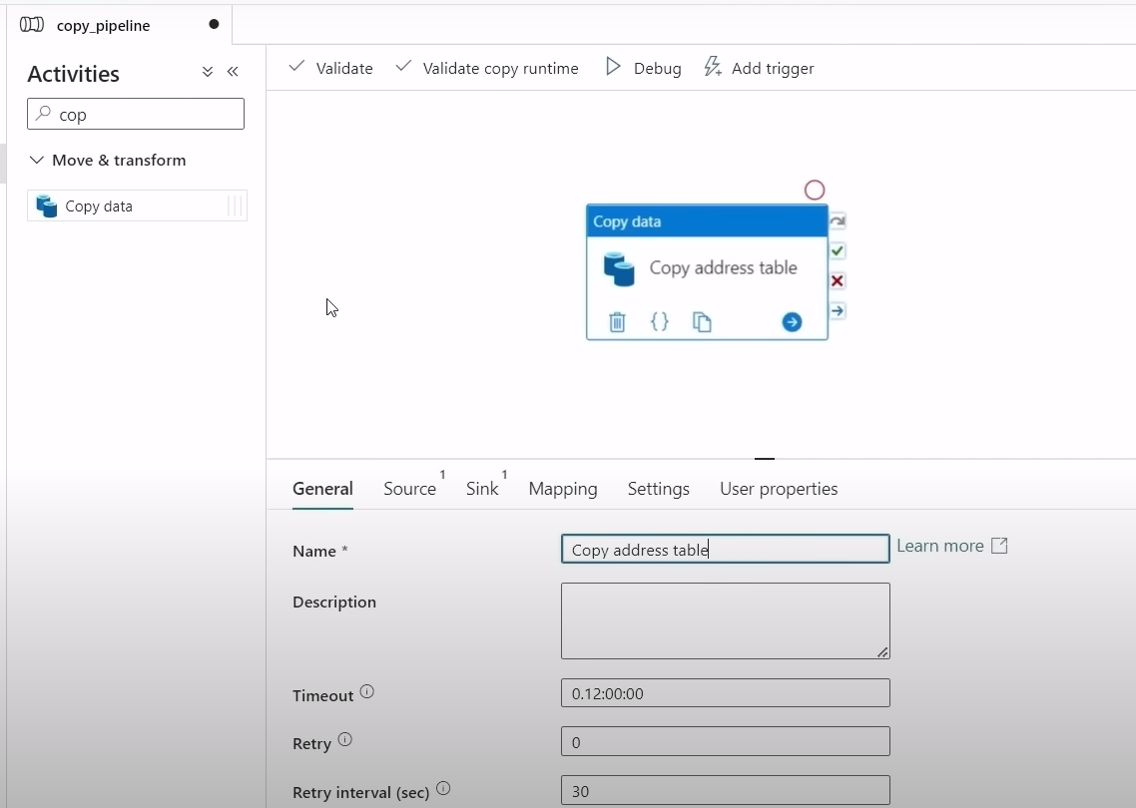

--

Now in source tab we will go to source data set , click on + to get source details.

Now we will select SQL Server from data store and click on next

We are copying single address table from source, so we are giving address as the name of the data set.

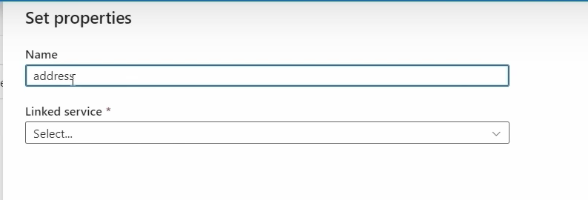

Now go to Linked service 🡪go to drop down 🡪 click on +

We need to enter below credentials.

linked service name : onpremsqlserver. Select SHIR, server name : localhost , Database name : AdventureWorksLT2017

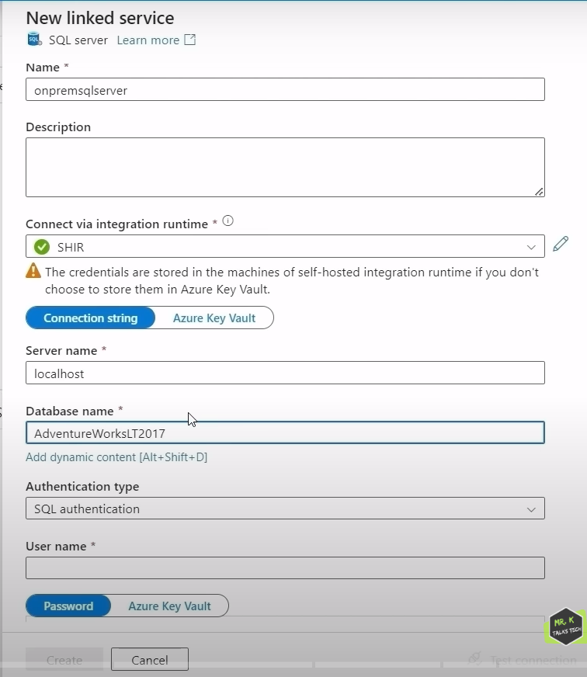

Now we need to enter SQL username. Instead of entering password directly, we can select password from key vault secret as shown below.

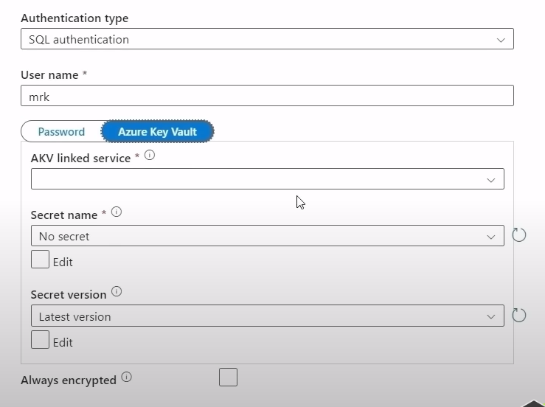

Now go to AKV linked service 🡪 click on + to create AKV linked service as shown below.

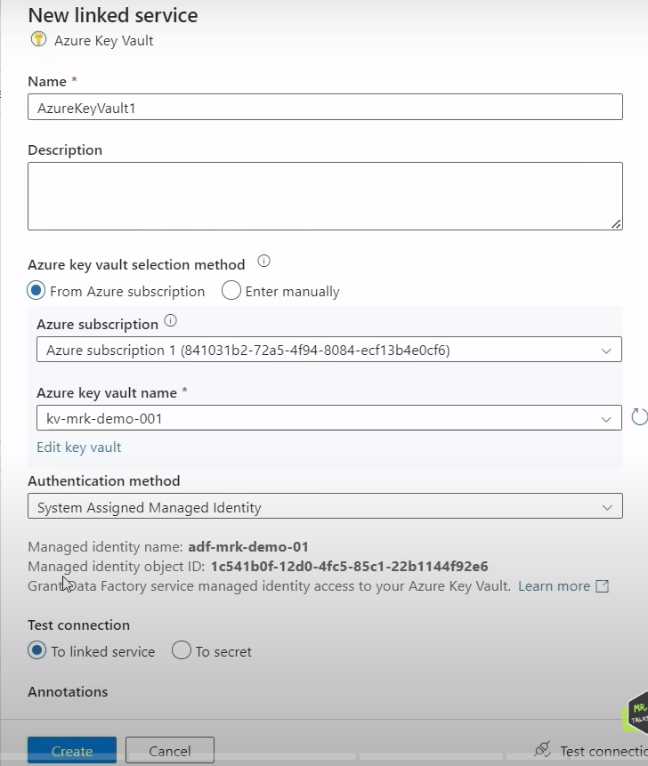

**System Assigned Managed identity vs User Assigned Managed Identity:**

When we create any resource in azure, we will get a default ID with it. In ADF, we can see a Managed identity object ID in above screenshot. When we use this managed identity to connect to this AKV, it will use this ID to authenticate it. So, using this managed identity object ID, we will connect to key vault.

ADF can now connect onto key vault successfully. After creating AKV linked service, we are unable to retrieve secret name as it shows failed to get it as shown below.

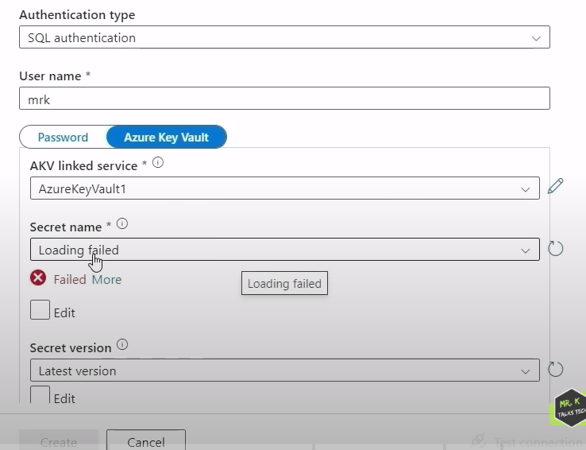

We don’t have reader permission to read the secret. So to give that required access to ADF to read secrets from key vault, we need to configure additional things in the azure key vault side.

In Azure Key Vault, we have access policies in left side. Access policies are used to give key/secret/certificate permissions to ADF to read the secrets.

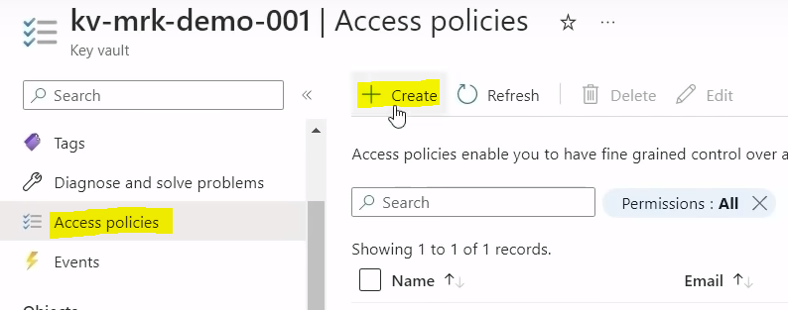

Access policies 🡪 click on + create. We will get below screen.

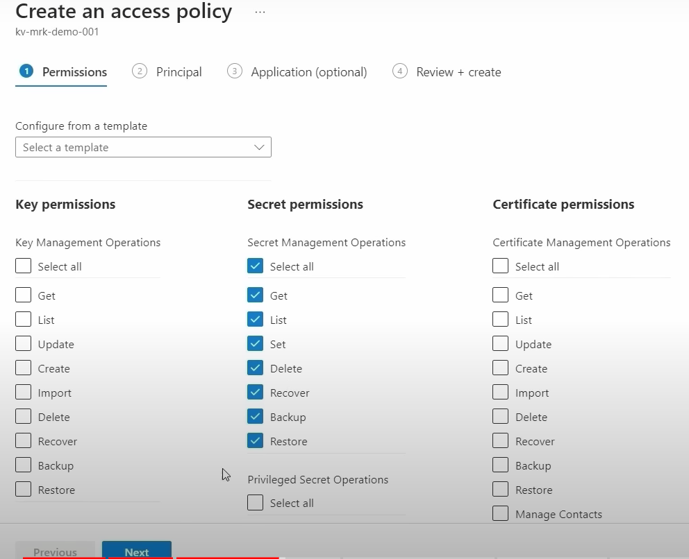

We will select all secret permissions and click on next.

Now in Principal tab , we have selected Azure Data Factory name and click on next.

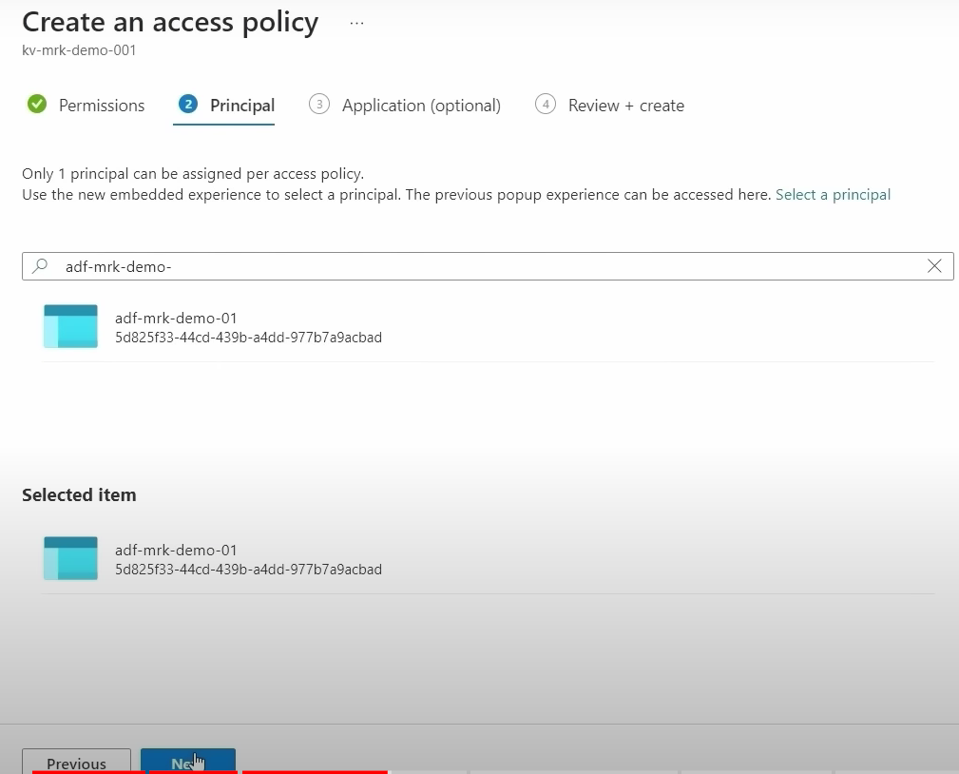

Click on next , review and create.

Now access policy for ADF is created.

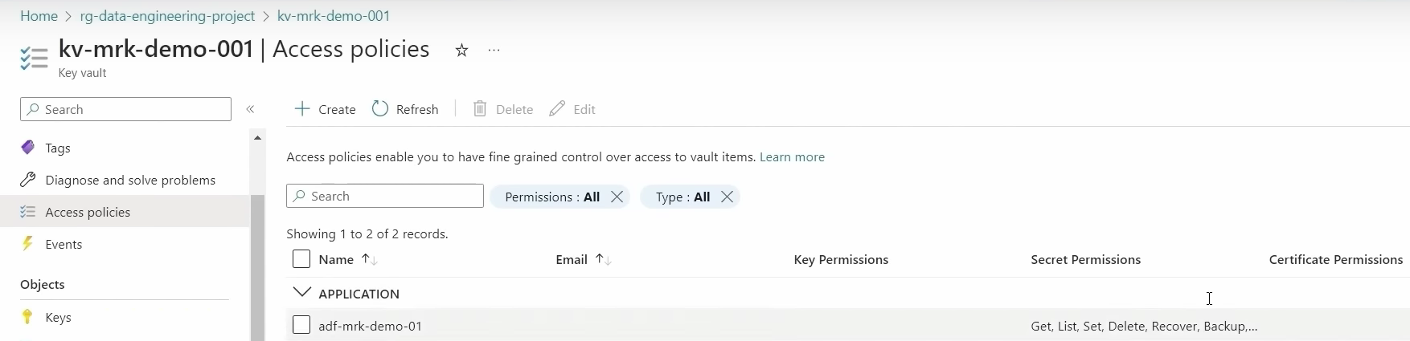

Now if we refresh, we can see 2 secret names here, we can select password here .

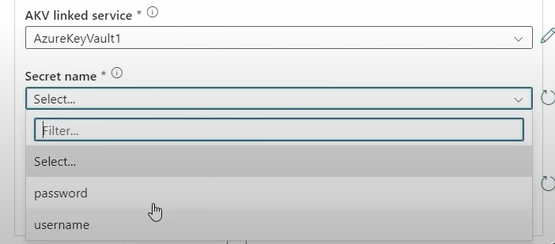

Now we will click test connection and click on create as shown below.

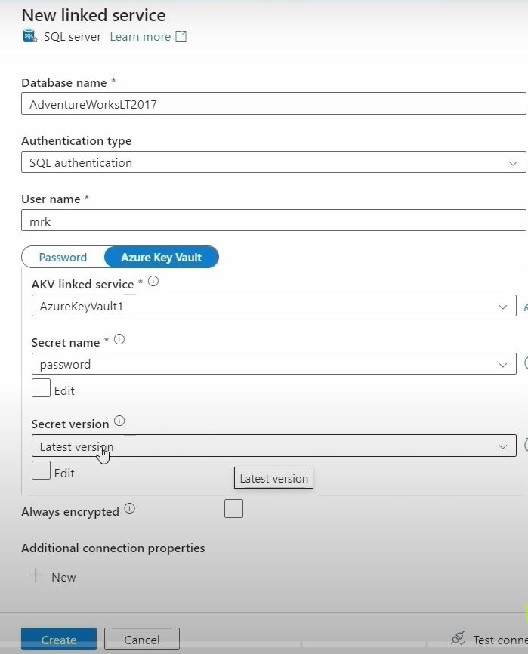

Now we will select table name and click on ok.

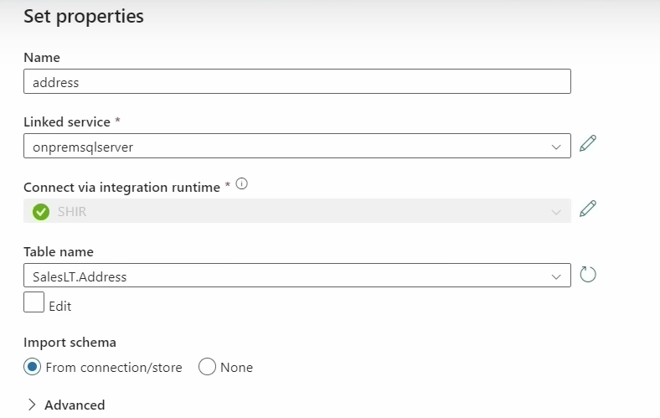

Now source work is completed and next we will go to sink.

In Sink, in sink data set, we will click on + and select sink data source. We will select ADLS gen2 and we will select format of sink file. we will select parquet and click on continue.

Now we will give sink data set name in set properties as address_parquet as shown below.

Now we need to create Linked Service.

Linked Service 🡪 Click on +. Now we will give sink linked service name.

We will select integration run time as Auto Resolve Integration Run Time because we are selecting ADLS as sink and it is azure resource so auto resolve integration run time we are using.

We will enter storage name and click test connection.

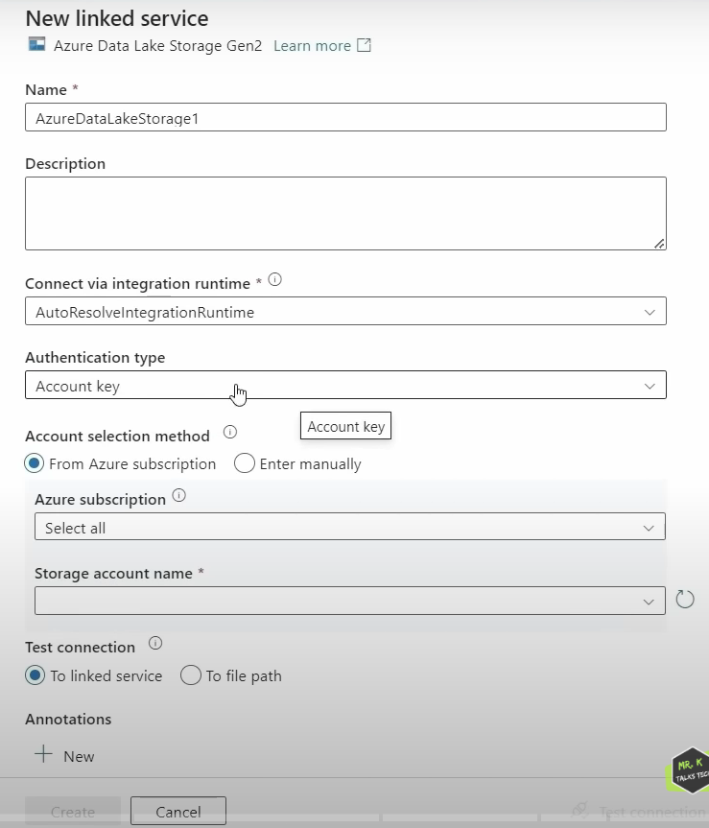

Now we have created Linked Service.

Now we will select container name bronze from below file path and click on OK.

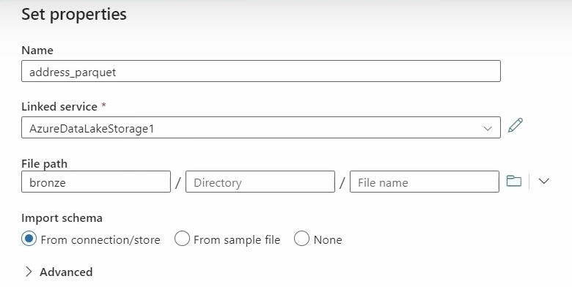

Now we will click on debug button to run pipeline.

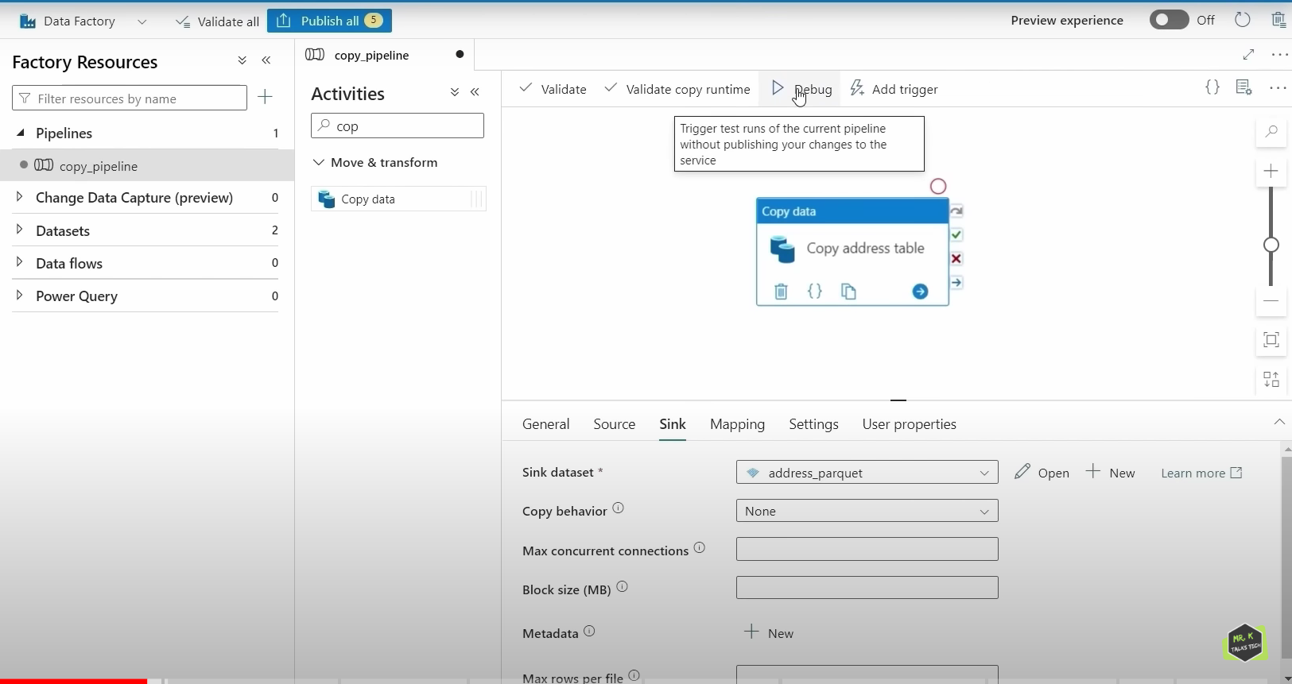

Now what pipeline do is it will connect onto on-premise SQL Server database copy that address table and put it in ADLS Gen2 bronze layer container. Now pipeline ran and it got succeeded.

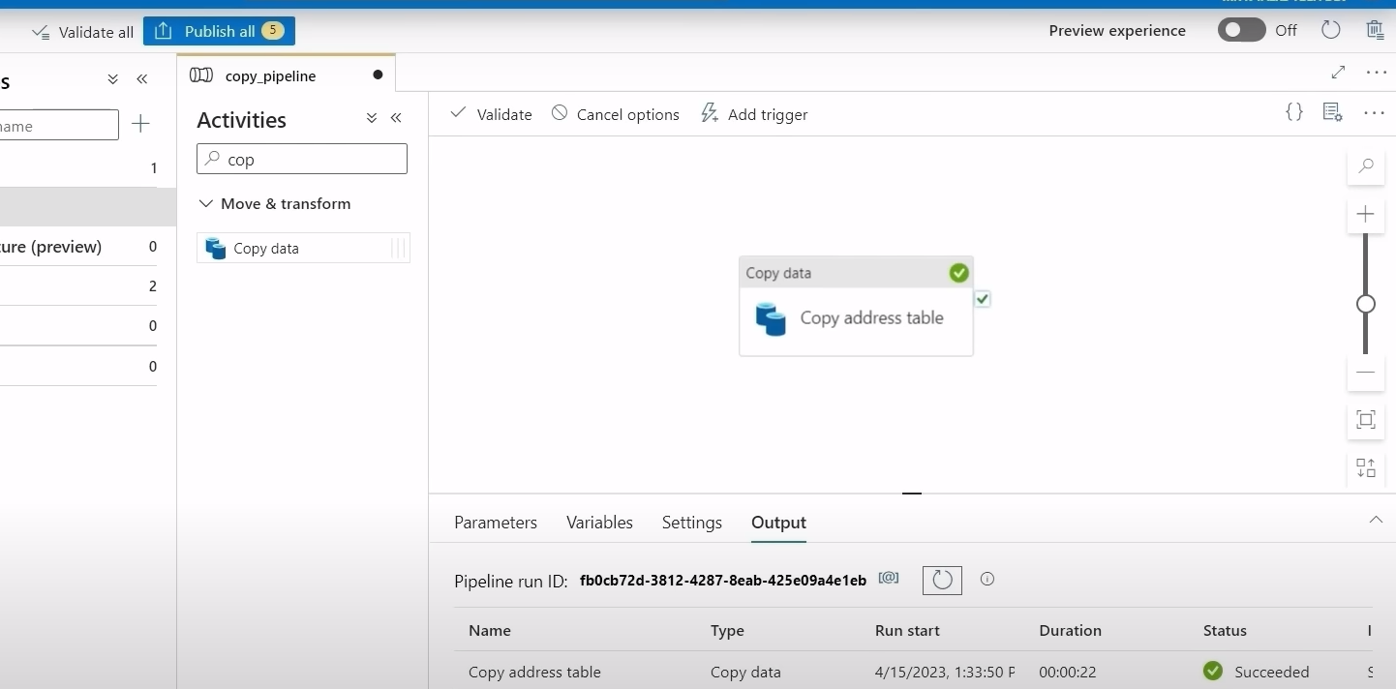

Now new file SalesLT.Address.parquet got stored in bronze container.

After pipeline ran successfully, we will click publish all as shown below.

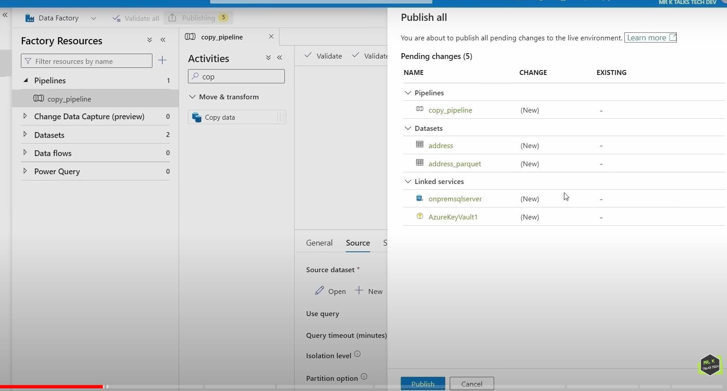

**DATA INGESTION- COPY MULTIPLE TABLES FROM ONPREMISE DATA SOURCE**

Using single pipeline, we can copy multiple tables from on-premise SQL server to data lake.

Author 🡪 + 🡪 Pipeline 🡪 change pipeline name to copy_all_tables in LHS in properties side.

Now we will go to on-premise SQL server , we want to get all tables from SalesLT schema, so we need to query first.

**SELECT**

**s.name AS SchemaName ,**

**t.name AS TableName**

**FROM sys.tables t**

**INNER JOIN sys.schema s**

**ON t.schema_id = s.schema_id**

**WHERE s.name = ‘SalesLT’**

The above query will give us result as shown below. These tables we are going to ingest in data lake using ADF.

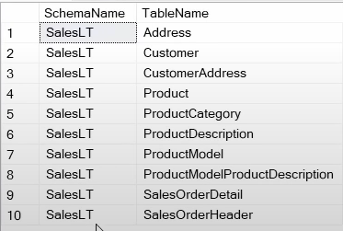

Now come back to ADF, we will search lookup and will drag lookup activity in canvas.

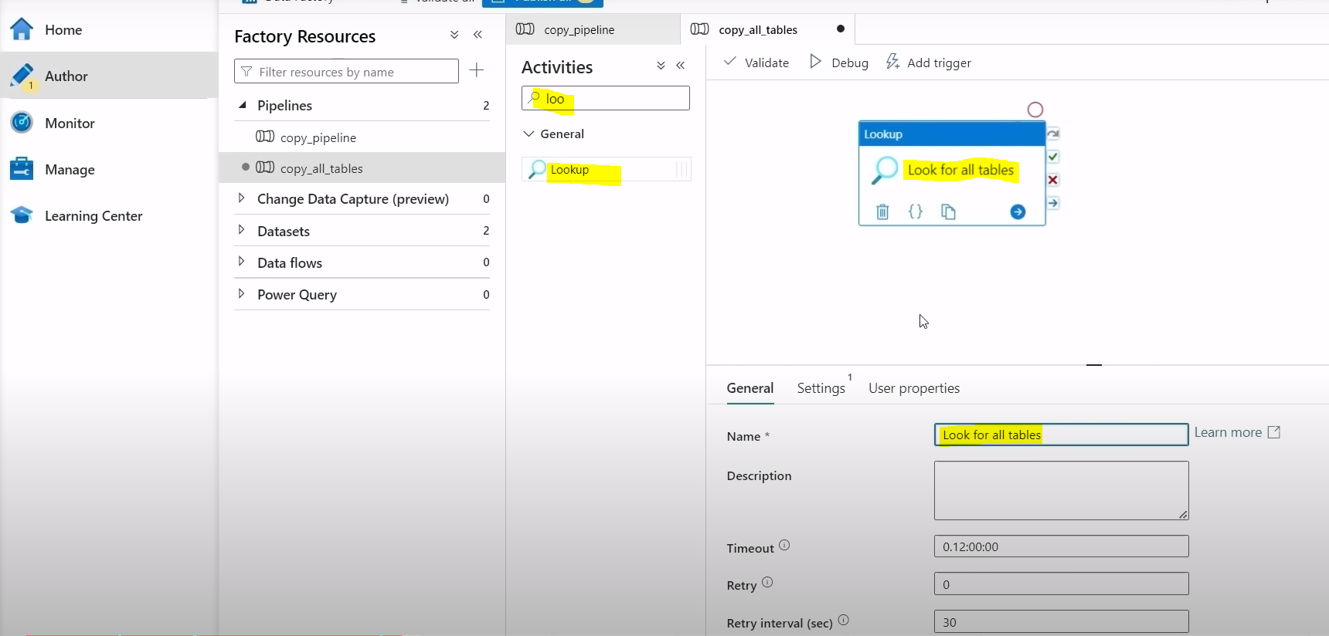

Now in Settings tab , we will create source data set , the above data ingestion in part-1 is only for address table, so we are creating another source data set.

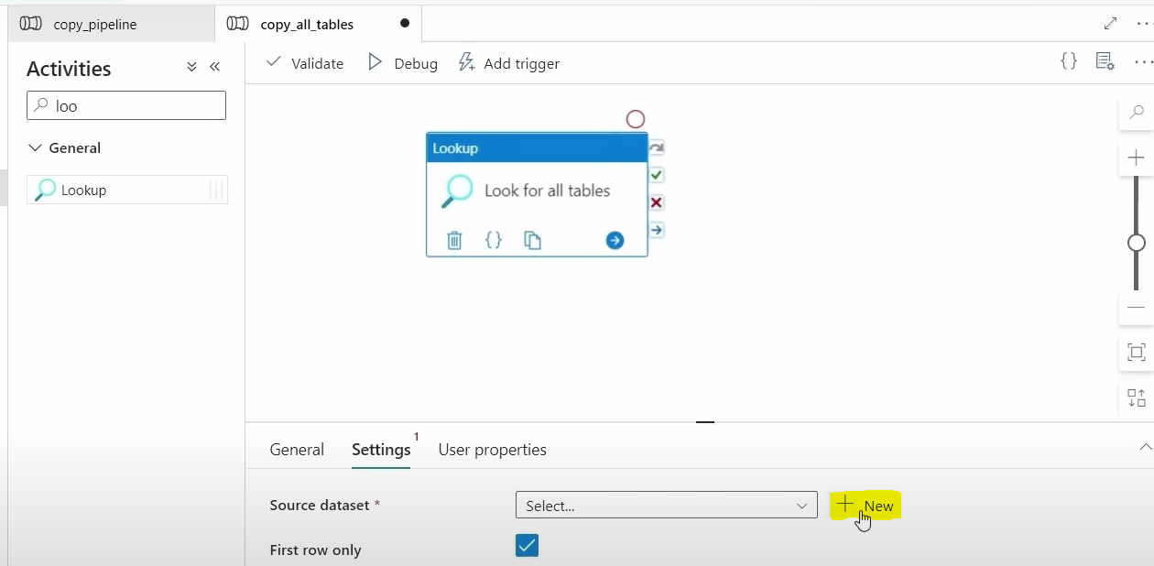

Click on + and select source as SQL Server and enter data set name as SqlDBTables .

Linked Service we will select from drop down, because we are selecting data from same data source as on-premise SQL server.

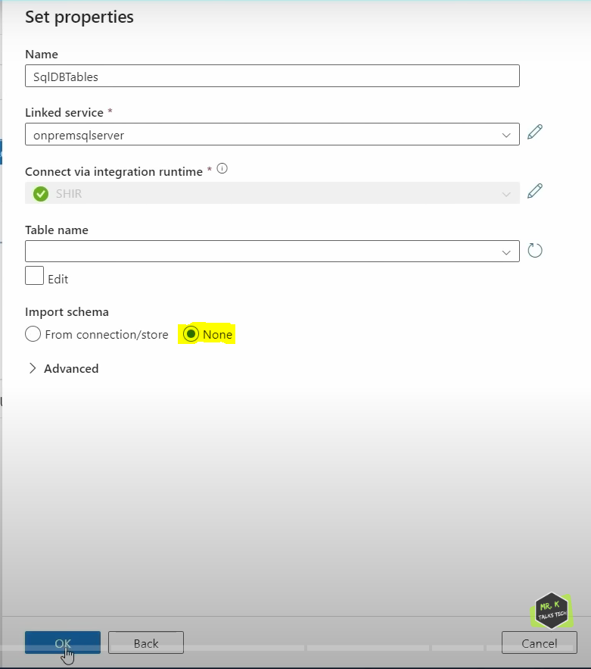

We are not selecting any table details here and leave it as it is and click on OK.

Here we need to select Query option instead of Table in Use query .

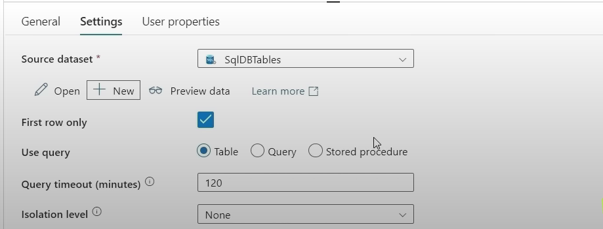

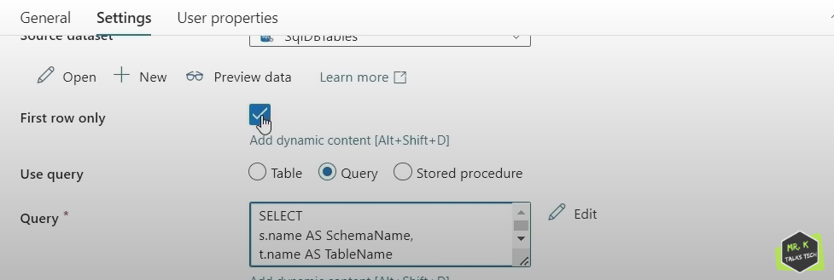

When we click on Preview data , we can see only 1 row as shown below.

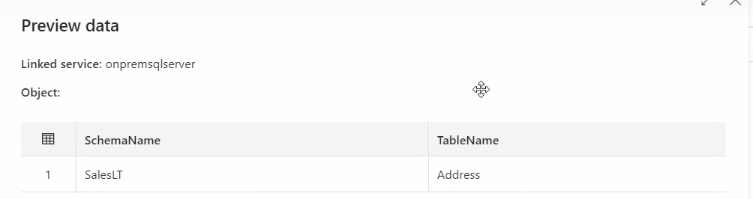

Reason of getting 1 row is we have enabled First row only checkbox as shown in above screenshot. If we disable it and preview data again then we can see all 10 rows of 10 tables as shown below.

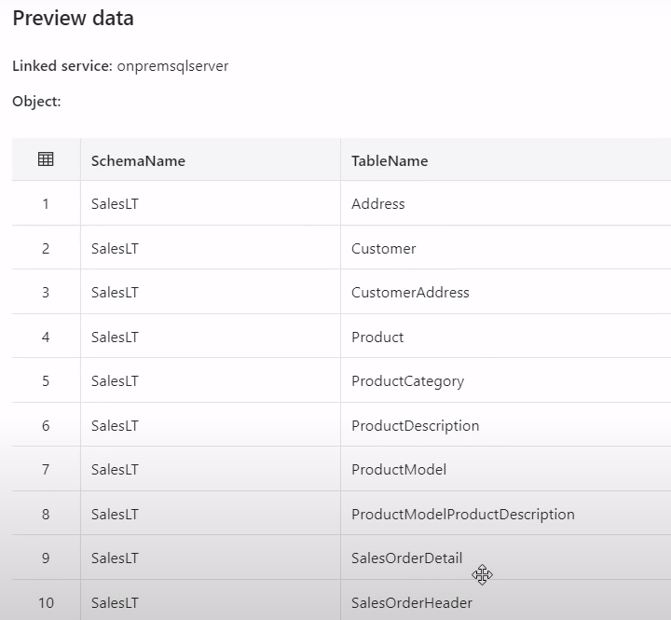

Now lookup activity work is completed, we need to click on debug option to check everything is succeeded or not.

Once it is succeeded , we need to drag for each activity in canvas.

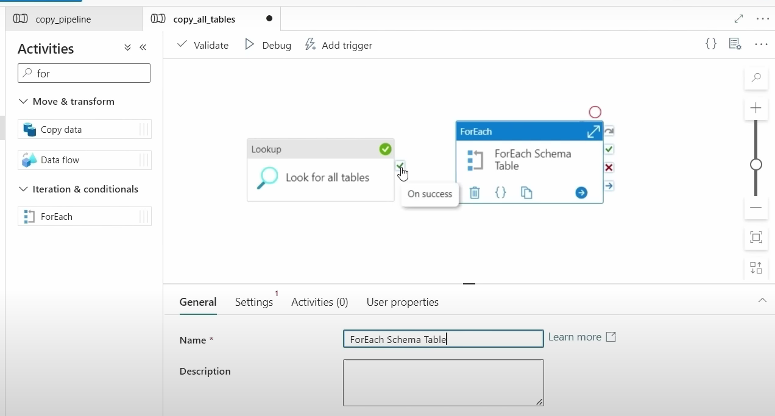

We need to connect this lookup activity on success to foreach loop activity which means that this foreach loop will run only when this lookup activity is successful.

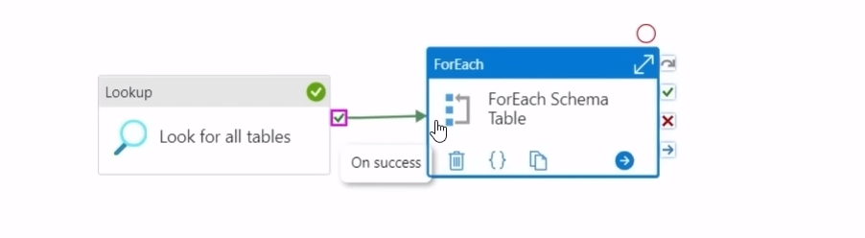

We got 10 tables as input to foreach so foreach loop will run 10 times.

Now in Settings 🡪 Items 🡪 we should pass output of lookup activity to this items* field in for each loop.

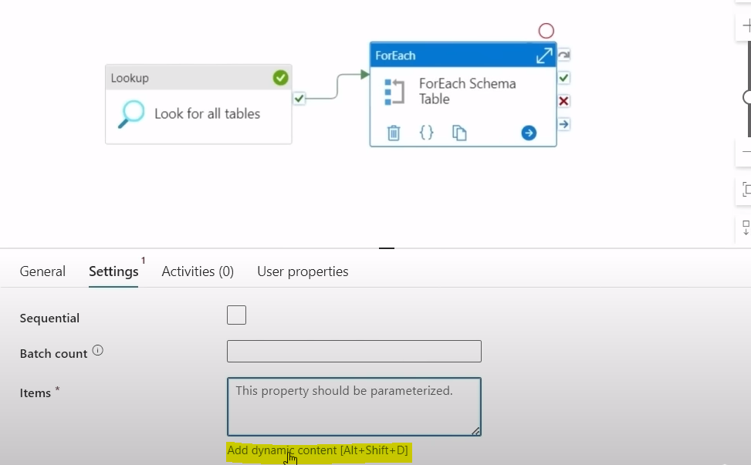

We need to click Add dynamic content and we need to select highlighted one in the Activity outputs and type .value after that and click on Ok. Why we added .value means in lookup activity output after debug if we see we have value in json template as shown below.

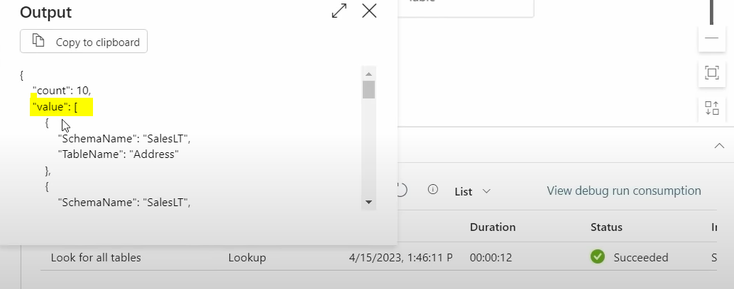

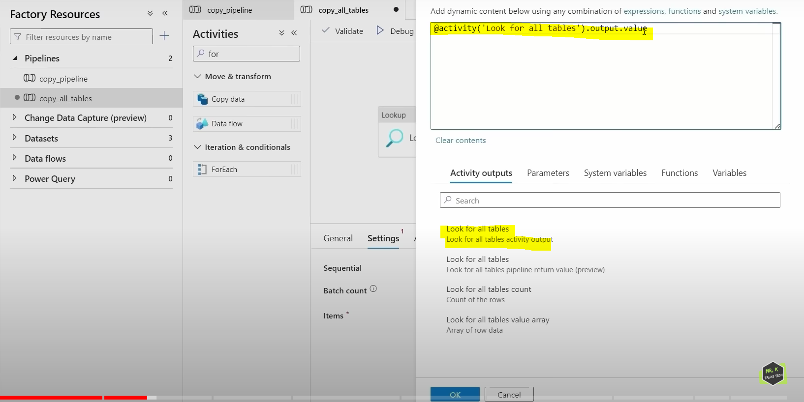

Now we have entire list inside that value properties.Now we have passed this value as an item to this for each activity so for each can iterate through the list one by one and get the schema name and table name from list .

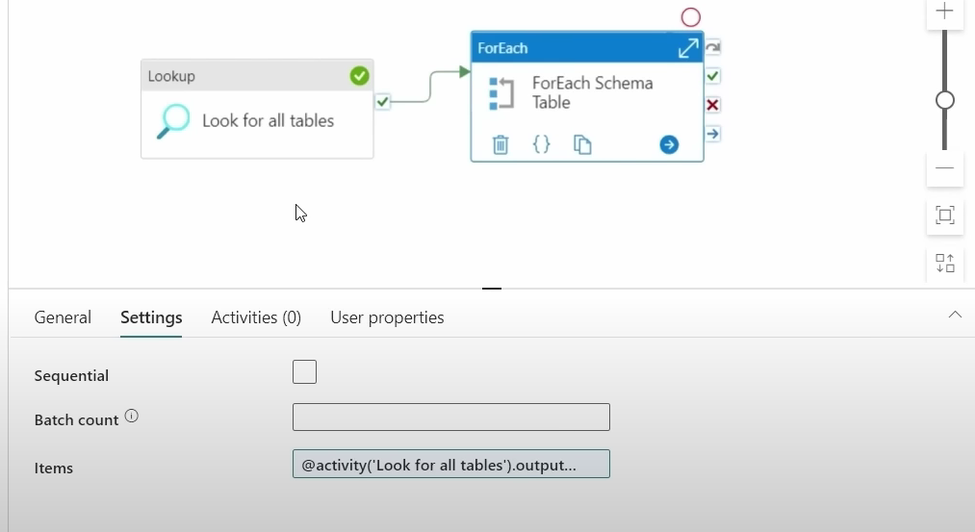

Now we go to Activities tab in for each activity, and click on pencil icon.

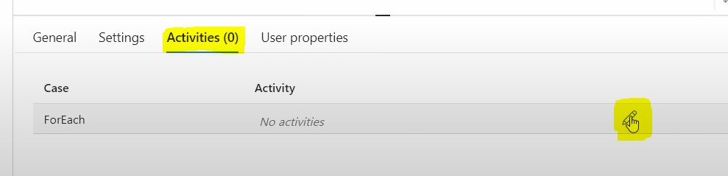

After clicking pencil icon symbol, we need to drag copy activity as shown below.

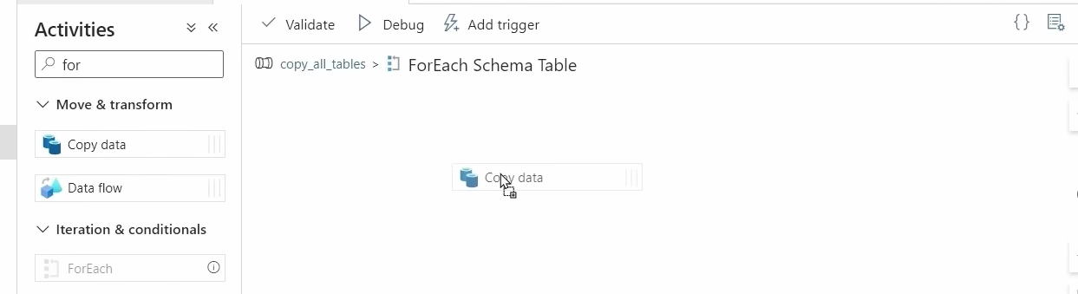

Now we will rename copy data activity to Copy Each Table

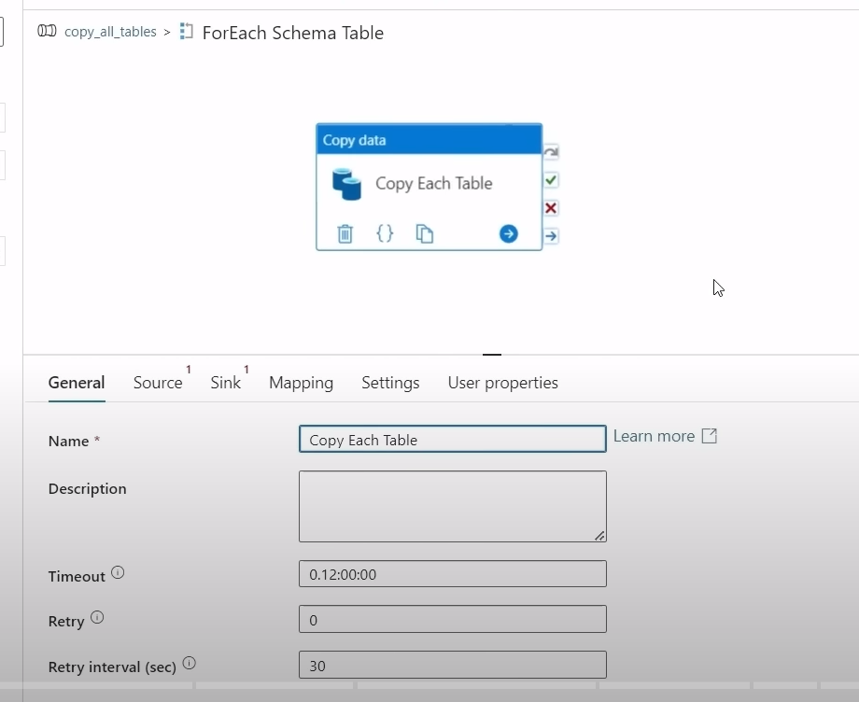

Now we will go to source tab and create new data set , for that we will select source as SQL server and enter data set name as SqlServercopy and we will select linked service from drop down as on-premise SQL server and we wont select any tables and click on OK.

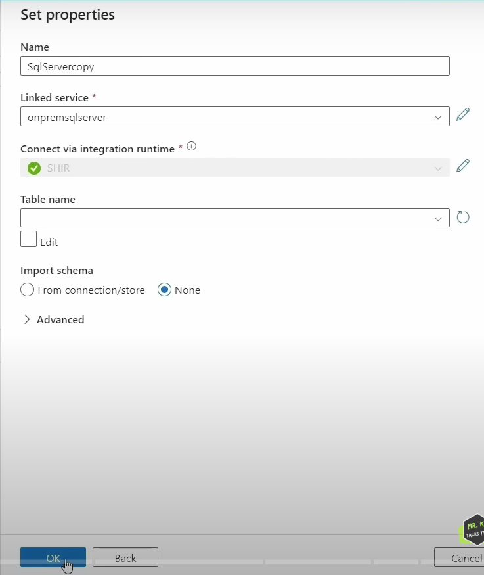

Now we will shift table to query in Use query and click Add dynamic content as shown below.

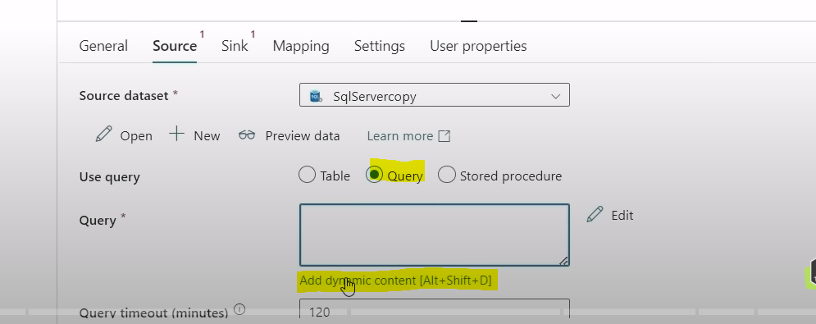

We need to enter the code in dynamic content as shown below and click on OK.

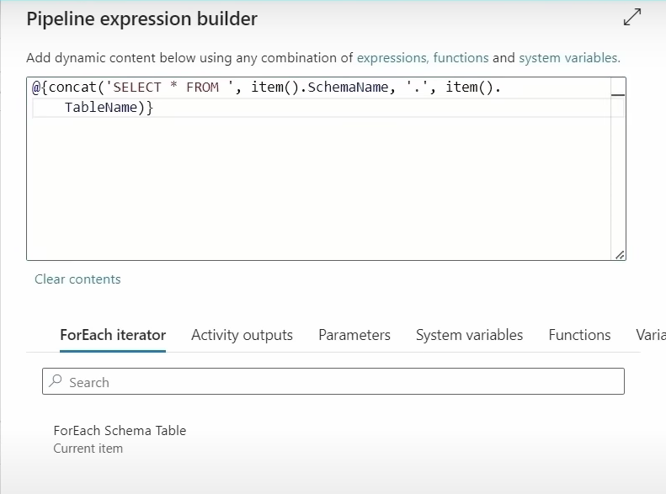

Here note down that after select * from there should be space as shown in above screenshot.

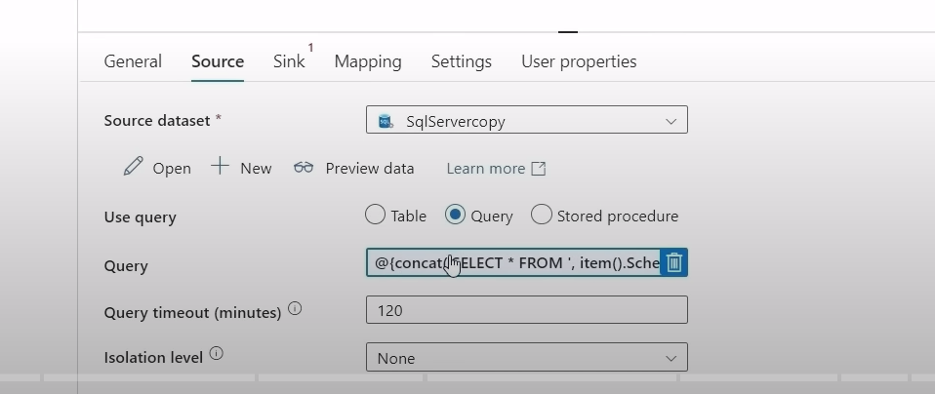

Each item from lookup activity(schema and table name) output is passed to for each activity. And for each loop will get schema and table name and it will be used in the copy data activity in the source in the query that we have defined.This process will happen one by one iteratively until all the tables have been copied.

Now we will go to Sink , we will create new data set for sink , click + and select ADLS Gen2 , and select parquet format continue and enter data set name as parquetTables and we will select Linked Service from drop down and we will select file path as shown below.

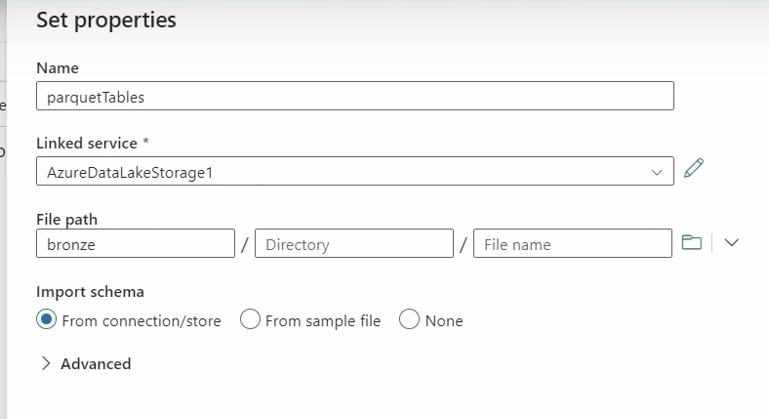

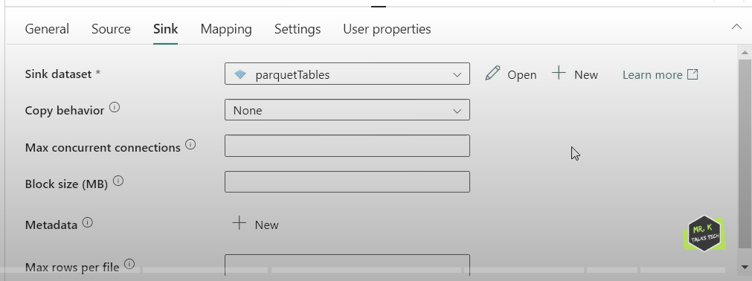

--

If we want folder structure as below, In Bronze folder, Schema Folder, In Schema Folder, Tablename Folder. In Tablename folder , Tablename.parquet file.

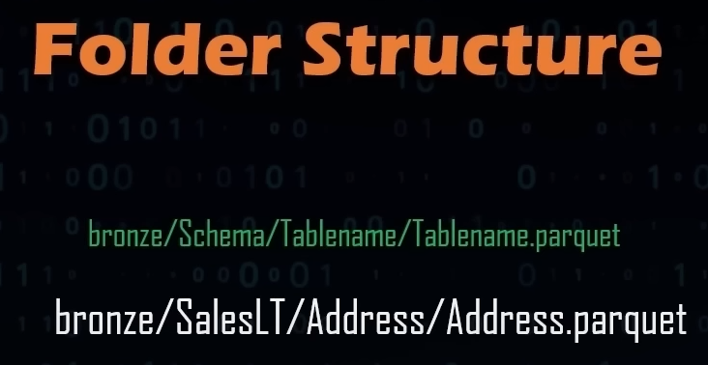

In order to configure folder structure in ADLS using ADF, we will go to sink in copy data activity and we will click on open.

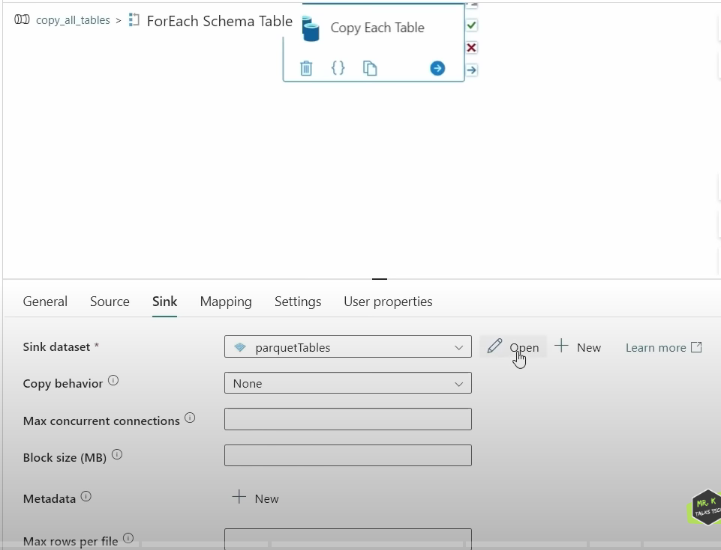

We will go to parameters tab and click on + to create 2 parameters.

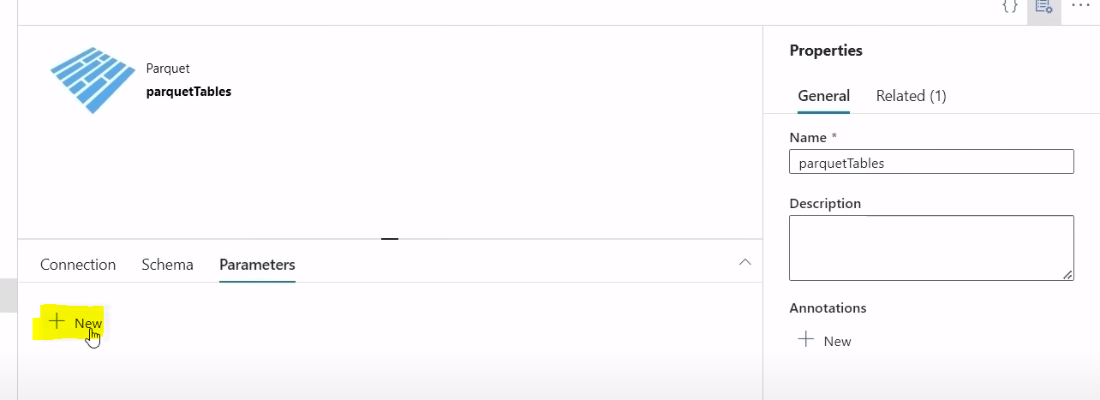

Now we will create 2 parameters one with schemaname and other with tablename in the sink data set. We need to give values to this parameters from the item values.

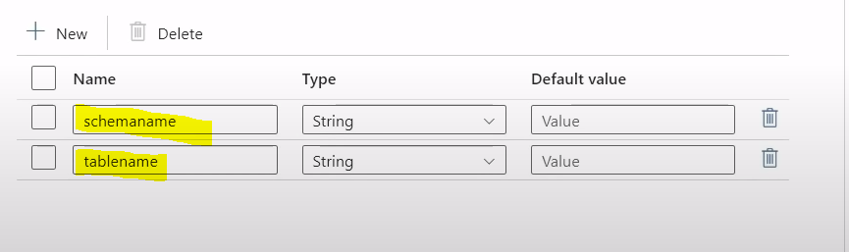

Now we will go back to pipeline , we will select add dynamic content as shown below.

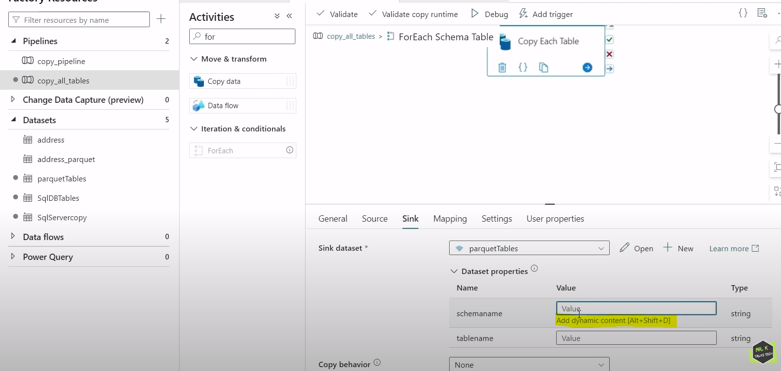

Now we will select highlighted one from the ForEach iterator tab and we will type .SchemaName and click on Ok.

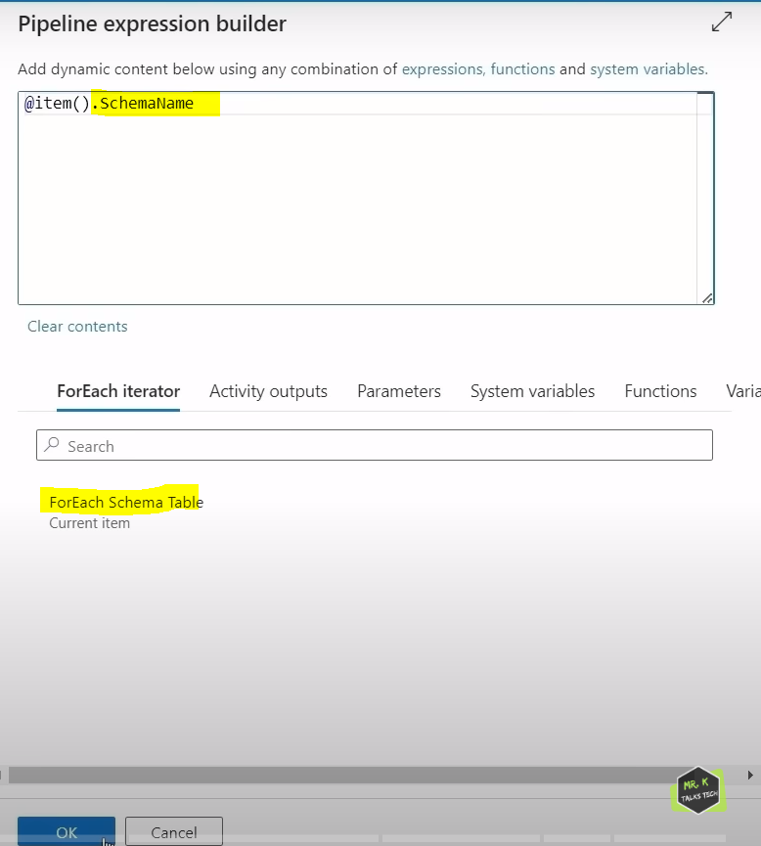

Similarly for the tablename parameter also we will go to dynamic expression builder and enter expression as shown below.

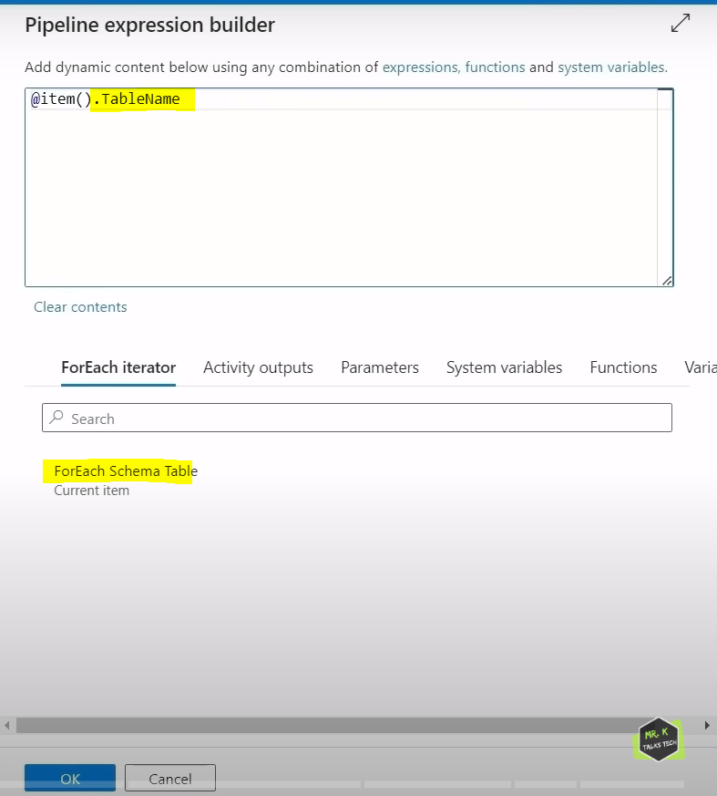

SchemaName and TableName in expression builder is coming from lookup activity from outer loop which is now used in parameters value.

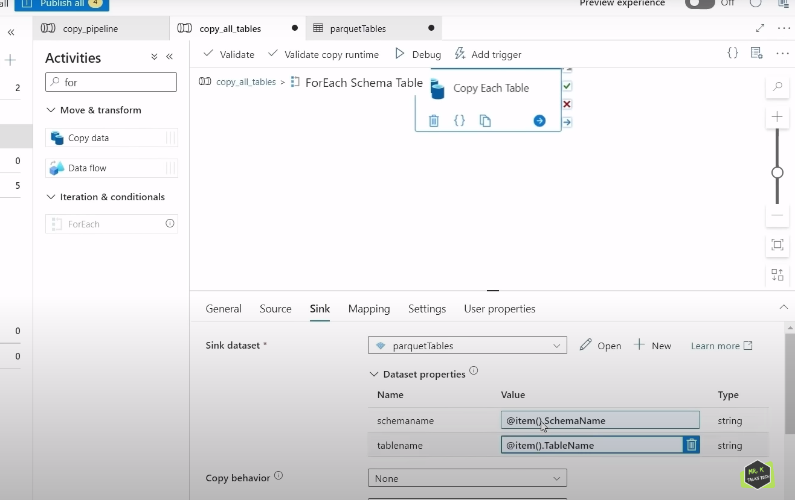

Now if we again click on open, it will take us to sink data set as shown below.

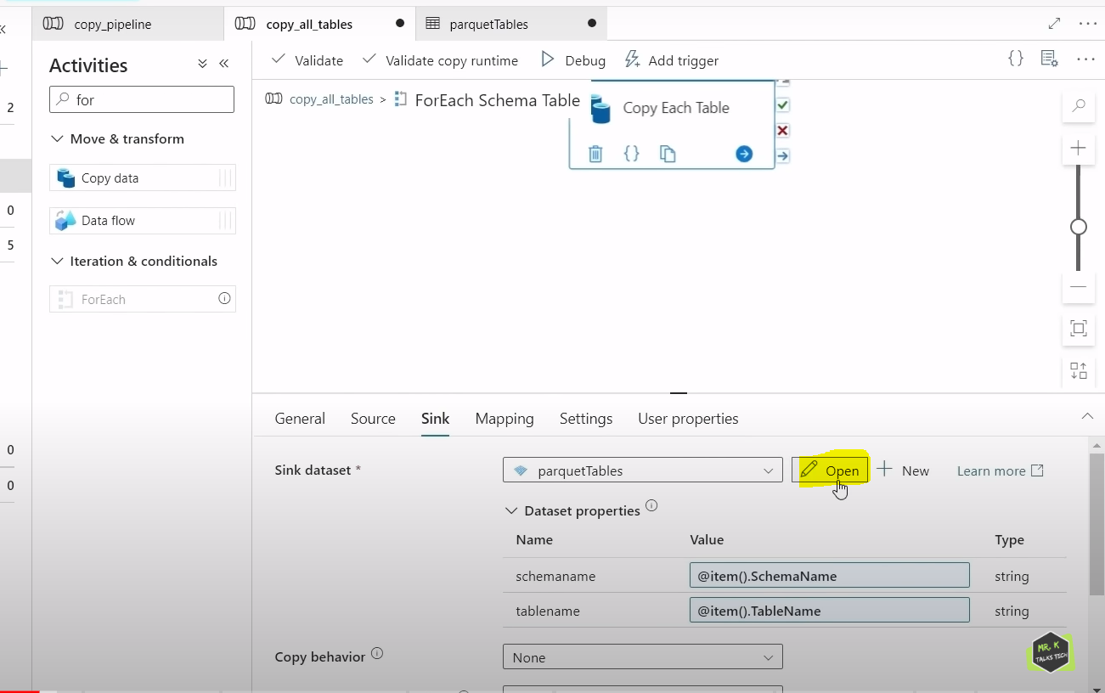

Now we go to connection tab , in file path, at directory , we will click on Add dynamic content as shown below.

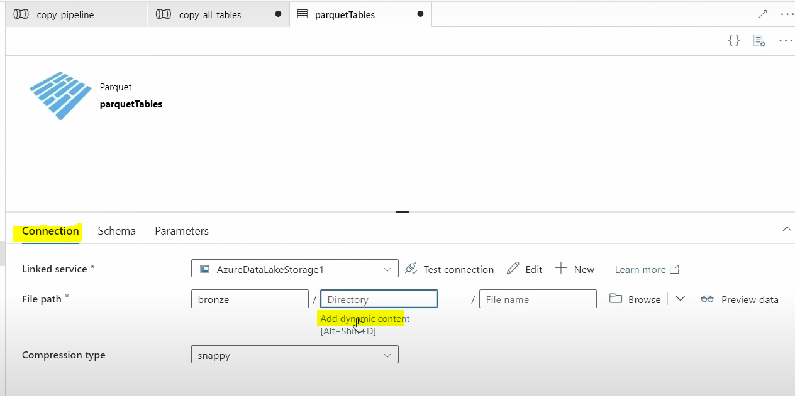

Inside pipeline expression builder, the code what we written will generate folder structure in ADLS Gen2 as shown in below screenshot.

It is concat method which concats schema name / table name. This code will generate directory structure for us. dataset().schemaname and dataset().tablename is directly coming from parameters that we have defined for this data set .

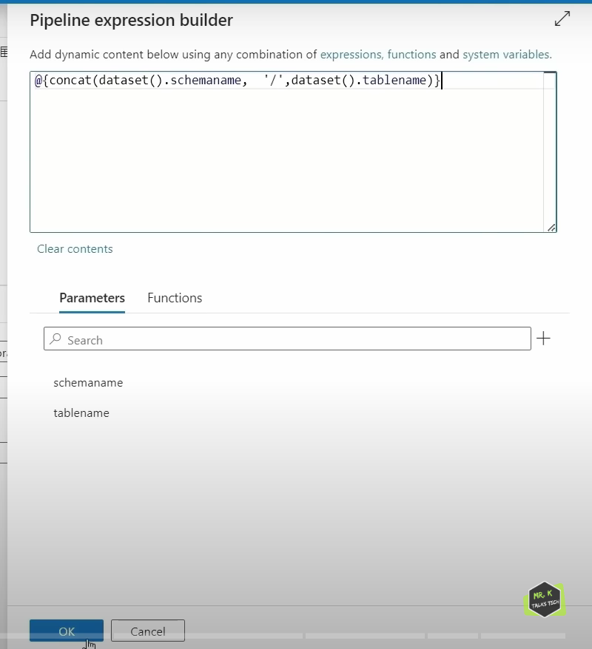

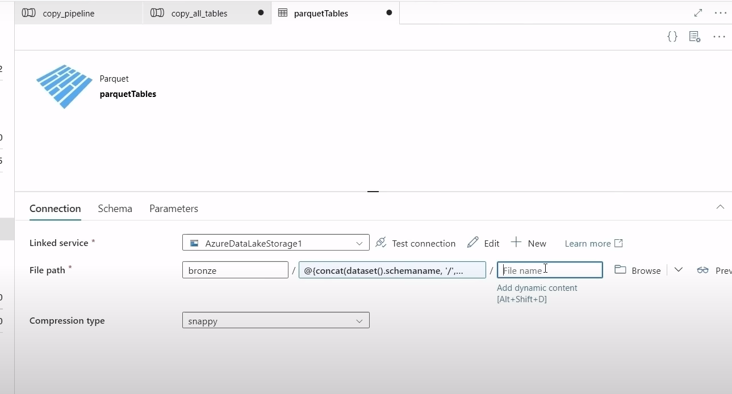

Now we need to configure File name now . Go to add dynamic content and paste below code and click ok.

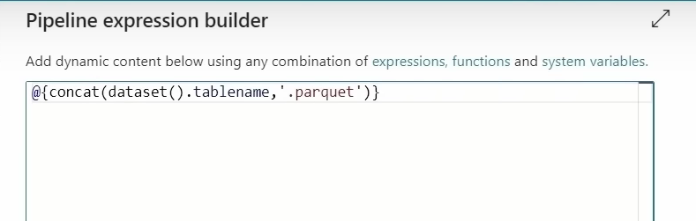

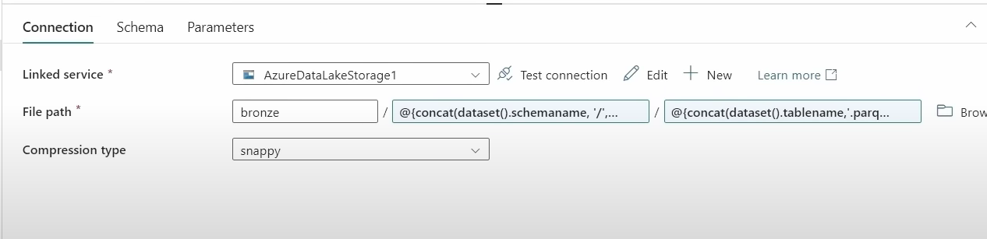

Now we go to outer pipeline by clicking on pipeline link as shown below in highlighted.

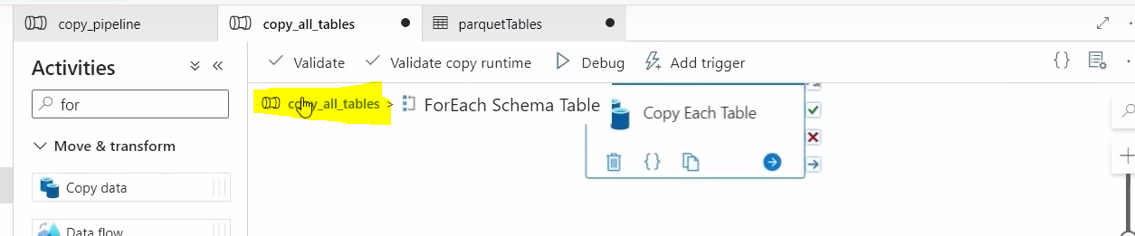

Now we are publishing our changes.

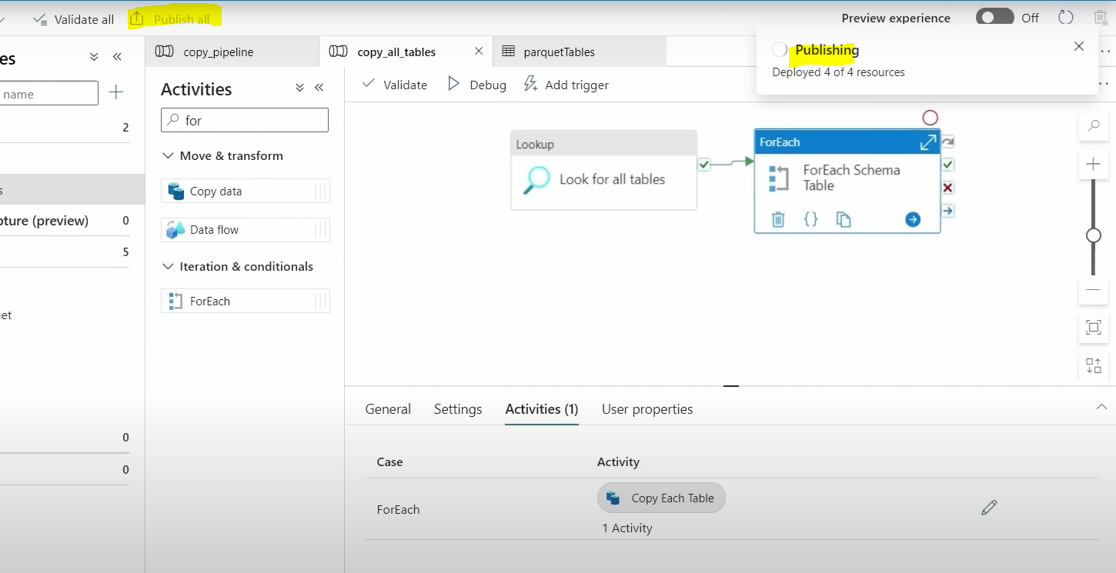

Now we will run pipeline, Add trigger 🡪 Trigger now.

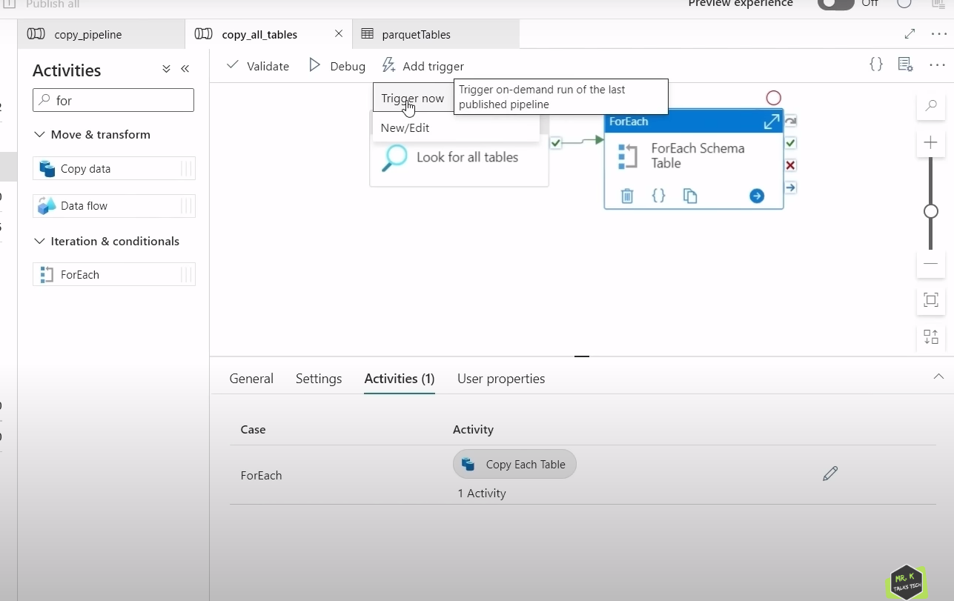

We can monitor pipeline now using below tab.

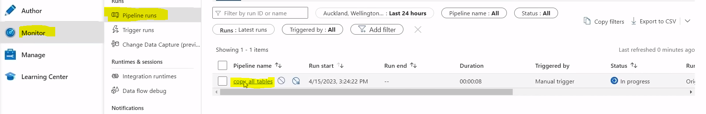

If we click on pipeline name copy_all_tables , the below screenshot will be visible. It will monitor all the individual activities here.

As we can see here lookup activity has been completed , it is with green tick and for each activity is currently running.

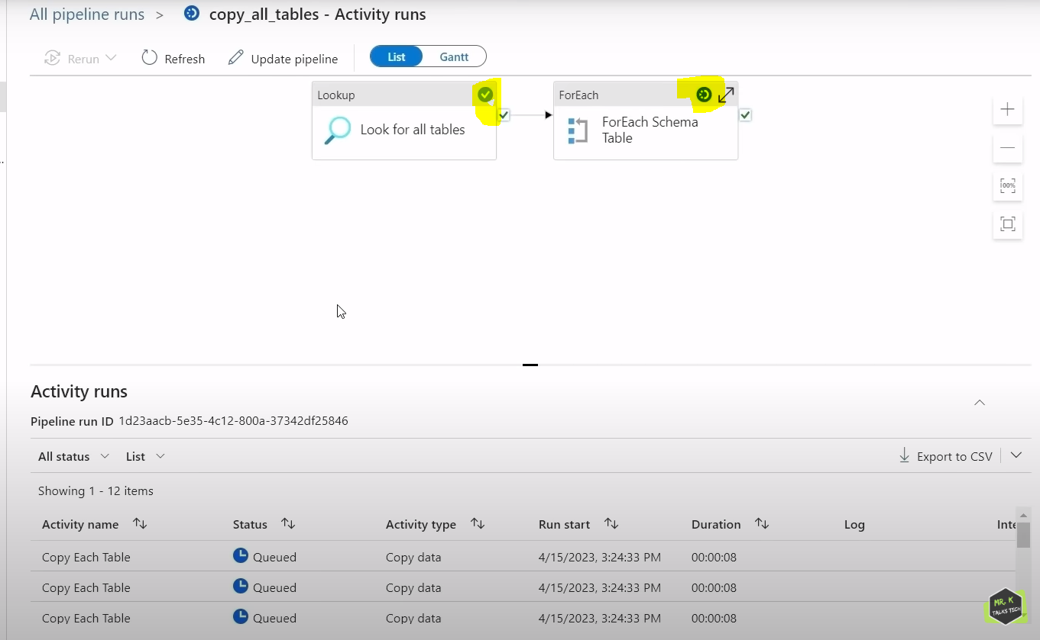

In Activity Runs we can see that 10 for each activities is running at the same time . so, each for each activity is trying to copy an individual table .

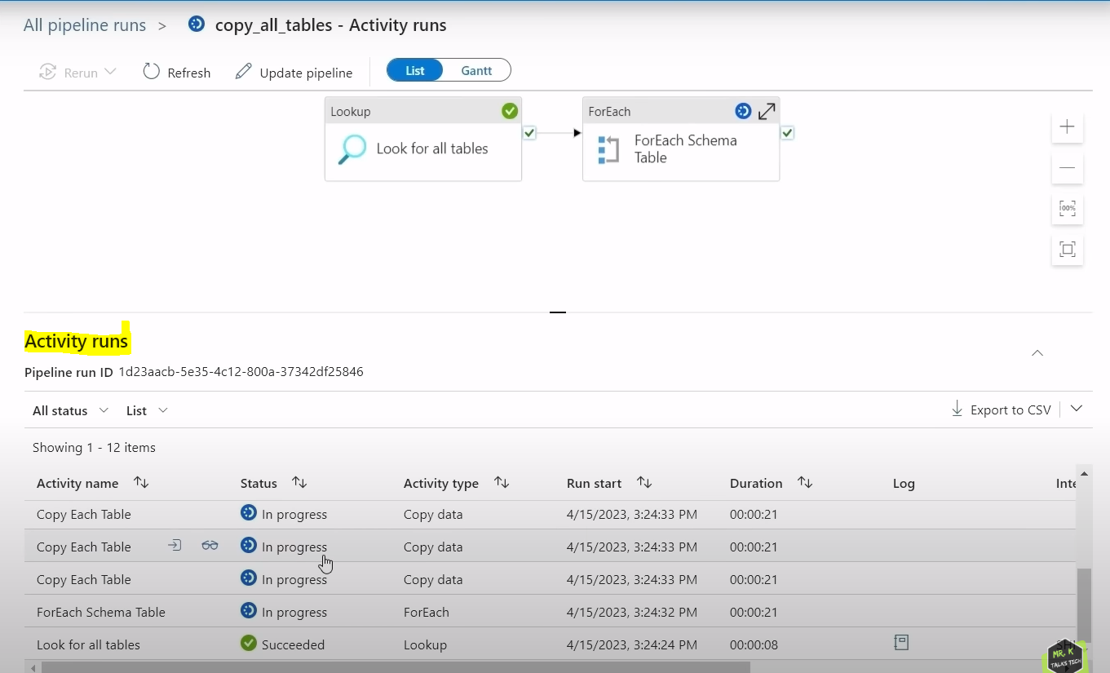

Now for each activity also in green tick on success state. Now pipeline ran succeeded and all tables are loaded into ADLS gen2.

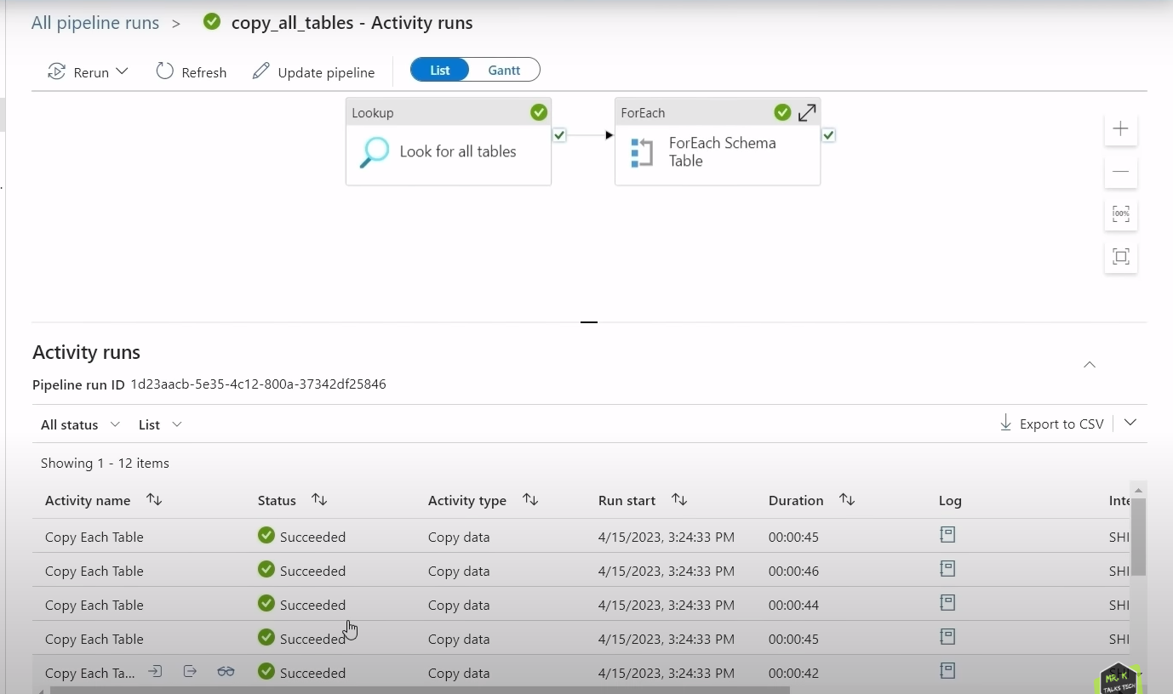

In ADLS Gen2 folder structure is also created as shown below.

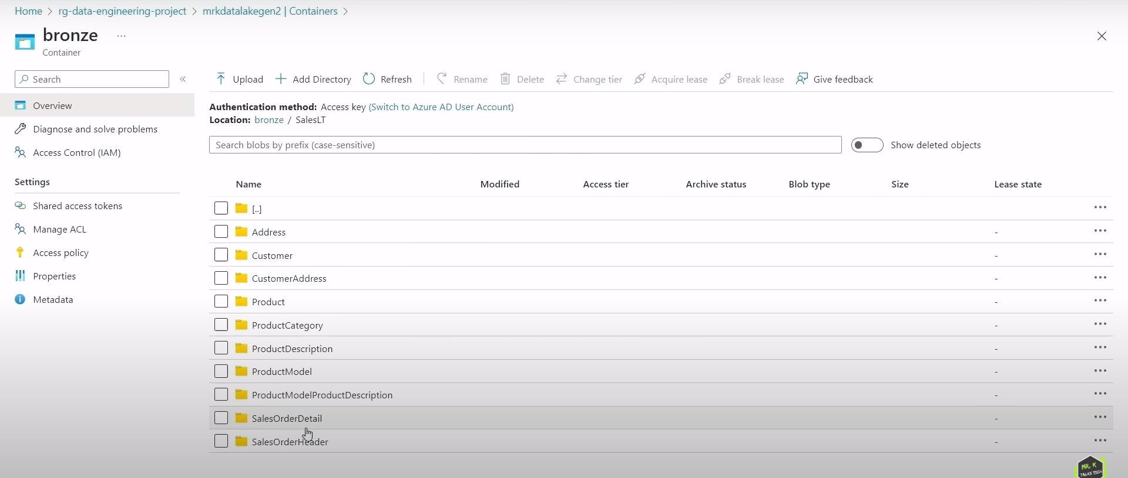

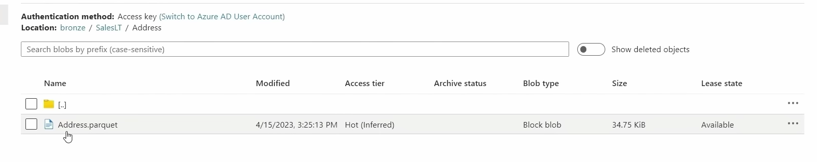

Till now we have covered data ingestion in bronze layer in ADLS Gen2.

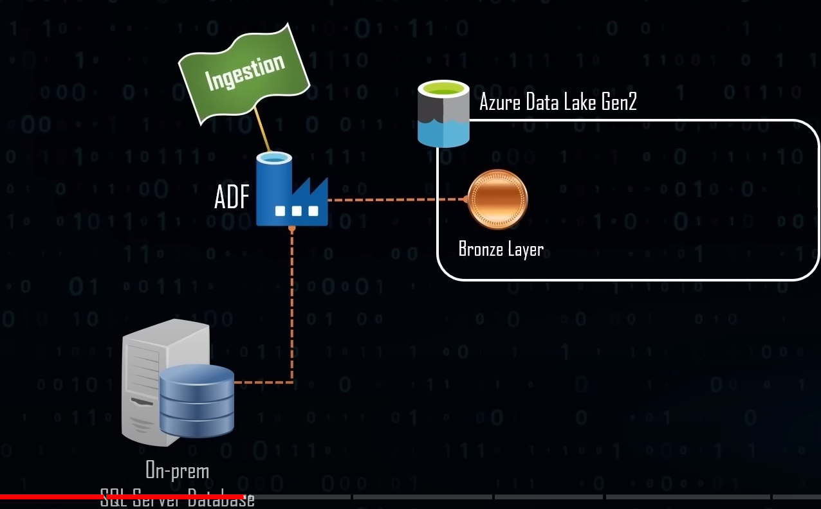

**DATA TRANSFORMATION USING DATA BRICKS**

While creating cluster in ADB, we will enable credential pass through in Advanced options.

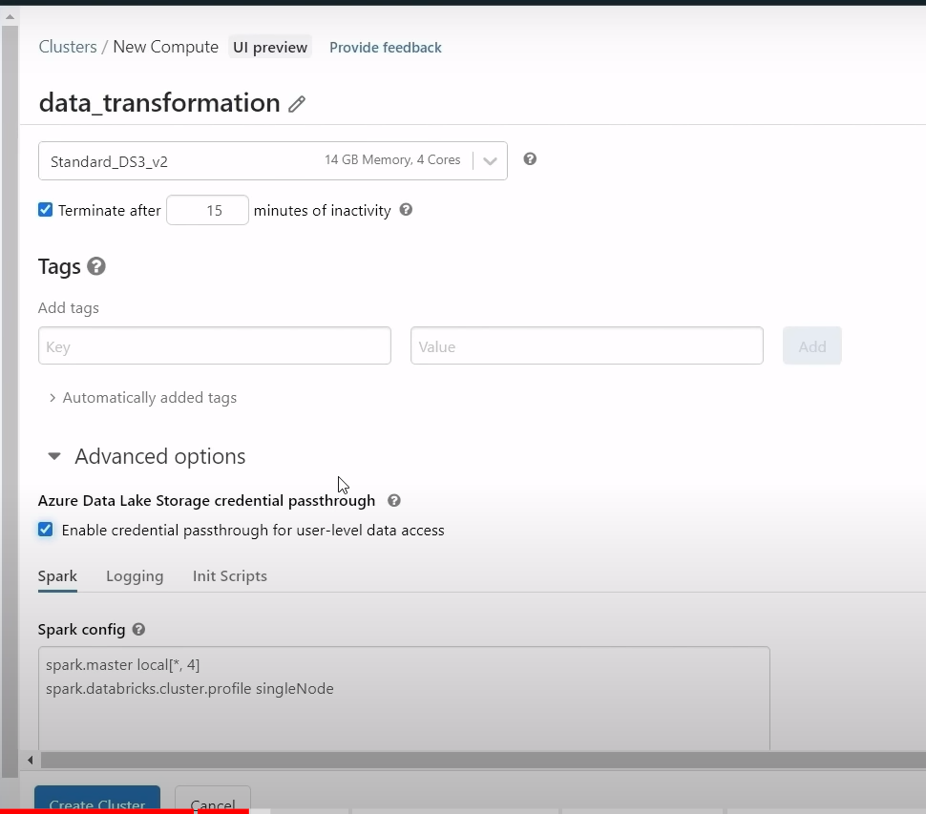

Reason behind enabling credential passthrough is in ADLS Gen2 , Go to Access Control(IAM) 🡪 Role Assignments.

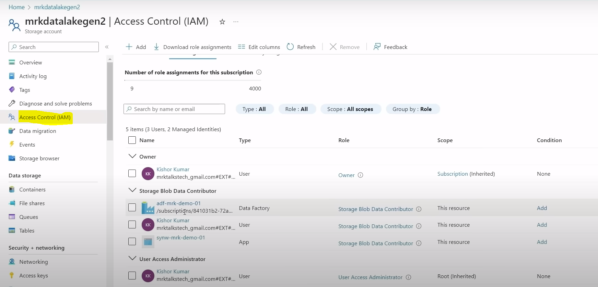

ADF, user mrk and ASA has Storage Blob Data Contributor access to the data lake. All the 3 things which has Blob Storage Data Contributor access is given access based on managed identity. Managed Identity means any resource that we created in azure it comes with a default id and we can assign that ID to give any sort of permission but currently we cannot assign databricks managed identity to give a blob storage contributor access to the data lake so this is not supported yet which means there is no connection between ADB and ADLS. So, in order to establish connection, there are different ways to do it using service principal to mount the data lake and other method is credential pass-through method in ADB. Once we enable credential pass through in cluster in advanced information as shown in above screenshot , user mrk account has blob storage contributor access, so ADB will use this set of access to connect to the data lake by enabling credential pass through . So ADB workspace was using by [mrktalkstech@gmail.com](mailto:mrktalkstech@gmail.com), so that particular user should have blob storage data contributor access , then only data bricks can use that mrk user access to connect to data lake.

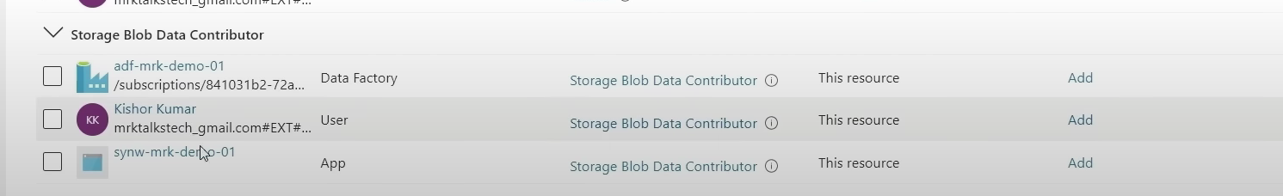

Now after creating cluster and creating notebook,

We will enter below piece of code to mount ADLS Gen2.

**configs = {**

**"fs.azure.account.auth.type": "CustomAccessToken",**

**"fs.azure.account.custom.token.provider.class": spark.conf.get("spark.databricks.passthrough.adls.gen2.tokenProviderClassName")**

**}**

**# Optionally, you can add <directory-name> to the source URI of your mount point.**

**dbutils.fs.mount(**

**source = "abfss://<container-name>@<storage-account-name>.dfs.core.windows.net/",**

**mount_point = "/mnt/<mount-name>",**

**extra_configs = configs)**

**dbutils.fs.mount(**

**source = "abfss://bronze@mrkdatalakegen2.dfs.core.windows.net/",**

**mount_point = "/mnt/bronze",**

**extra_configs = configs)**

**Out[1]: True**

Here mount name is container name. we actually using mount_point to access data inside bronze container . After executing this code , we can access all data inside this bronze container using the mount point name that we have defined. We can actually now use this mount point to actually access all the data inside this bronze container.

dbutils.fs.ls(“/mnt/bronze”) 🡪 This will list all the data that is present inside this bronze container

Out[2] : 

There is one folder inside bronze container that is SalesLT.

dbutils.fs.ls(“/mnt/bronze/SalesLT/”)

Out[3]:

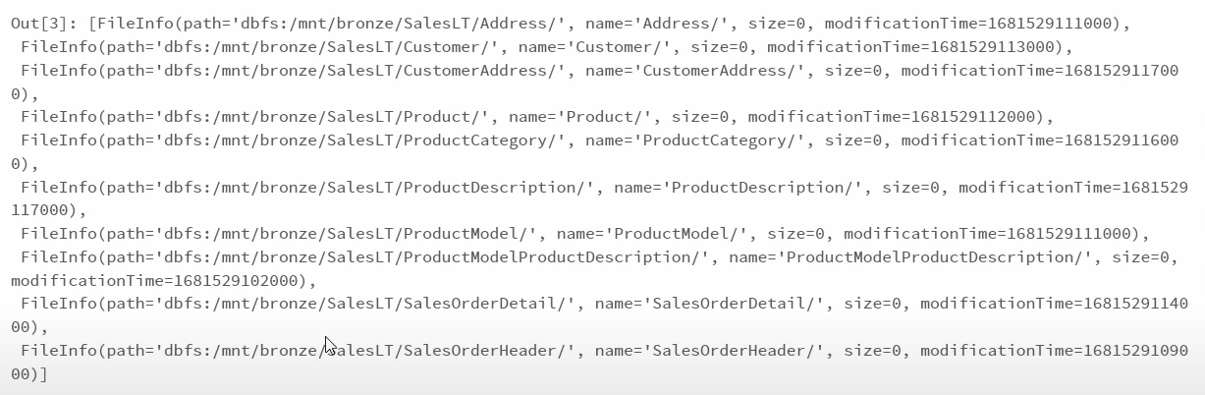

If we are using credential pass through in cluster creation , we can not only access data via mount . we can access data directly using ADLS path in dbutils.fs.ls also without access tokens. Using mount point it is very easy to access. So, we are using mount concept.

**configs = {**

**"fs.azure.account.auth.type": "CustomAccessToken",**

**"fs.azure.account.custom.token.provider.class": spark.conf.get("spark.databricks.passthrough.adls.gen2.tokenProviderClassName")**

**}**

**dbutils.fs.mount(**

**source = "abfss://bronze@mrkdatalakegen2.dfs.core.windows.net/",**

**mount_point = "/mnt/silver",**

**extra_configs = configs)**

**configs = {**

**"fs.azure.account.auth.type": "CustomAccessToken",**

**"fs.azure.account.custom.token.provider.class": spark.conf.get("spark.databricks.passthrough.adls.gen2.tokenProviderClassName")**

**}**

**dbutils.fs.mount(**

**source = "abfss://bronze@mrkdatalakegen2.dfs.core.windows.net/",**

**mount_point = "/mnt/gold",**

**extra_configs = configs)**

Similarly, we are mounting mount point for silver and gold containers in ADLS Gen2.

Note: We can use bronze mount point to read all the data that exist in the bronze container, do some transformation and load the transformed data into silver container using the silver mount point and that would be first level of transformation we will be doing and after that we will read transformed data from silver container , do further transformation and put the final transformed layer into gold layer using gold mount point.

In real time projects we will create notebook in workspace 🡪 shared ,so that multiple users in the team can collaborate and work. Here we have created 3 notebooks.

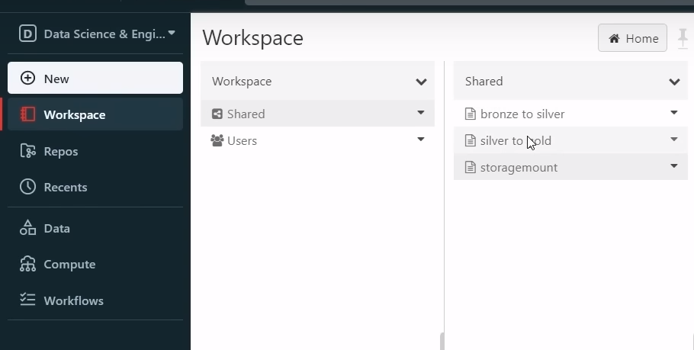

--

TRANSFORMATION : PART-1:

dbutils.fs.ls(‘mnt/bronze/SalesLT/’) 🡪 If we get no permission , in IAM 🡪 Storage Blob Data Contributor role to be given in ADLS Gen2 (IAM )

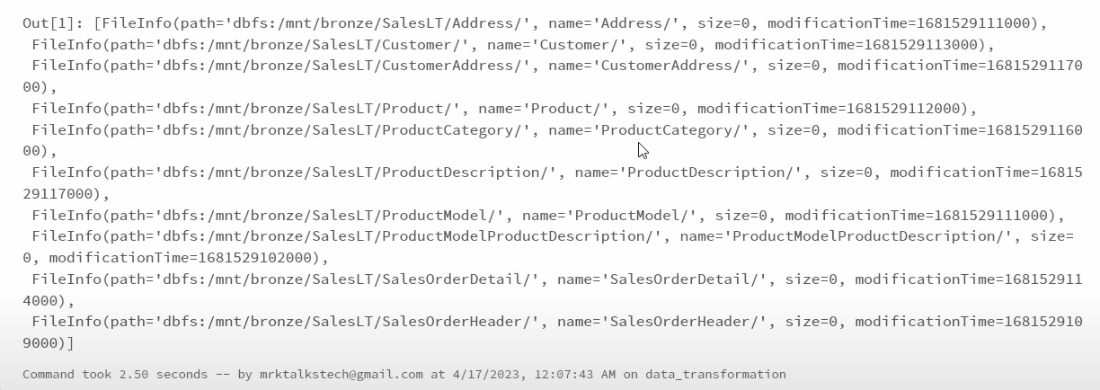

dbutils.fs.ls(‘mnt/silver/’)

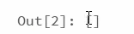 we don’t have any files in silver container . At the end of level-1 transformation we should be seeing output in silver container as well.

**input_path = ‘/mnt/bronze/SalesLT/Address/Address.parquet’**

**df= spark.read.format(‘parquet’).load(input_path) 1 spark job ran.**

**display(df) 1 spark job ran**

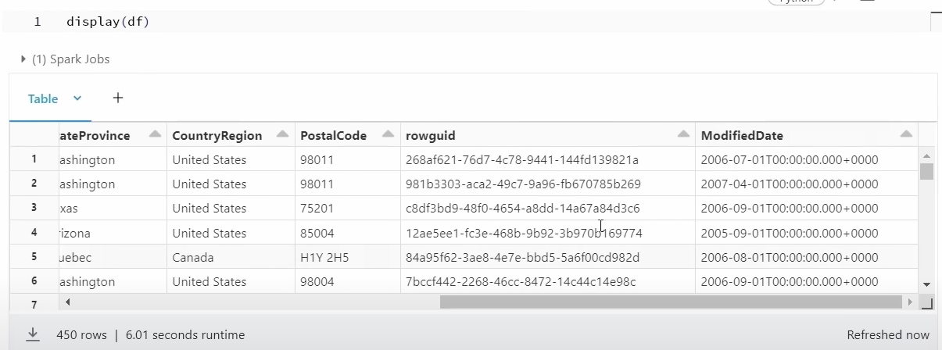

Now we want to change ModifiedDate column data from date-time format to date format for only 1 Address column.

**from pyspark.sql.functions import from_utc_timestamp, date_format**

**from pyspark.sql.types import TimestampType**

**df = df.withColumn(“ModifiedDate”,** **date_format(from_utc_timestamp(df[“ModifiedDate”].cast(TimestampType()), “UTC”), “yyyy-MM-dd”))**

code explanation: date_format function will convert timestamp or date or date time column to date in string format. From_utc_timestamp will convert our timestamp to UTC timestamp.

---

If I want to transform timestamp to date format for all columns which is having column name as date for all tables then below code will be used for that.

Or

from pyspark.sql.functions import date_format, to_date

df1 = df.withColumn("ModifiedDate",date_format(to_date("ModifiedDate"),"yyyy-MM-dd"))

Any code we can use.

**table_name = []** 🡪 we have an array called table_name

**for i in dbutils.fs.ls(‘mnt/bronze/SalesLT/’) :**

**table_name.append(i.name.split(‘/’)[0])** 🡪 we are using for each loop to iterate through the bronze container , we will get directory name and we will append directory name to table_name array .

When we run above 2 lines code, what happens is all directory name that exists under bronze container will get added as a table name to the table name array.

**table_name 🡪** If I run only table_name array we will get list of all tables as shown below,

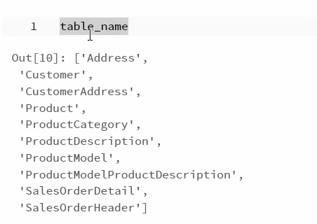

Code Explanation : Now we have another for each loop which iterates to the table_name array. Inside this for each loop , we are generating input path for all the tables iteratively. After generating input path , we are loading as a data frame. After that we declared a variable column which gets all column names from data frame as a list , once it is done, we are doing another for each loop to iterate through the column names to check. If any of column is having a value date in it, we have to do the transformation, we will use same transformation logic inside if condition to transform date columns from datetime format to date format. Once it is done, we will be generating output path that points to silver container and that will load tables again back to silver container. Final step is we will be writing transformed data frame to the data lake using output path in delta format. When we are saving data into bronze layer , we saved as parquet format. When we are writing data to gold container, we will save in delta format.

**from pyspark.sql.functions import from_utc_timestamp, date_format**

**from pyspark.sql.types import TimestampType**

**for i in table_name:**

**path = ‘/mnt/bronze/SalesLT/’ + i + ‘/’ + i + ‘.parquet’**

**df= spark.read.format(‘parquet’).load(path)**

**column = df.columns**

**for col in column:**

**if “Date” in col or “date” in col:**

**df= df.withColumn(col, date_format(from_utc_timestamp(df[col].cast(TimestampType()),”UTC”) , “yyyy-MM-dd”))**

**output_path = ‘/mnt/silver/SalesLT/’ +i +’/’**

**df.write.format(‘delta’).mode(“overwrite”).save(output_path)**

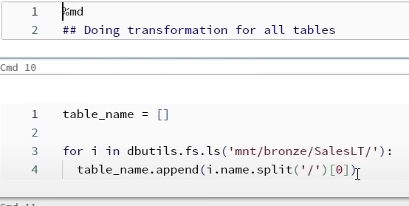

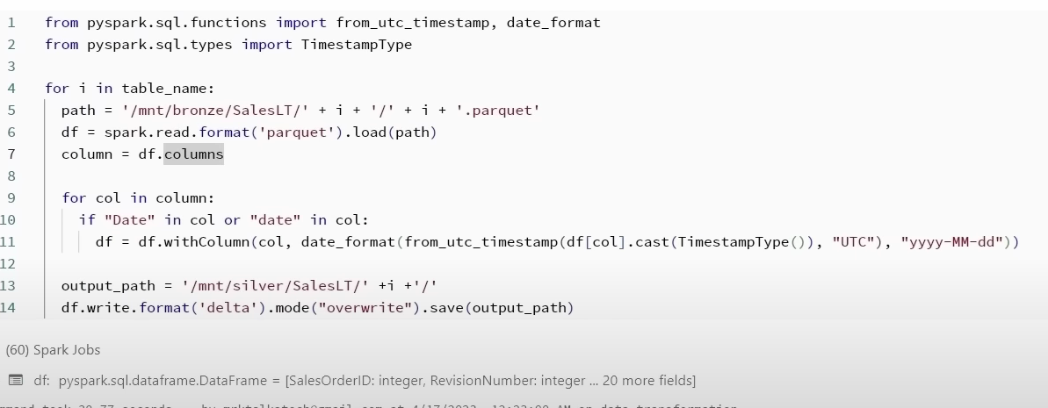

**Or below code , any code will work.**

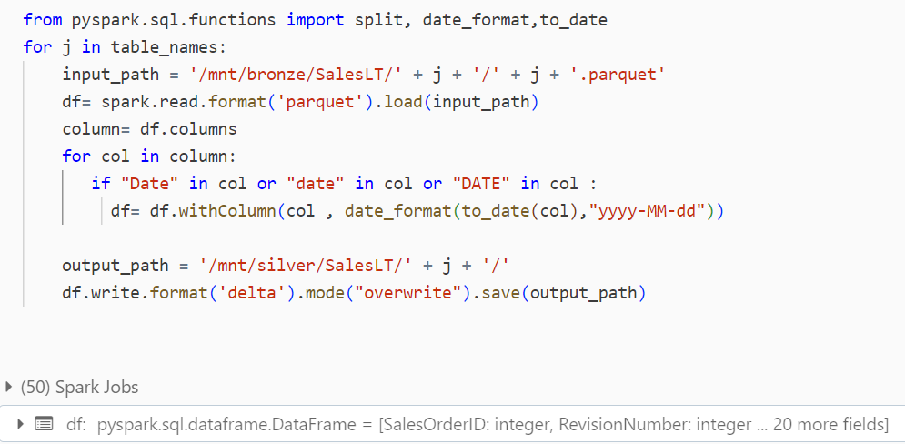

We need to make sure indentation of for and if loops are in correct line otherwise we will get indentation error.

Once we run above command, table data will be loaded to silver container.

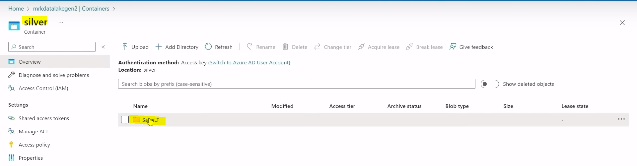

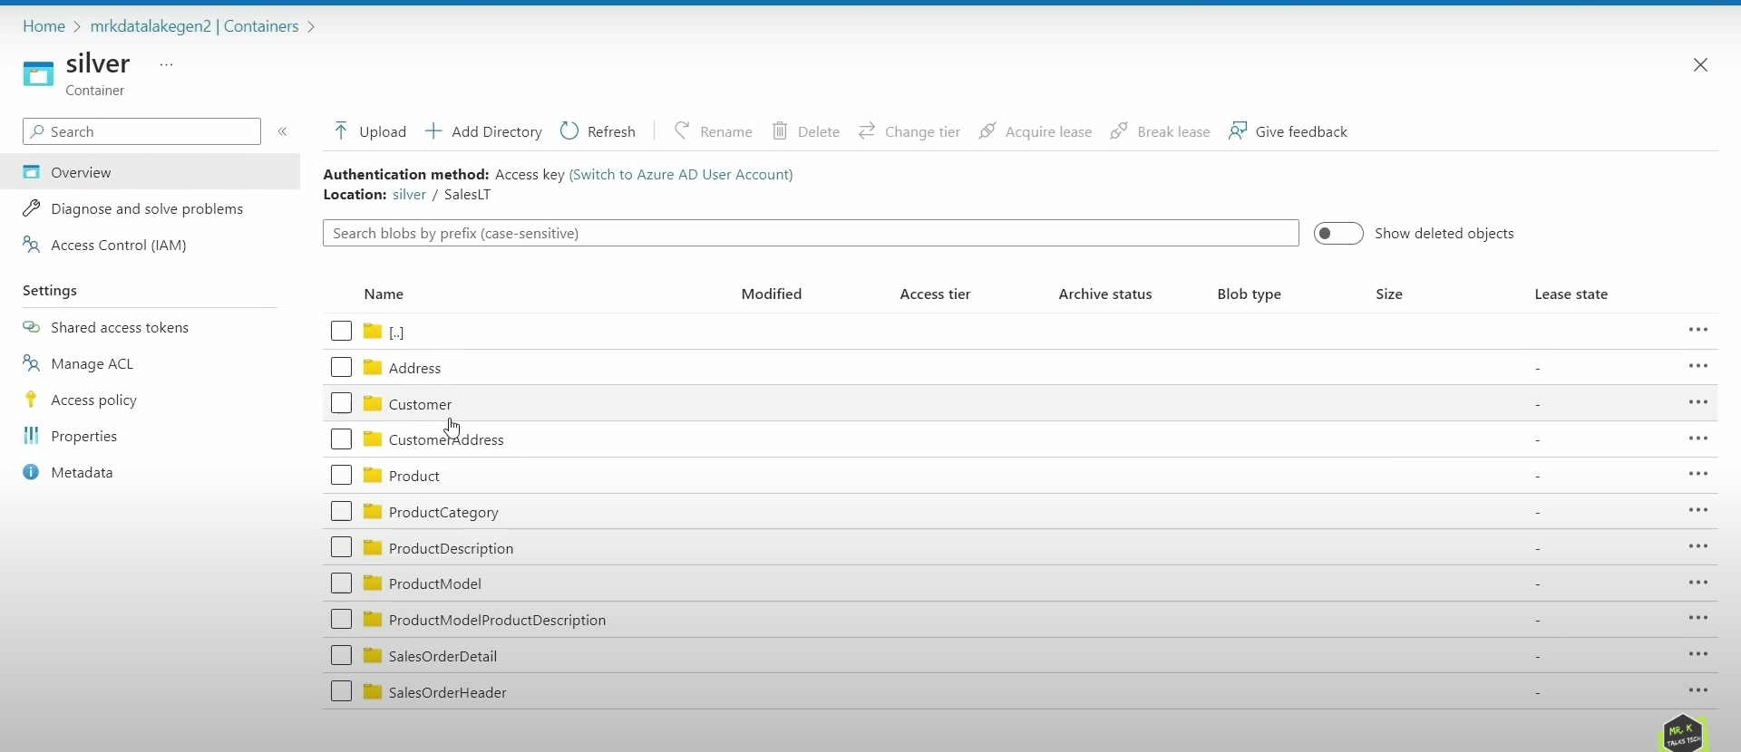

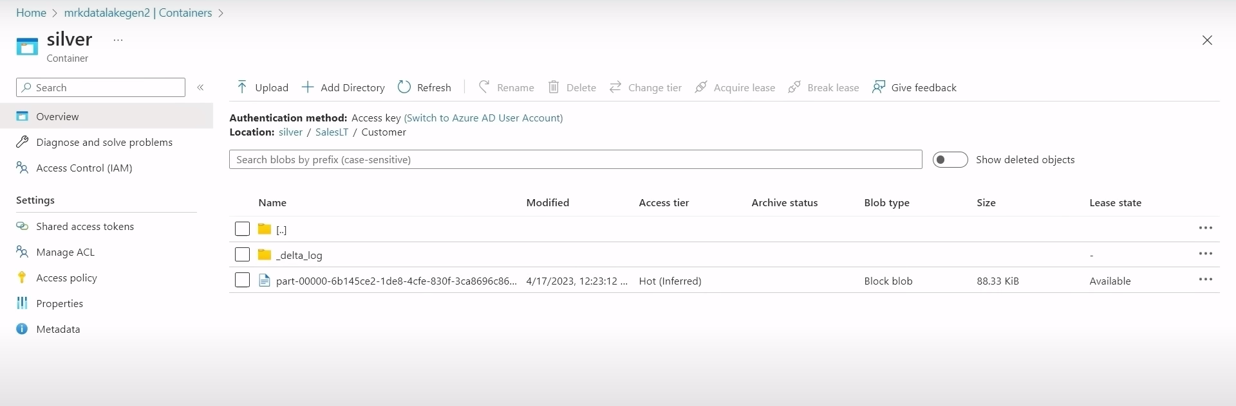

Delta format will save data in silver container as above format. _delta_log is mainly used to do version tracking.

display(df) 🡪 will display df of last item in that list which is SalesOrderHeader.

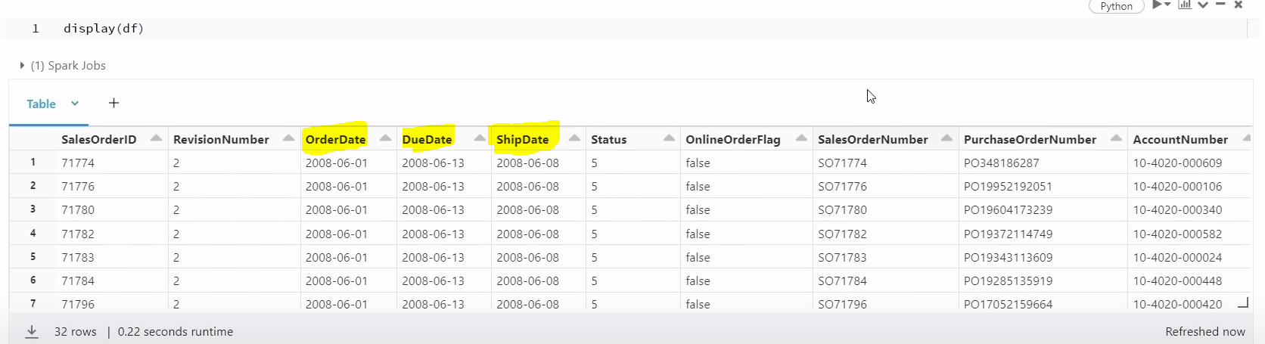

**DIFFERENCE BETWEEN DELTA AND PARQUET FORMAT:**

Delta Format is built on top of parquet format and it is developed by data bricks which means delta format will have all the features that parquet format already has and also few other extra features. Some of the features are in delta format we can track the different version history and also it can handle different schema changes . For example now we are writing data into one schema structure. In the future if the input data schema changes then delta format can easily handle that. so databricks recommends to use delta format to store the data into data lake.

**LEVEL -2 TRANSFORMATION FROM SILVER TO GOLD:**

We are going to fetch transformed data from silver container and will do further transformation on that and put final transformed data into gold container. So, data in gold container is the final data and this data will be used for reporting. In silver to gold transformation, we will do kind of transformations like joining multiple tables together or doing some aggregation. Basically, final fact and dimensions which is related to DWH is done in level 2 of transformation. In level2 transformation, we can change naming convention in column names. For example if we see one column ListPrice , it has 2 words List and Price.Instead of having that as a single word , we need to do a transformation to split these 2 words with an underscore. So transformed column will look like List_Price . This we need to do for other columns in the table and for all tables. If there are any columns which is single word then we keep it as it is.

dbutils.fs.ls(‘mnt/silver/SalesLT/’) 🡪 these are the different files that exist in silver container that we generated in Level-1 transformation

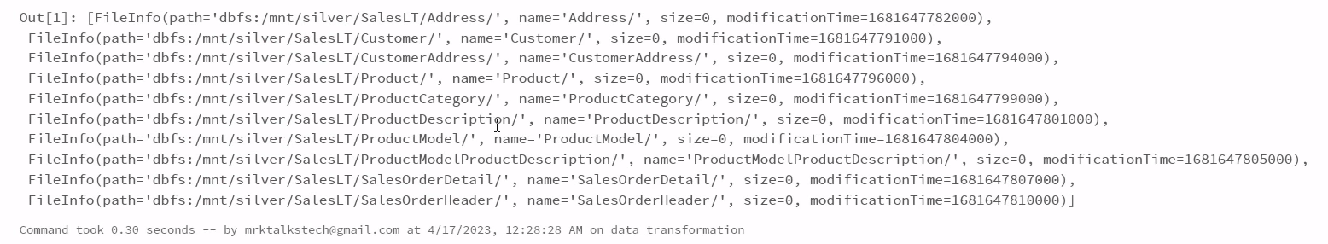

dbutils.fs.ls(‘mnt/gold/’) 🡪 data in gold container is the final data and this will be used for reporting.

Out[2] : []

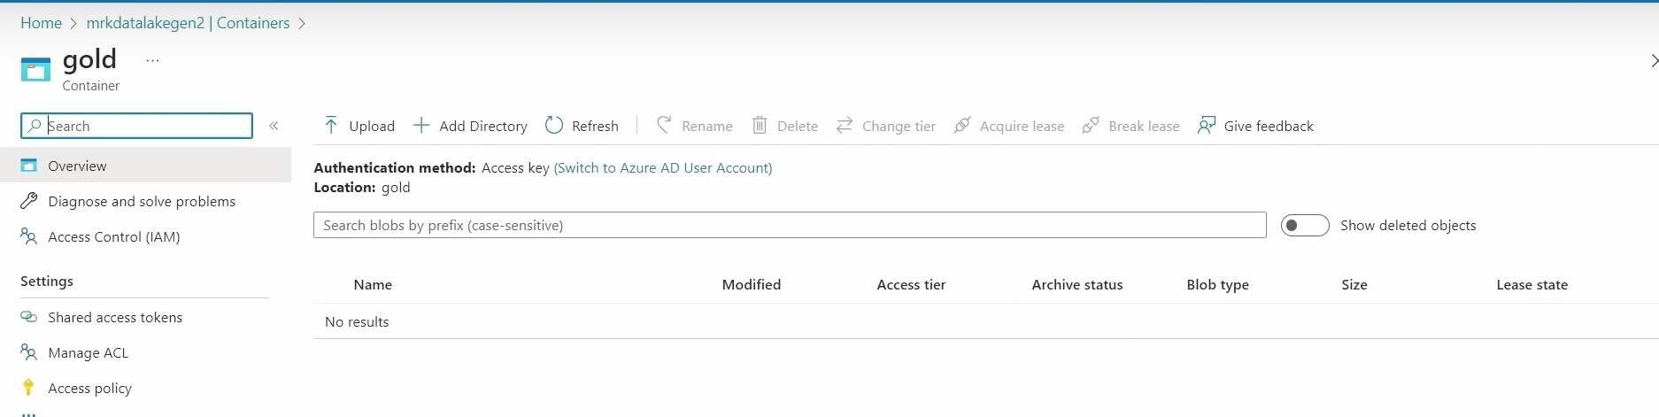

We need to do level 2 transformation by getting transformed data from silver container and put final transformed data into gold container.

input_path = ‘/mnt/silver/SalesLT/Address/’

df= spark.read.format(‘delta’).load(input_path)

display(df)

2 spark jobs ran, one for read , and 2nd is to display data frame.

For single table if we want to change ColumnName to Column_Name format then we will use below code.

**from pyspark.sql import SparkSession**

**from pyspark.sql.functions import col, regexp_replace**

#Get list of column names

**column_names = df.columns**

**for old_col_name in column_names:**

**#convert column name from ColumnName to Column_Name format**

**new_col_name = “ “.join([“_” + char if char.isupper() and not old_col_name[i-1].isupper() else char for i,char in enumerate(old_col_name)]).lstrip(“_”)**

**#change column name using withColumnRenamed and regexp_replace**

**df = df.withColumnRenamed(old_col_name, new_col_name)**

display(df)

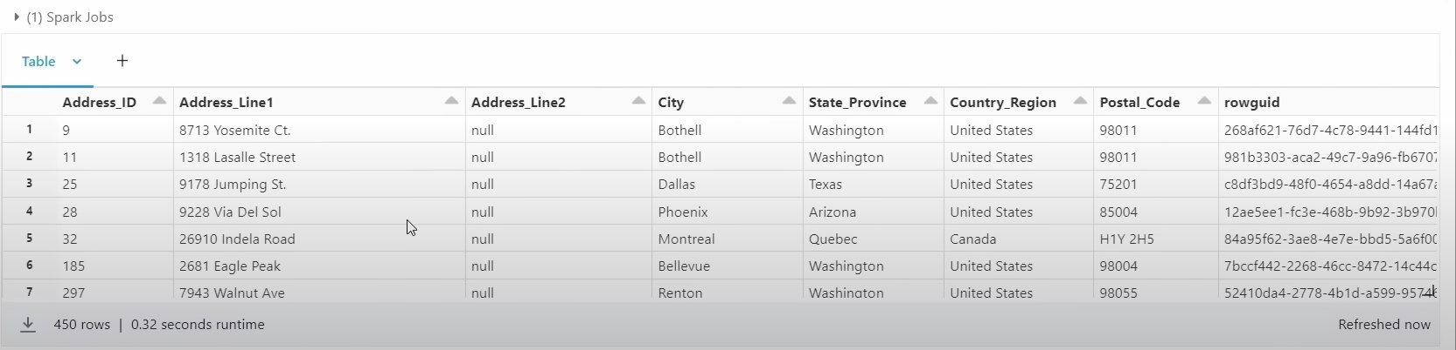

Doing Transformation for all tables (Changing column names)

table_name = []

for i in dbutils.fs.ls(‘mnt/silver/SalesLT/’):

table_name.append(i.name.split(‘/’)[0])

-----

table_name

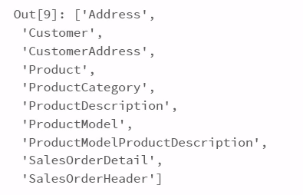

Now we are using that list to iterate using for each loop and also generated input path using for each loop and after generating input path we are reading that as a data frame using delta format. After that ,using data frame to convert all the column names to expected format and once that is done, we are finally write data frame using output path and save it in gold container. If we run below code, what happens is it will iterate through table name list and it will do transformation for all the individual tables.

**for name in table_name:**

**path = ‘/mnt/silver/SalesLT/’ + name**

**print(path)**

**df = spark.read.format(‘delta’).load(path)**

**#Get list of column names**

**column_names = df.columns**

**for old_col_name in column_names:**

**#convert column name from ColumnName to Column_Name format**

**new_col_name = “ “.join([“_” + char if char.isupper() and not old_col_name[i-1].isupper() else char for i,char in enumerate(old_col_name)]).lstrip(“_”)**

**#Change column name using withColumnRenamed and regexp_replace**

**df= df.withColumnRenamed(old_col_name,new_col_name)**

**output_path = ‘/mnt/gold/SalesLT/’ +name +’/’**

**df.write.format(‘delta’).mode(“overwrite”).save(output_path)**

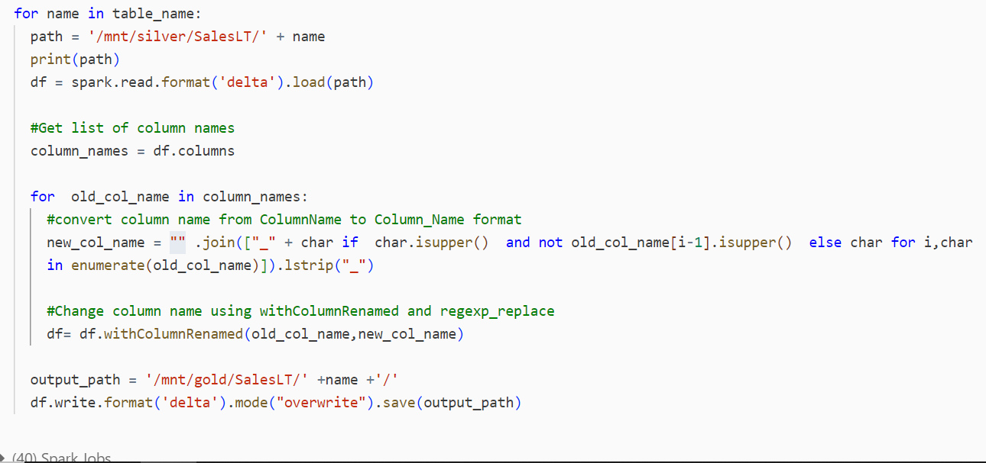

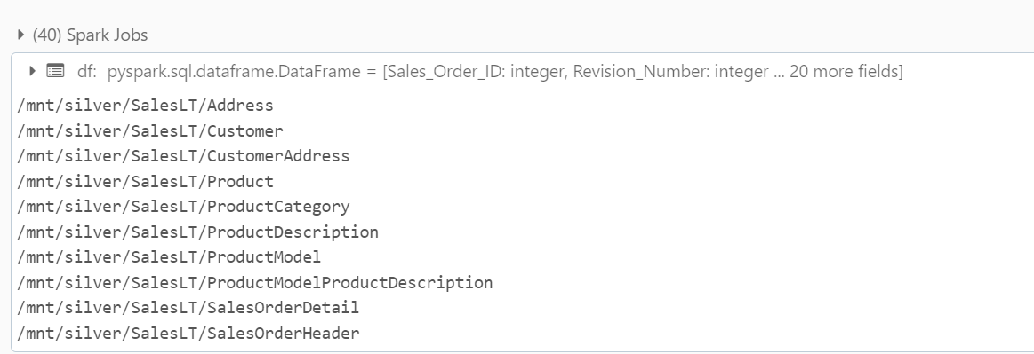

**display(df)**

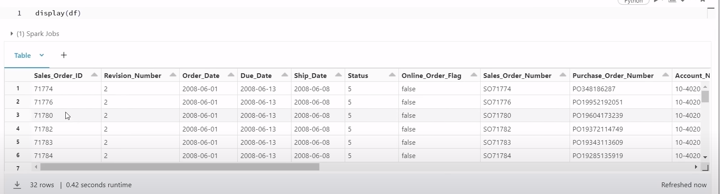

Now in ADLS Gen2,

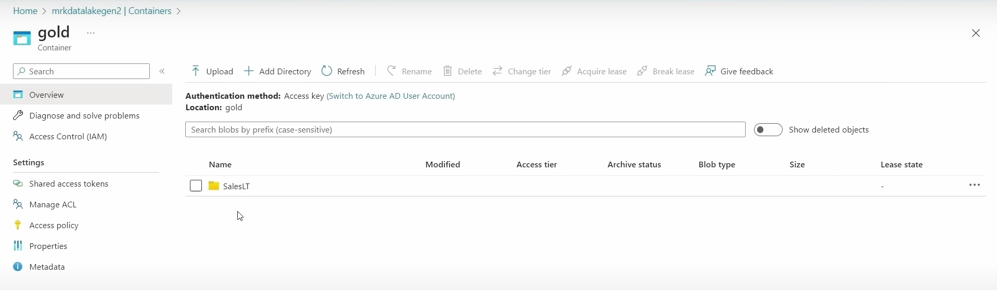

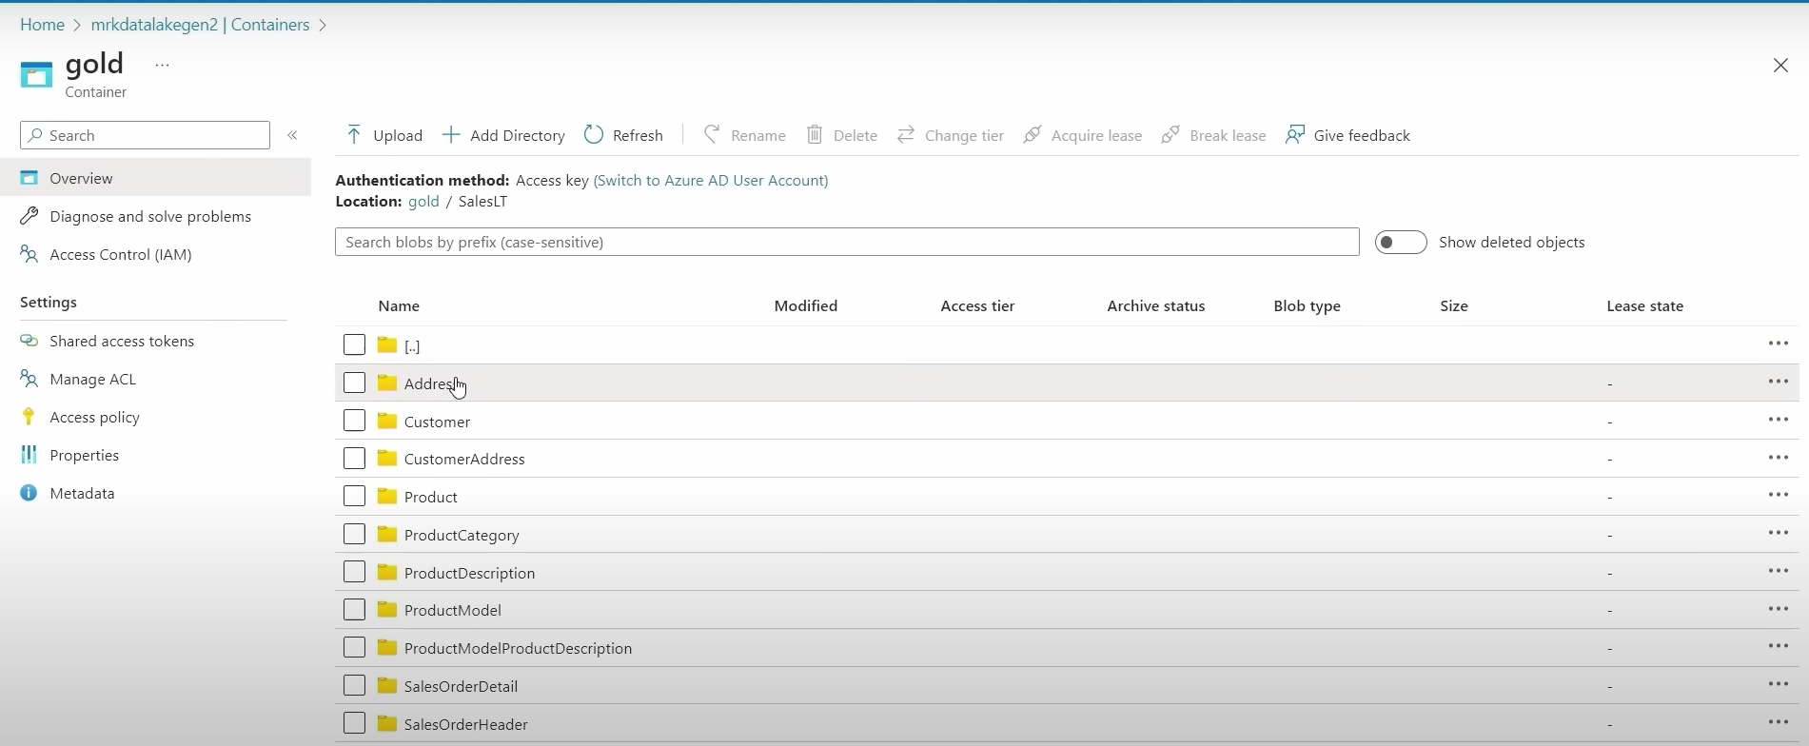

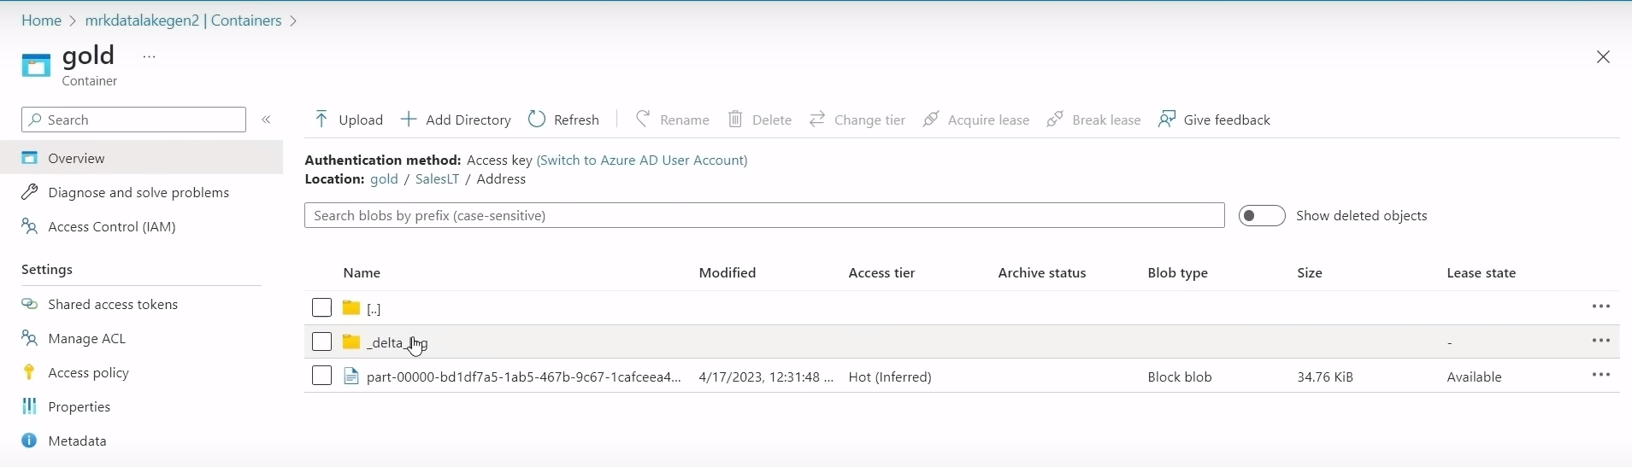

Now using ADF, we need to create notebook activity , and we now removed unnecessary code mentioned in bronze to silver and silver to gold notebook. We have removed single table transformations in both notebooks and kept all tables transformation in both notebook as shown like below.

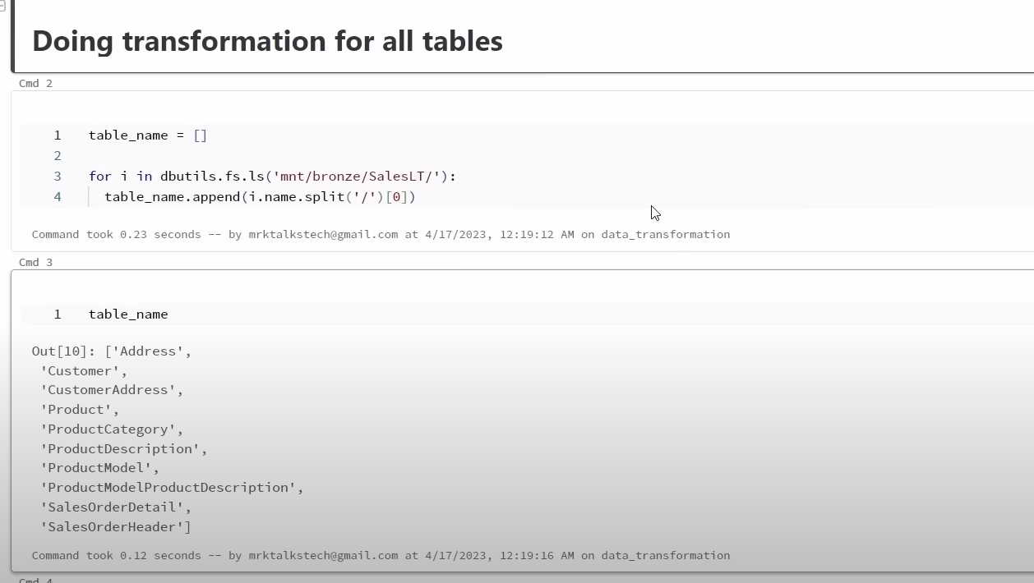

We created another notebook storagemount ,in that we have mounted bronze, silver and gold container. In storagemount notebook, we just mounted containers so no jobs required for it.

Now using ADF, we will update existing pipeline copy_all_tables pipeline to include data bricks notebook.so for that we need to establish connection between ADB and ADF. In order to establish connection between ADB and ADF, we will establish a linked service connection. So for that , we will go to Manage 🡪 Linked Services 🡪 click on + , we will select ADB in compute tab.

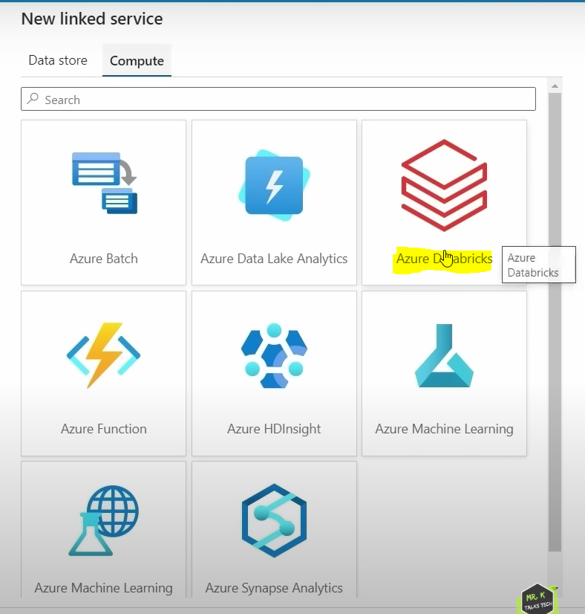

Click on continue,

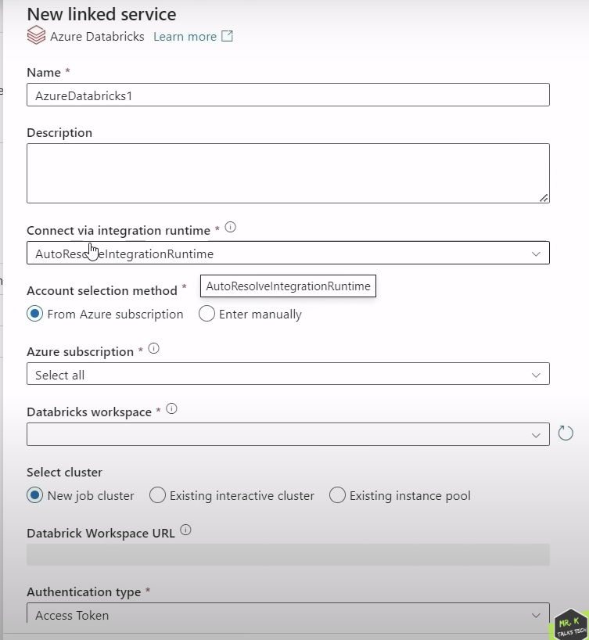

Authentication type is needed to establish connection between ADF and ADB.

In order to get access token from ADB, we will click on mail id at top right , go to user settings 🡪 Access token 🡪 Generate New Token

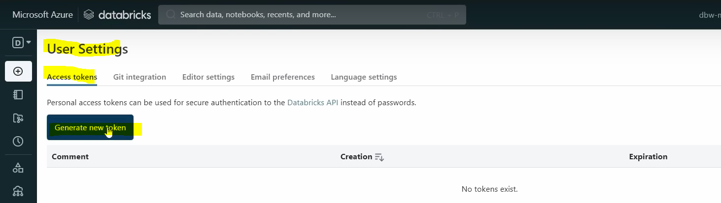

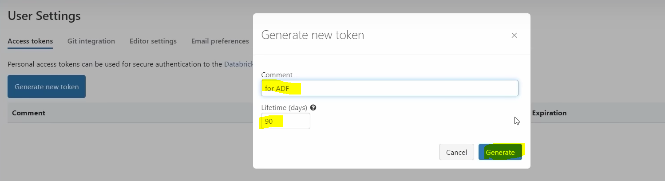

This token can use only once. So, copy token and click on done. Now copied token we will add as secret vault.

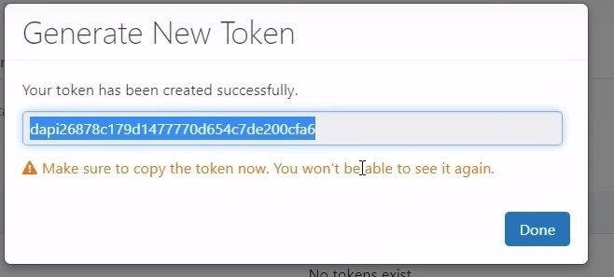

Now go to AKV 🡪 Secrets 🡪 click on + Generate/Import. Copied token we will paste in secret value. Enter name as dbwtoken and click on create.

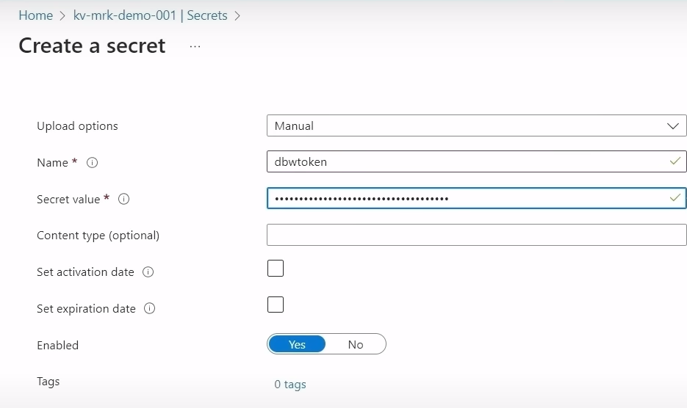

Now we created secret for the ADB as shown below,

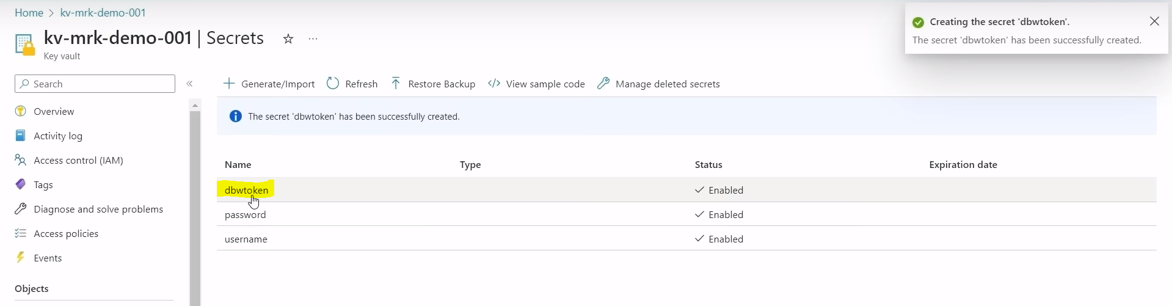

Now come back to ADF, we will select access token as AKV a shown below.

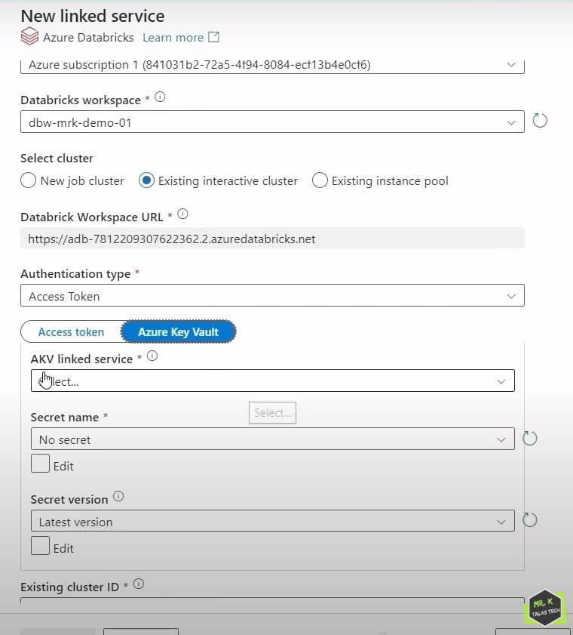

We have already created AKV previously, so we will select it from drop down as shown below.

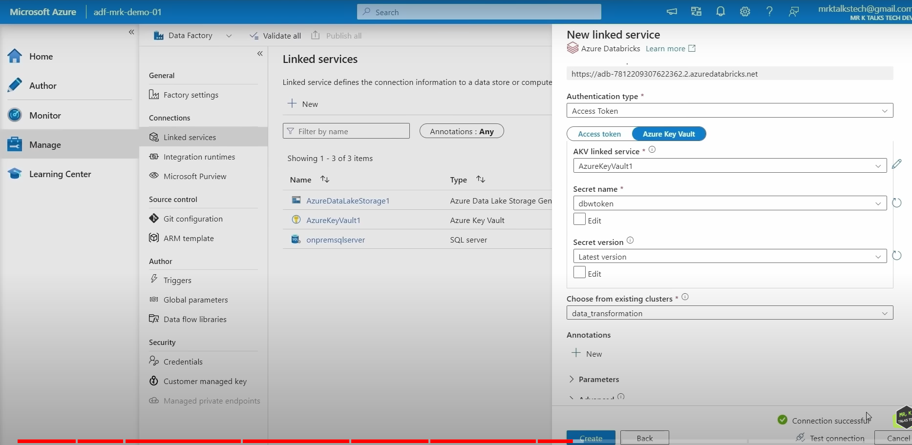

Click on create after connection is successful. Now ADB linked service is created as shown below. Now ADF can access any notebooks which is present inside data bricks workspace.

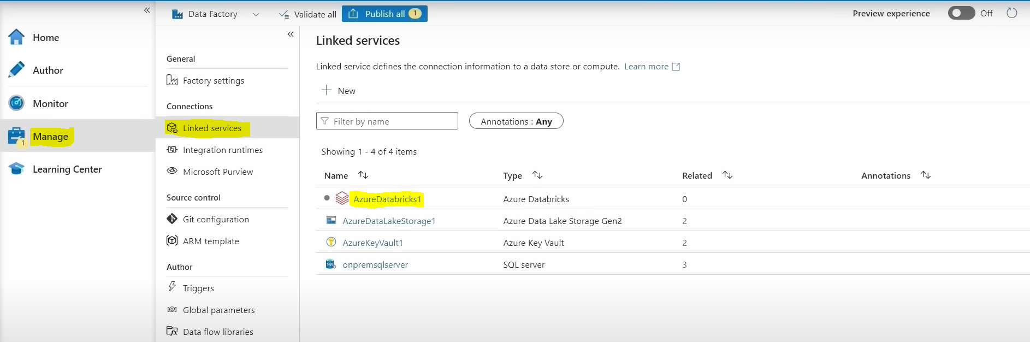

Now click on publish all option as shown above to save changes of new ADB linked service .

Now go to Author 🡪Pipeline 🡪 copy_all_tables pipeline.

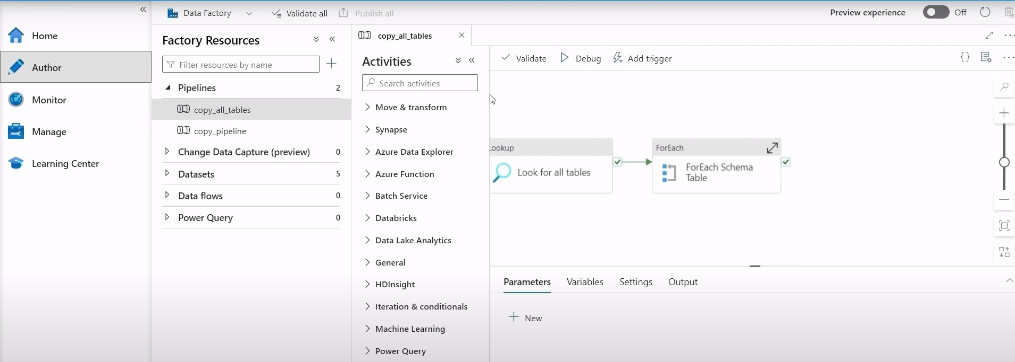

Now we need to create 2 notebook activities here, one for bronze to silver notebook and 2nd is for silver to gold notebook.

Now we need to drag ADB notebook to canvas as shown below.

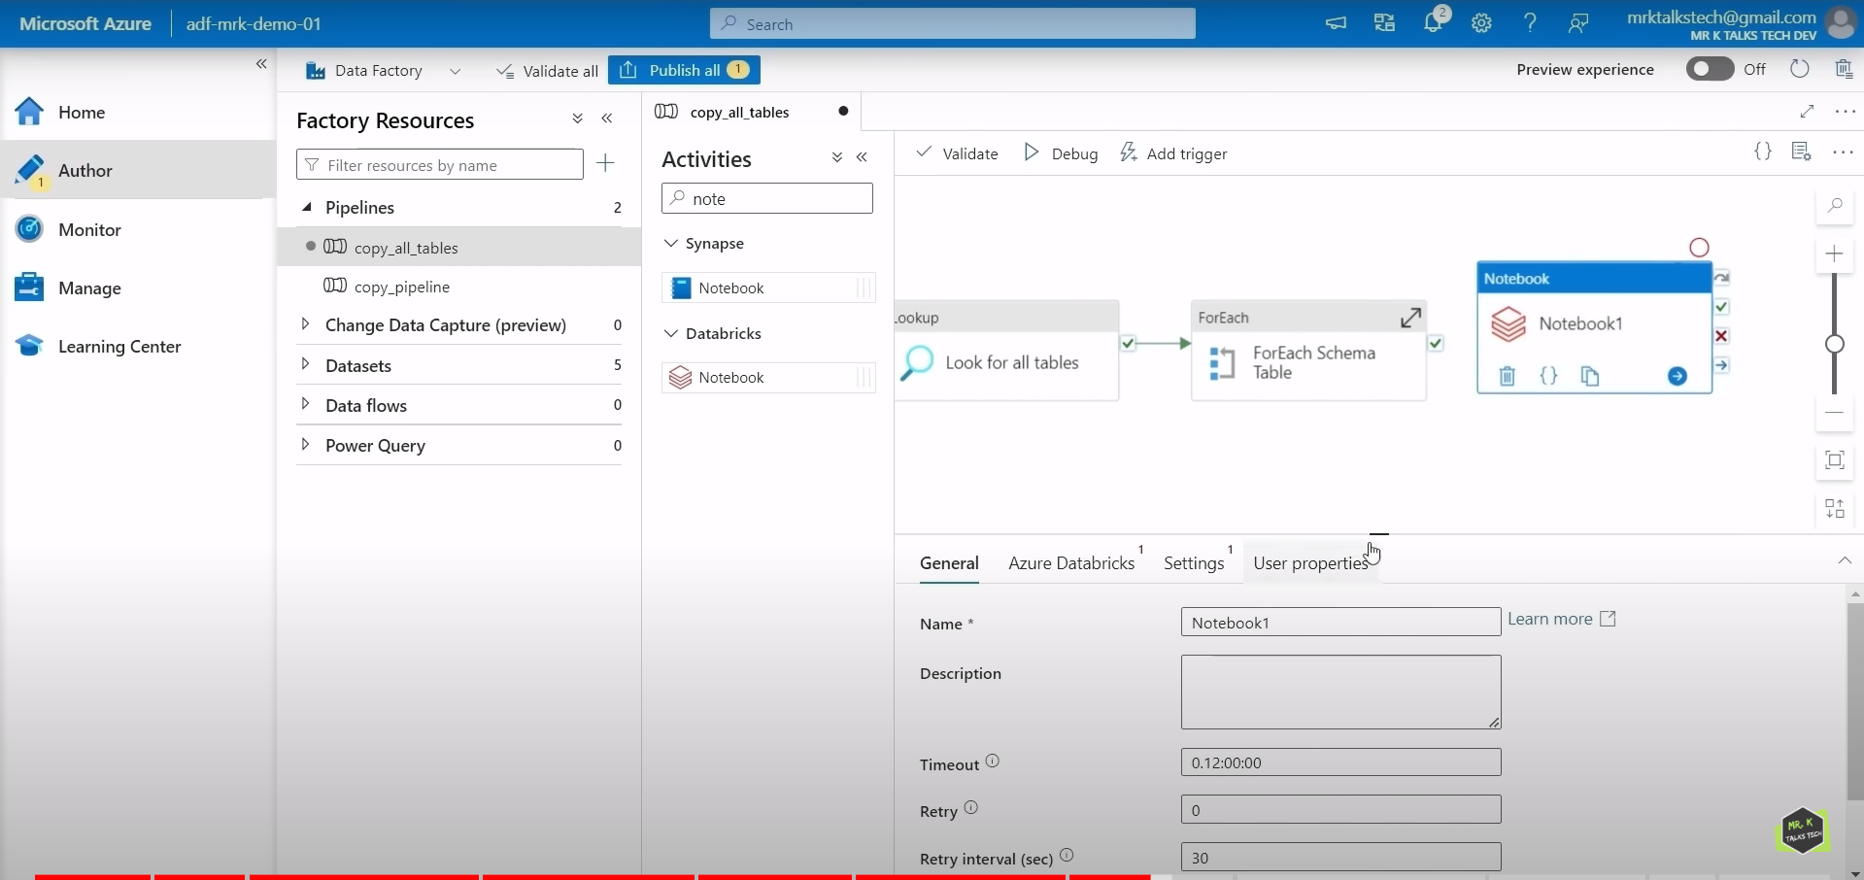

And we need to replace notebook name from Notebook1 to Bronze to Silver Notebook in general tab as shown below and we need to give output of for each activity to input as an bronze to silver notebook which means that bronze to silver notebook activity will run only when for each activity is succeeded.

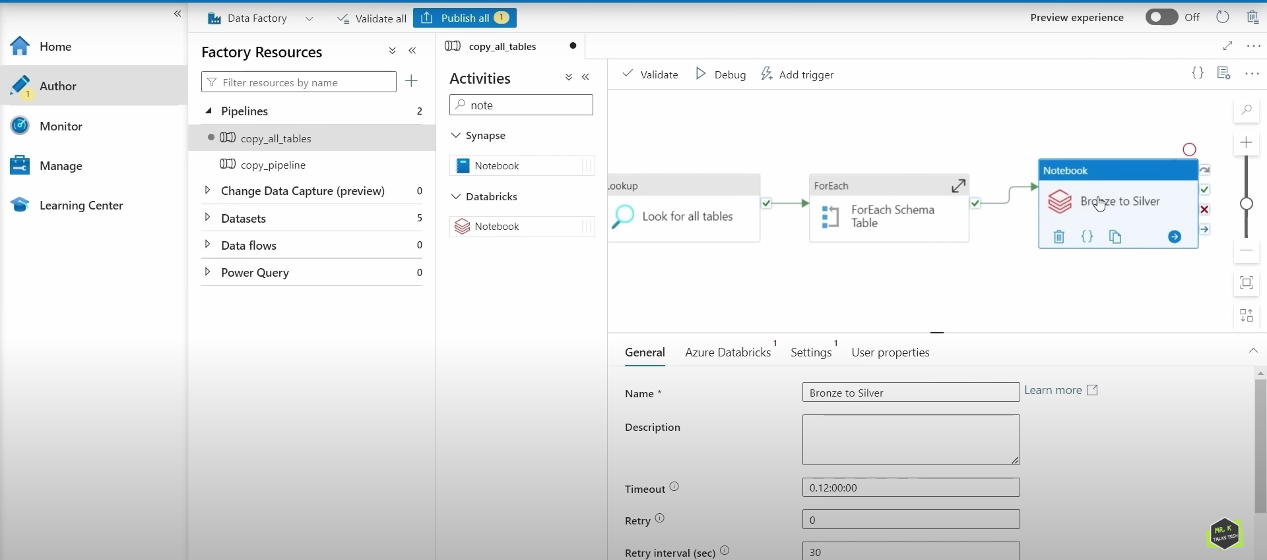

Now in Azure Databricks tab, we need to select ADB linked service which we created before . screenshot shown below.

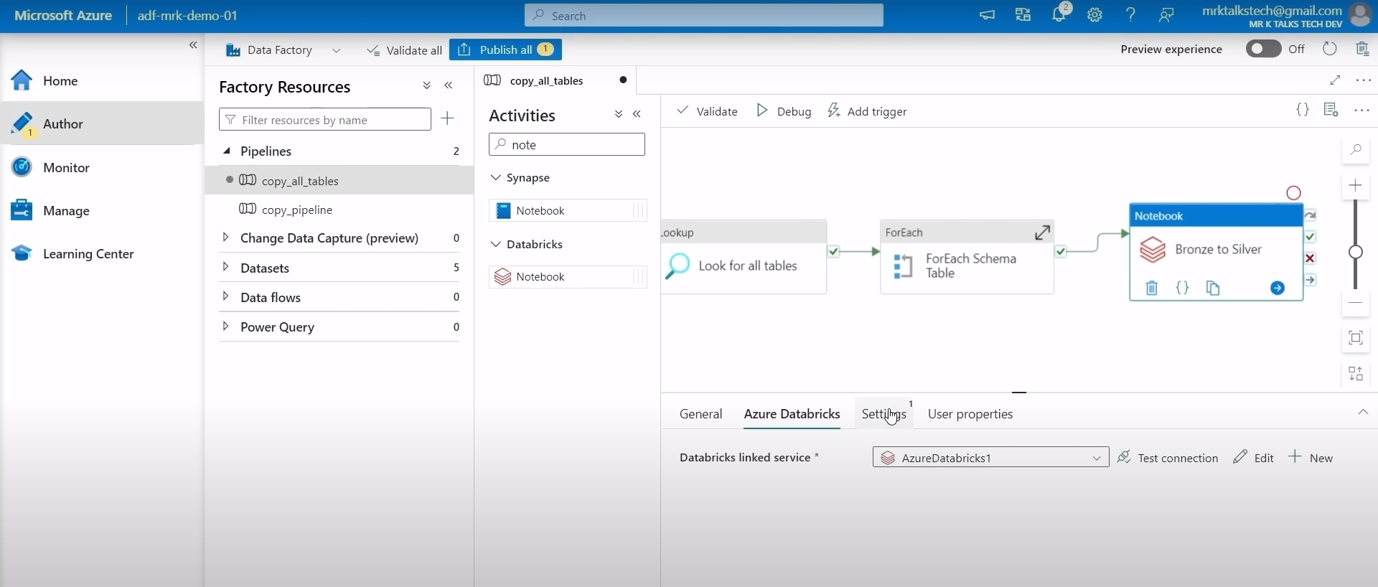

Now go to settings tab, in settings tab, we will specify notebook path for bronze to silver notebook by browsing.

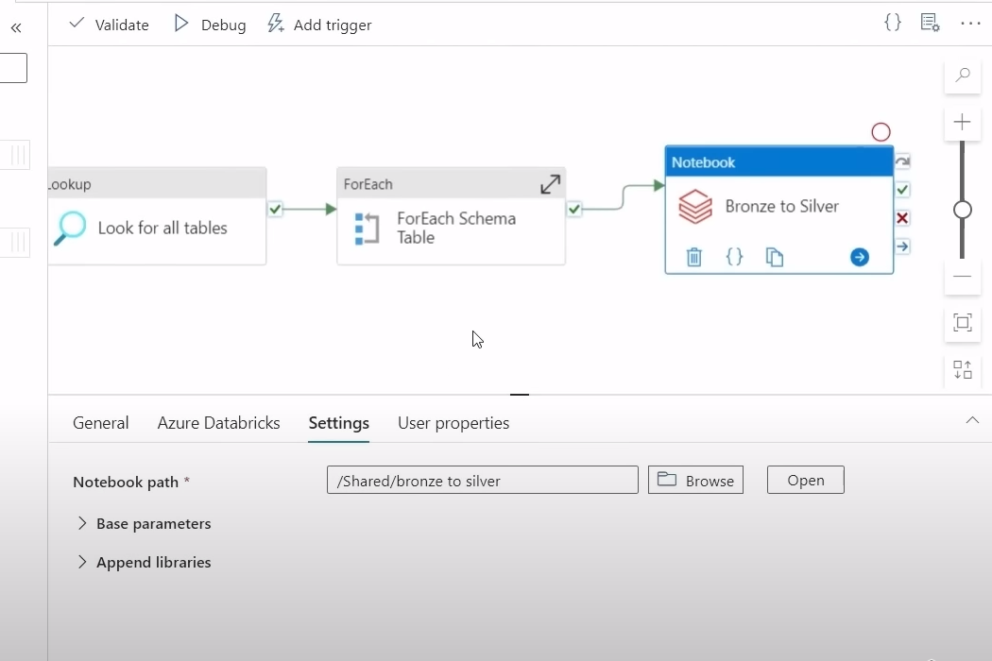

Now we need to drag another notebook activity in canvas as shown below.

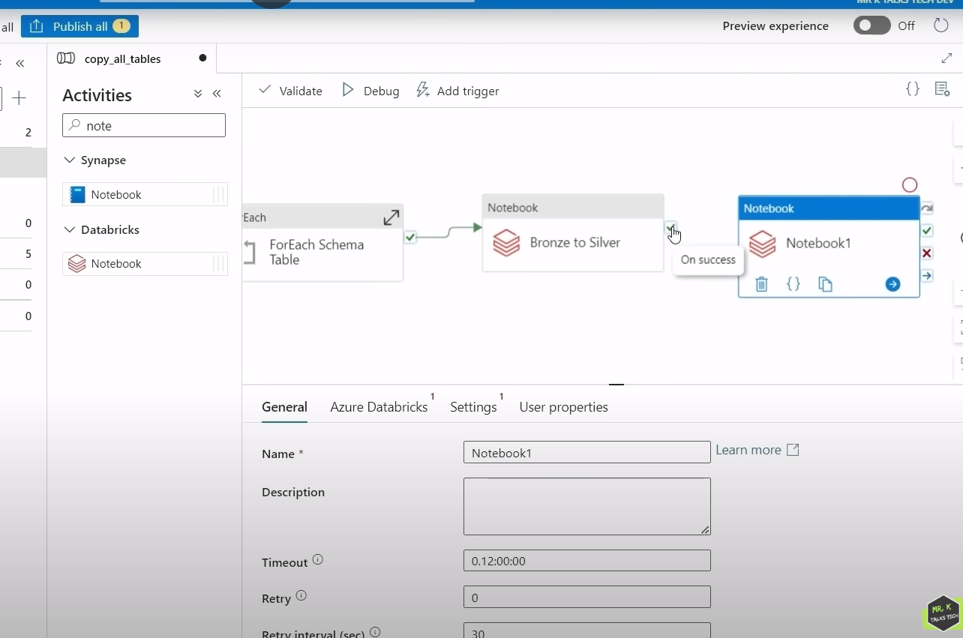

Now we will change notebook name to silver to gold in General tab name field and we will give success of bronze to silver notebook activity to silver to gold notebook activity.

Now go to Azure Databricks tab, we will select ADB linked service from drop down.

Now go to settings tab, select file path of silver to gold notebook.

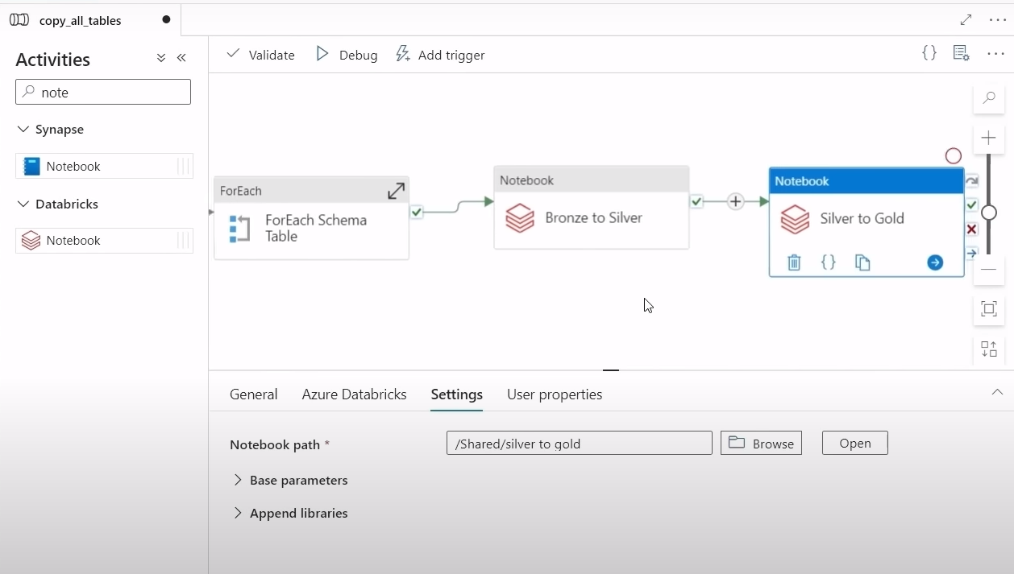

Now we have created end to end pipeline. This is the final pipeline we have created which is basically connecting to the source and getting all the tables and copy that into a bronze container once that is done, Bronze to silver notebook gets triggered, will gets latest data from bronze container, and will do the transformation and put the data into silver container. Once that is done, final silver to gold notebook gets triggered and this notebook will get latest data which is transformed data from silver container and do further transformation and put final transformed data into gold container.

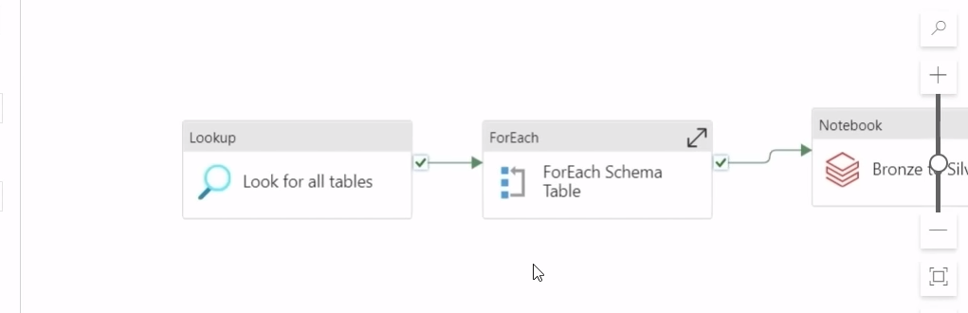

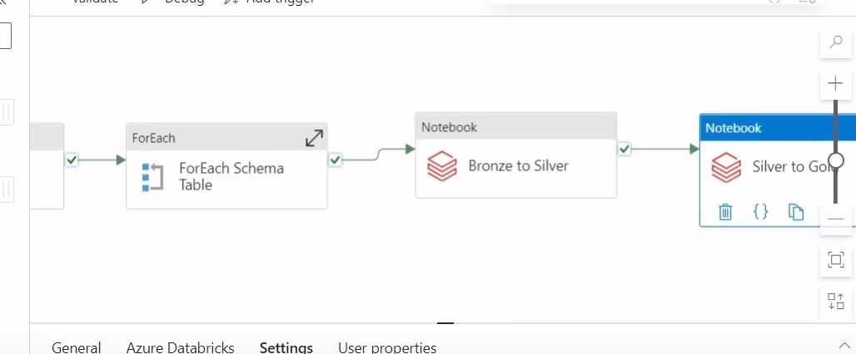

Now we will click on publish all to save the changes.

In order to test the pipeline, we will click on Add Trigger 🡪 Trigger Now.

Now go to Monitor 🡪 Pipeline runs 🡪 here we can see pipeline activities run and its status.

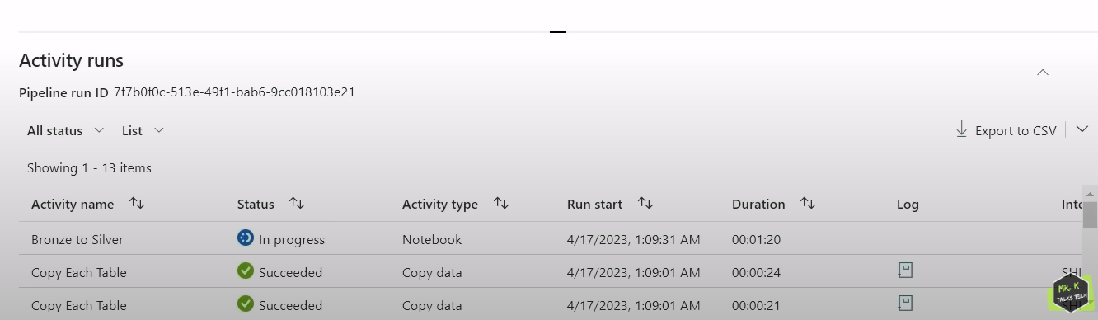

Here in above screenshot it shows us first 2 activities completed which means it copied all tables into bronze container.

We can monitor ADB notebook in real time.

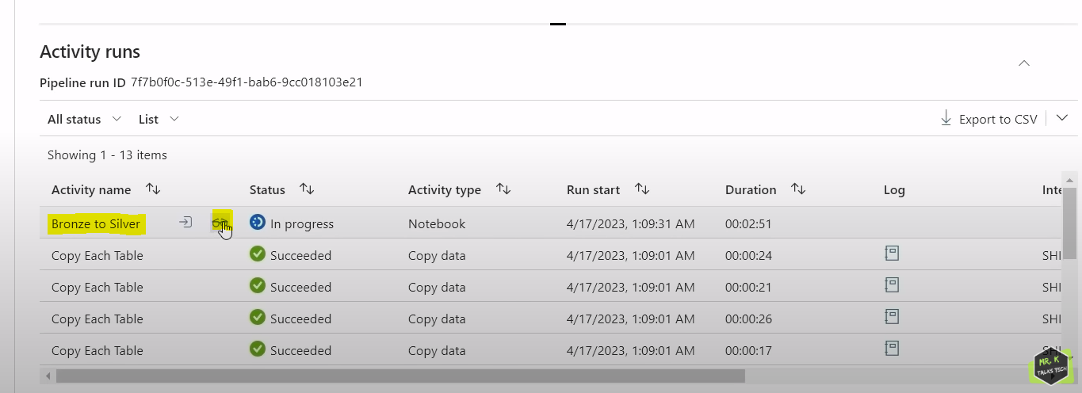

If we click on glass icon, we will see run page URL. This URL is URL for data bricks notebook that is currently running. If we click on run page URL, it will take us to ADB workspace notebook.

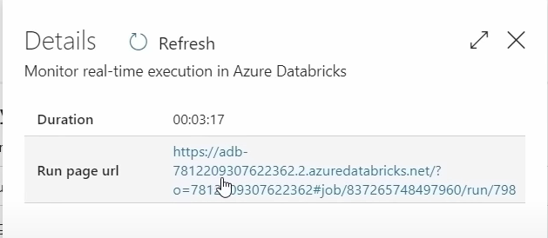

Using this page, we can monitor notebook runs in real time.

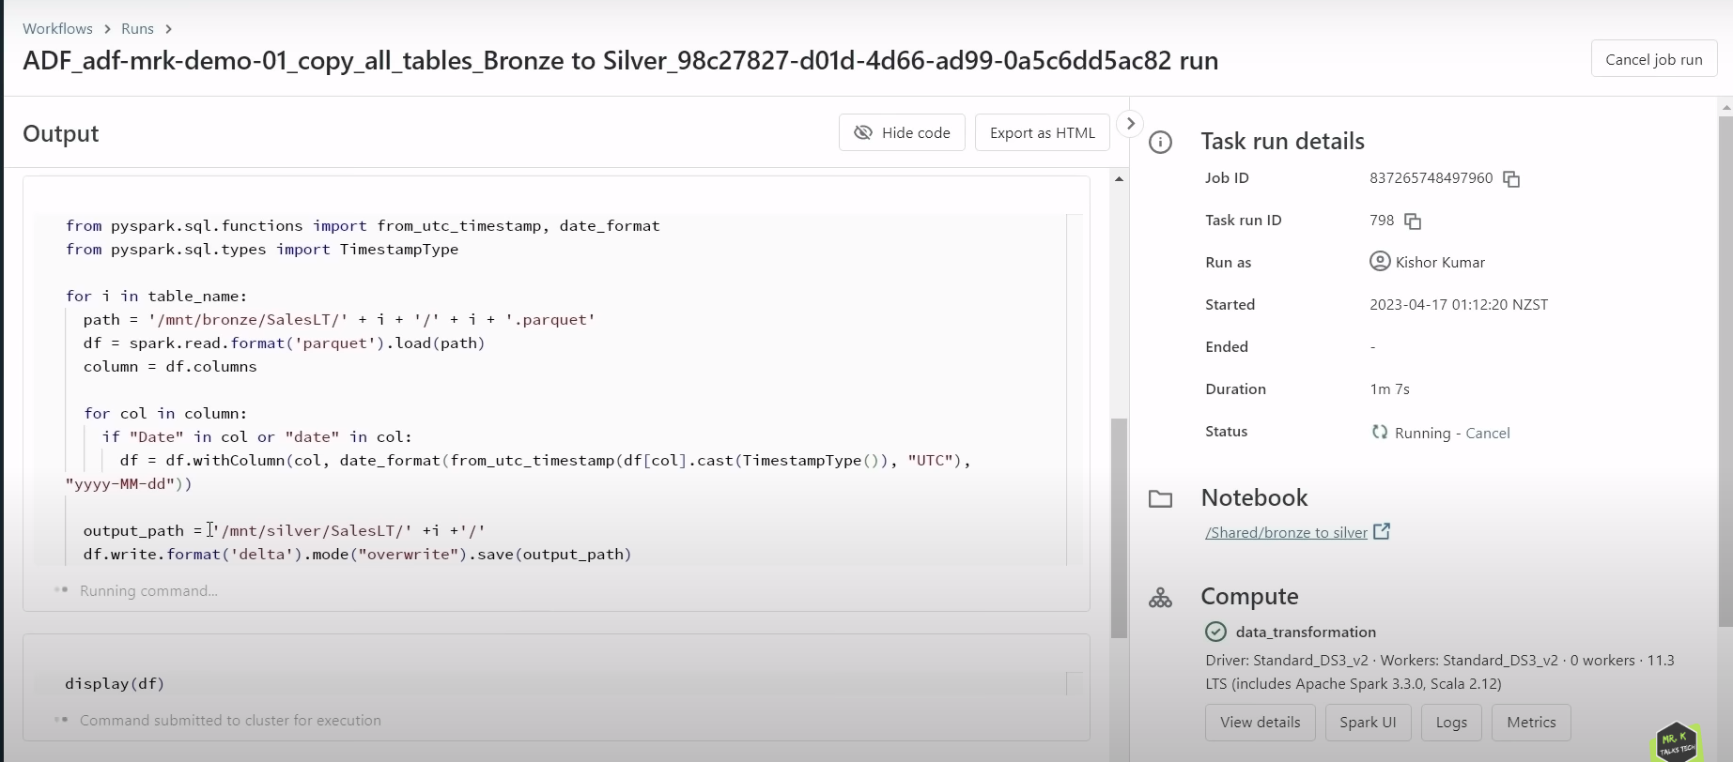

If something goes wrong in pipeline in notebook activity stage, we can come to this page URL and can see exactly in which cell code has broken.

DATA LOADING:

Now we will use final transformed data from gold container and load that it into database using azure synapse analytics. ASA is built on top of ADF.

In ASA, in Data tab, we can create data bases. This feature is not available in ADF.

In Develop tab, we can create SQL script, KQL script, Notebook,Data flow etc.

ASA is combination of ADF +ADB. Using ASA, we can create pipeline activities which acts as an orchestrator. Also, we have spark capabilities where we can create notebooks for transformation similar to data bricks.

Now we are creating data base in ASA.

DATA 🡪 click on + 🡪 SQL database 🡪 select dedicated SQL pool and create.

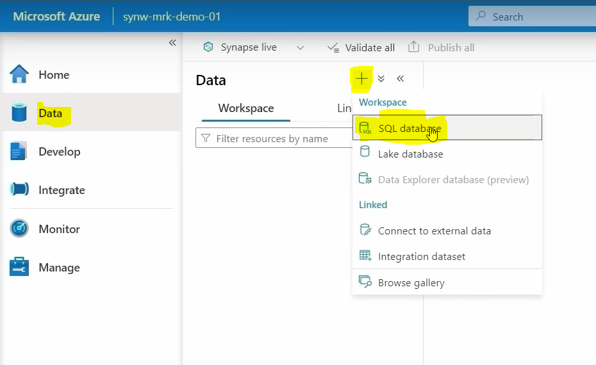

Now we get 2 options to select SQL pool type 1 is serverless and 2nd is dedicated SQL database. Serverless SQL database is mostly used in smaller workloads whereas dedicated SQL pool used in the scenarios which requires higher workloads. Other difference is serverless SQL database uses built-in pool to process the data. When we actually create a synapse analytics, we will get a default built-in pool. Serverless SQL database just uses that pool. Whereas in dedicated SQL database, we need to create an external compute. We need to create dedicated SQL pool for the database to process the data. We can create dedicated SQL pool with higher configuration which increases the performance of data processing whereas in serverless SQL database we don’t have any control over that and hence performance might be low but, in the cost, wise dedicated SQL pool is much expensive compared to the serverless SQL database. Another key difference between 2 databases is we can pause dedicated SQL pool if it is unused. But in serverless database we cannot pause built-in SQL pool .

If we see here , in manage tab 🡪 SQL pools 🡪 we can see built-in serverless SQL Pool, status is online as shown in below screenshot, which means that this built-in pool is going to be online all the time. This built-in serverless pool gets generated when we actually create synapse workspace so we can use this built-in SQL pool in the serverless SQL database to query all tables in the database. Dedicated SQL pool doesn’t get generated by default. Main difference between dedicated SQL pool and serverless SQL pool is in serverless SQL pool we are just using compute whereas in dedicated SQL database we are using both compute and storage. For example we have all data in gold container in data lake, if we are using serverless SQL data base, the data will still exist in data lake but we can just use built-in serverless SQL pool to query the data directly from data lake itself which means that it just uses compute and storage is in data lake itself whereas in dedicated SQL database, data in gold container should be completely loaded into database and data can be queried using dedicated SQL pool which means that it uses both storage and compute power.

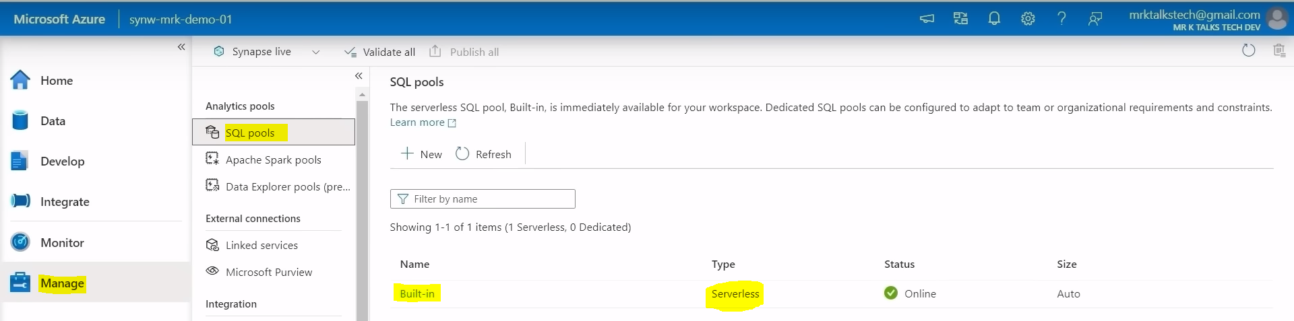

We can create dedicated SQL pool by Manage 🡪 SQL pools 🡪 click on + (New).

In this project , we have less workload . so we can go with serverless SQL Pool.



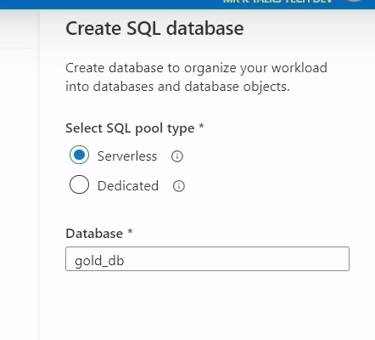

After selecting serverless SQL pool type , we enter database name and click on create. The below database screen will be visible .

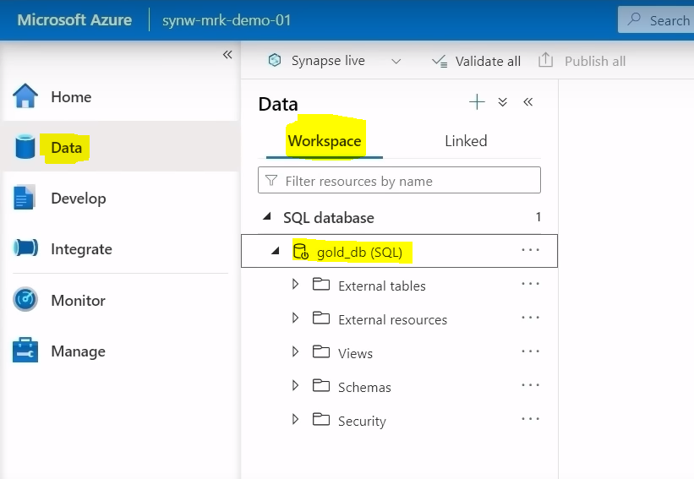

In serverless SQL database, data will be already existing in the data lake, we will be using just built-in SQL pool to query data directly from data lake. So main reason for this is ASA has already direct connection with azure data lake. If we switch to linked tab , there is ADLS Gen2 which is directly linked to our ASA when we actually create synapse workspace.

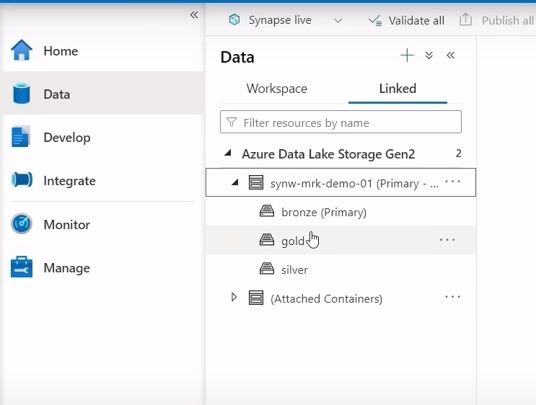

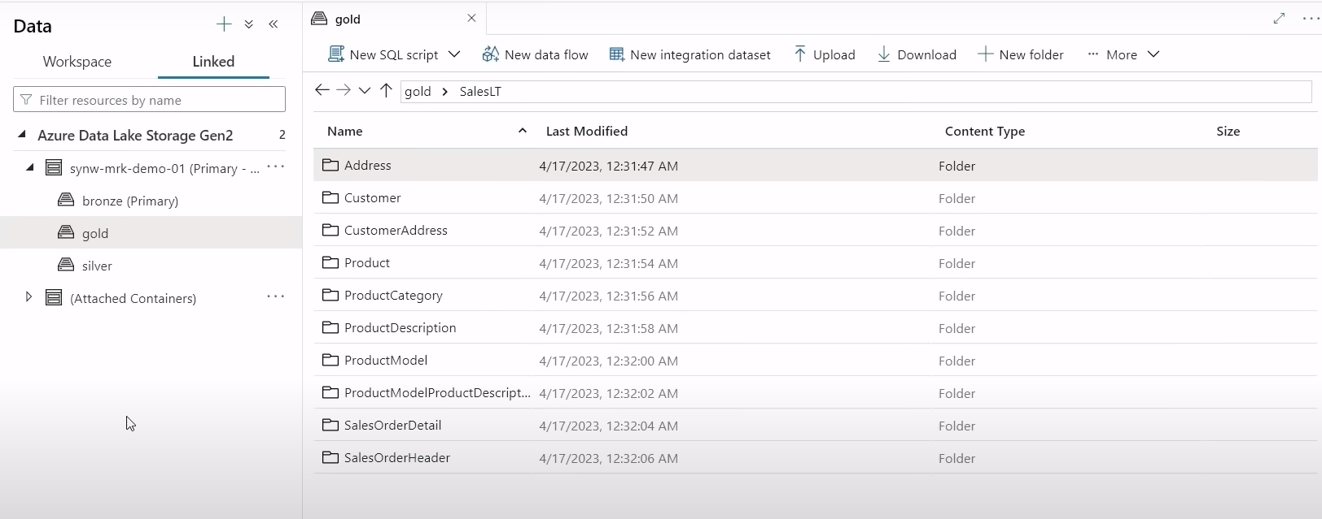

One of most important feature of synapse analytics is we can just query the data in the data lake directly from synapse workspace itself using the built-in SQL pool. What does it mean is for example if I want to query address table. We can right click on Address folder 🡪 New SQL script 🡪 Select TOP 100 rows.

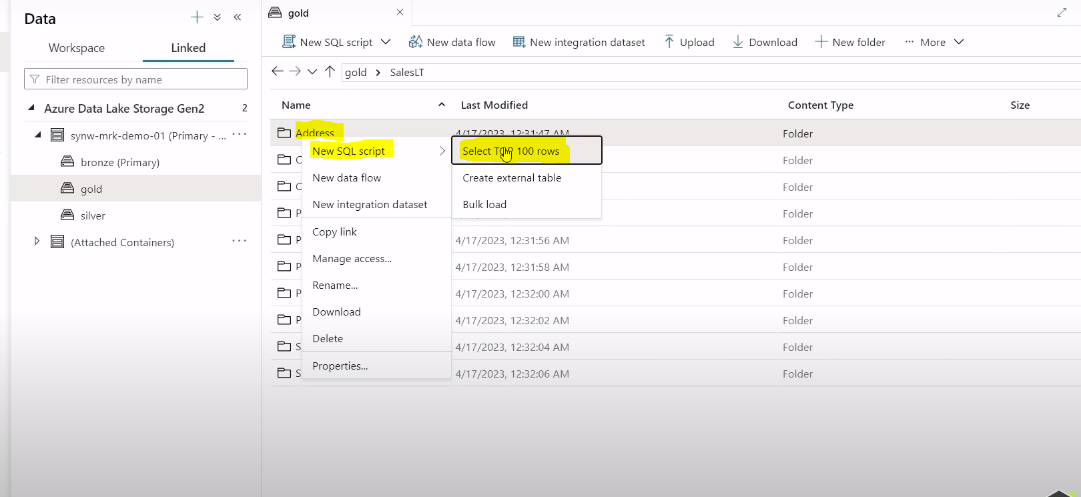

Then it will ask file type as shown below, we know data in gold container is in delta format . so from drop down we will select delta format and click on Apply.

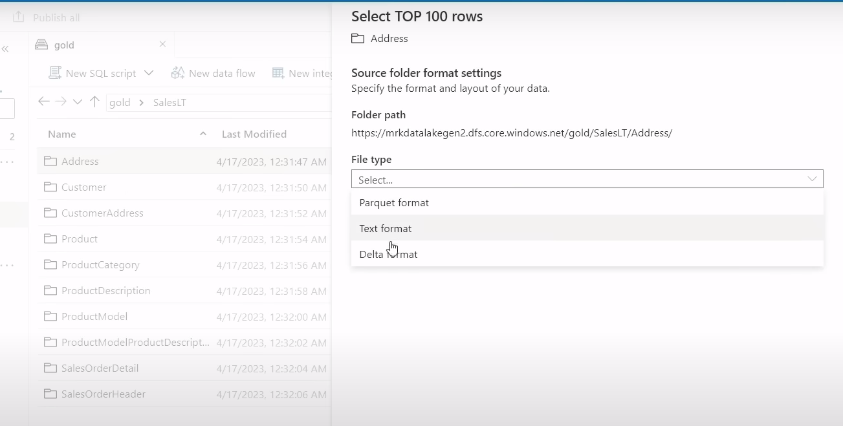

After clicking on apply, it has automatically created script for us which is T-SQL command. This command is trying to fetch data from data lake directly

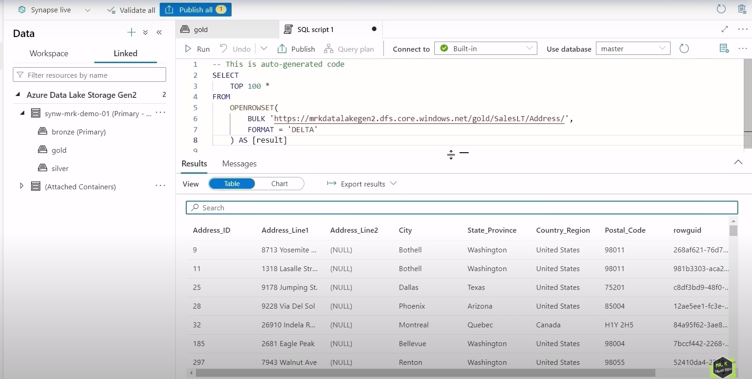

Storage cost in data lake is extremely cheap, since in Serverless SQL data base we are just using compute power and storage is just data lake , the total cost would be extremely cheap when compared to dedicated SQL database.

Using above script, we can create a view in serverless SQL database. Screenshot shown below and we will select data base name as gold_db.

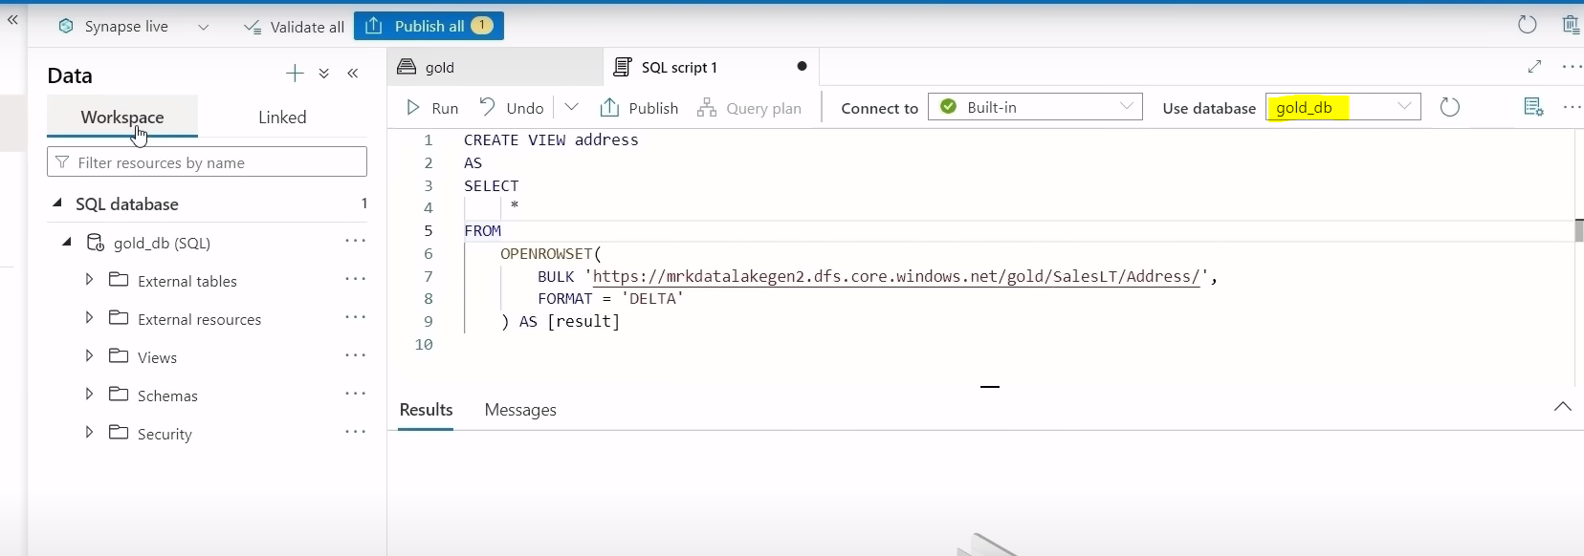

Now we will refresh data base in workspace tab as shown below. Right click on database name and refresh.

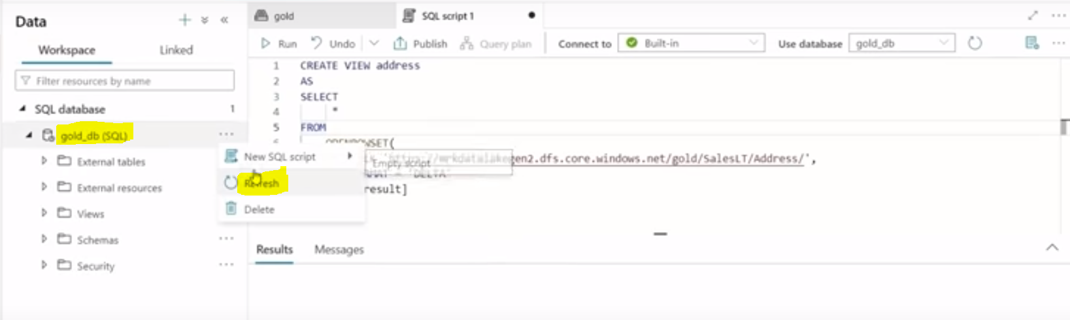

After refreshing database , dbo.address view has been created as shown below.

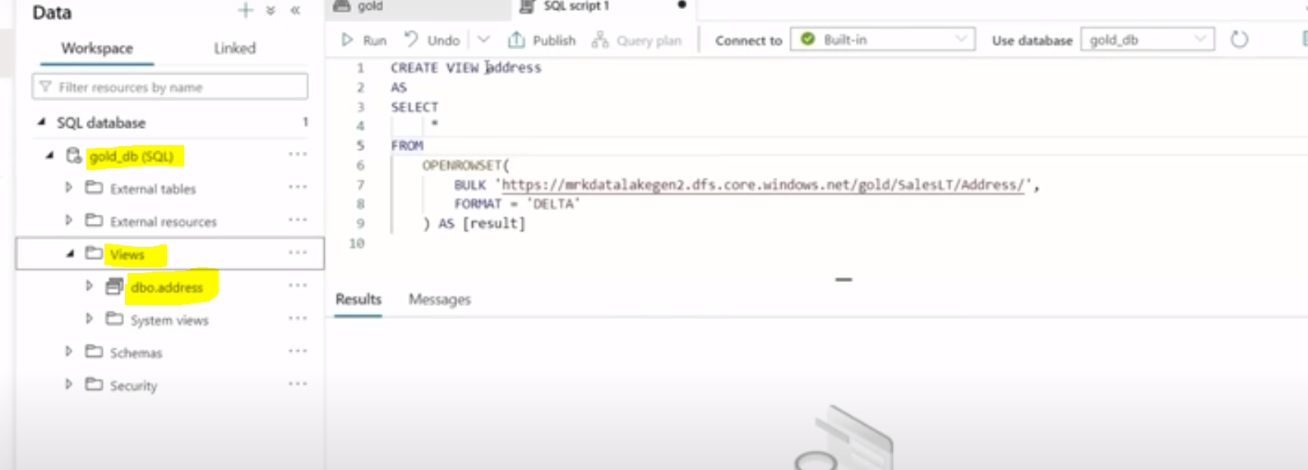

Now we can use this view to query the address table. Right click on dbo.address 🡪 New SQL script 🡪 Select TOP 100 rows as shown below.

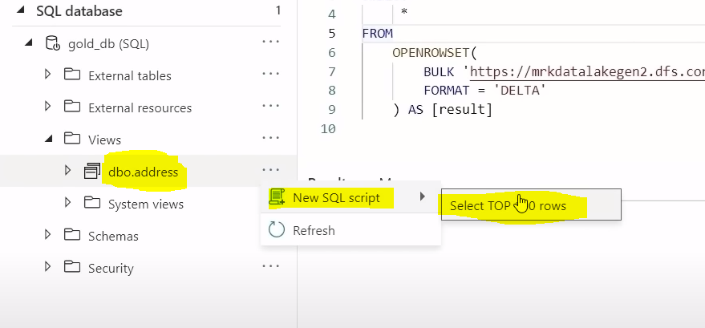

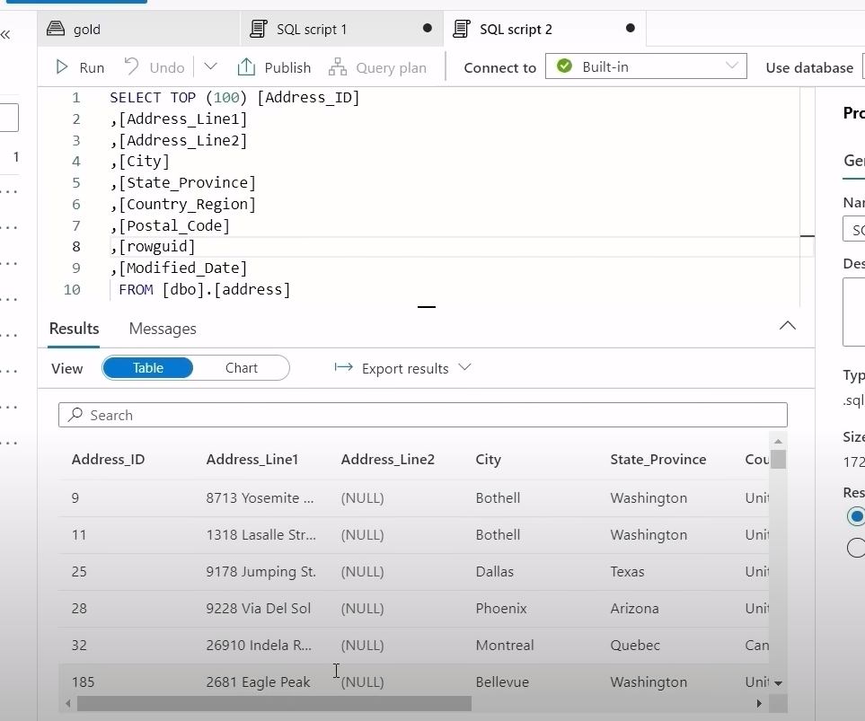

Since this view is just referencing to data lake location. If data changes in data lake, then this view will be automatically reflected. Say for example if new row is added to address table in the data lake, then this view will be automatically reflected to get that additional record that has been added recently.

If we want to create view for all the tables which is inside gold container, instead of typing create view statement for all individual tables, we can create a pipeline which dynamically create the views for all tables.

Go to Develop 🡪 + 🡪 Import button, and we will open file where code script is there to create view for all tables dynamically.

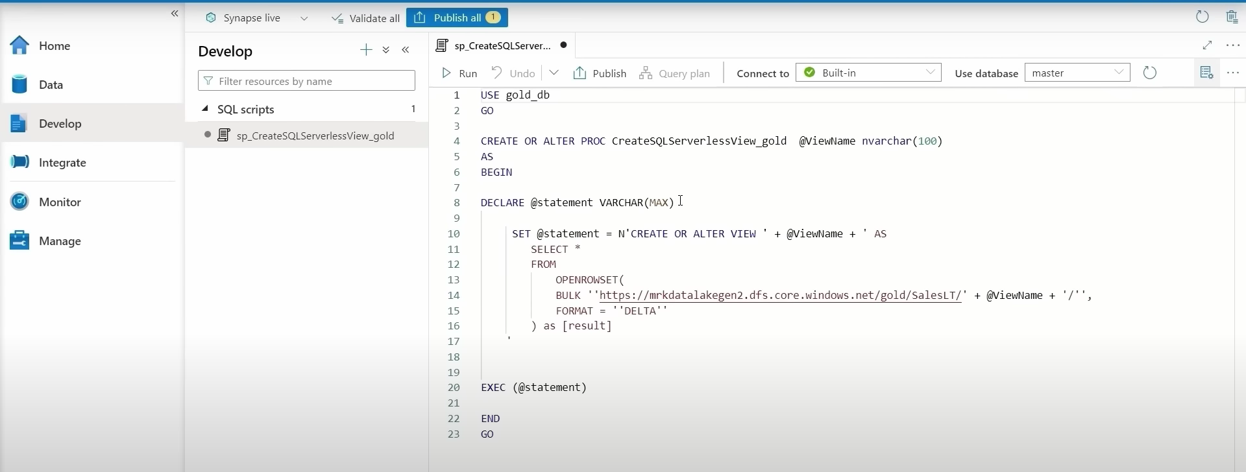

Using pipeline, we will get all table names from data lake and table name will be passed to this stored procedure as a parameter and it will be used in the view name and also in data lake location to create the views dynamically. We can create SP by clicking on run button and click on publish button to save the new script that we have created as shown above.

Now we are creating pipelines to use SP to create views in the serverless SQL data base. So for that we need to create a new linked service connection to connect to serverless SQL data base.

Manage 🡪 Linked Service 🡪 click on +

Select Azure SQL database

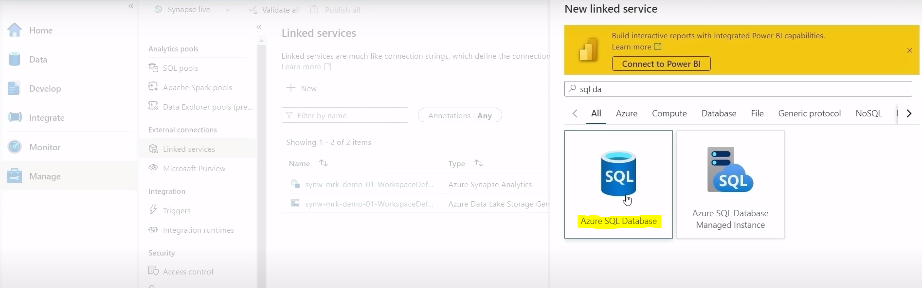

We have entered database name as serverlessSQLdb.

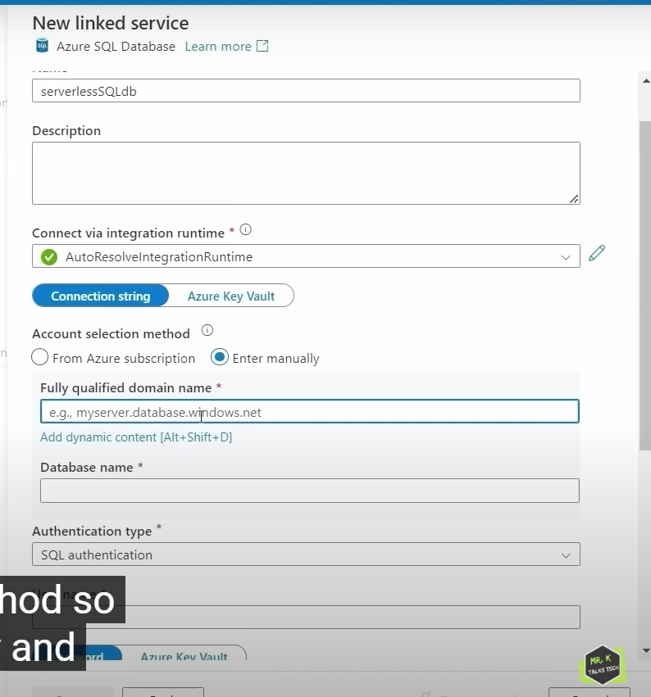

Account Selection Method : we will enter manually.

Fully qualified domain name we will get that information from synapse workspace as shown below.

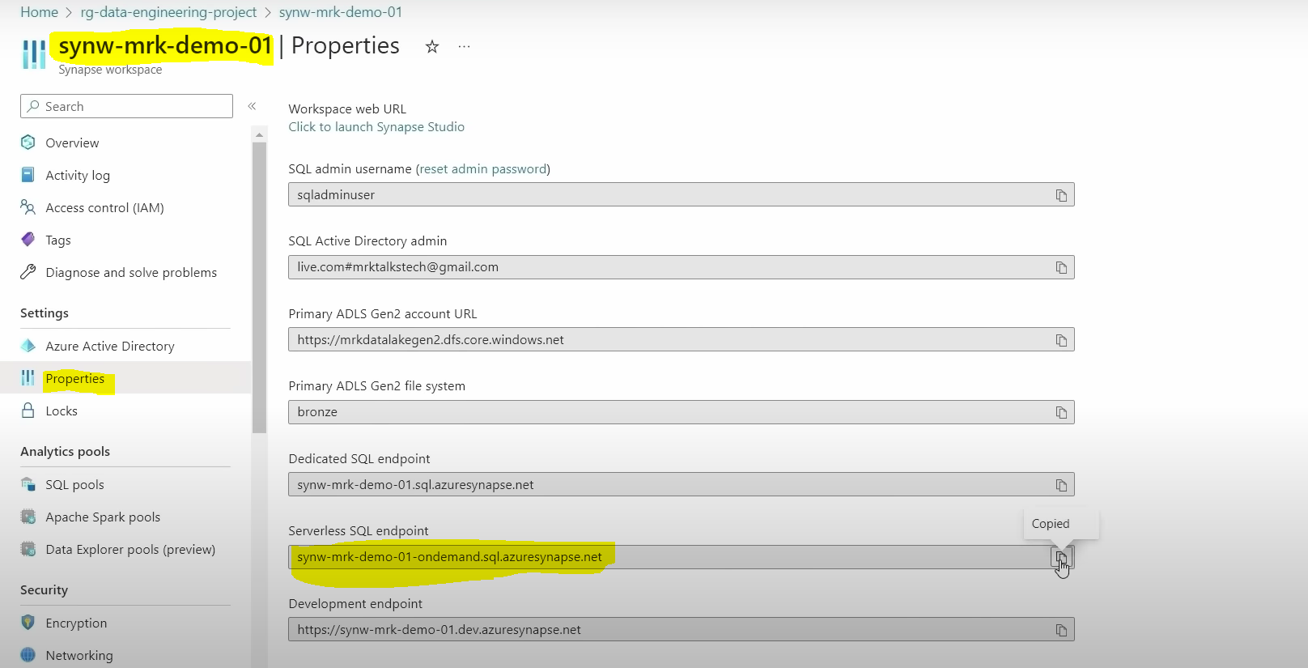

We will copy above copied one serverless SQL endpoint and we will paste it in Fully qualified domain name as shown below.

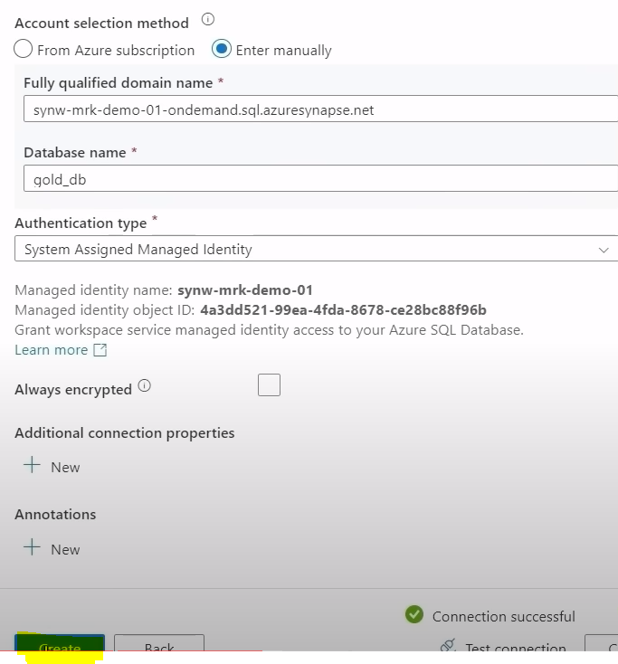

Now click on publish button to save the created linked service changes.

Now we need to create pipeline by Integrate 🡪 + 🡪 Pipeline.

Now we need to drag Get Metadata activity to canvas.

In General tab, we need to change Get Metadata activity name to Get Tablenames

In Settings tab, we will create new dataset by clicking on +.

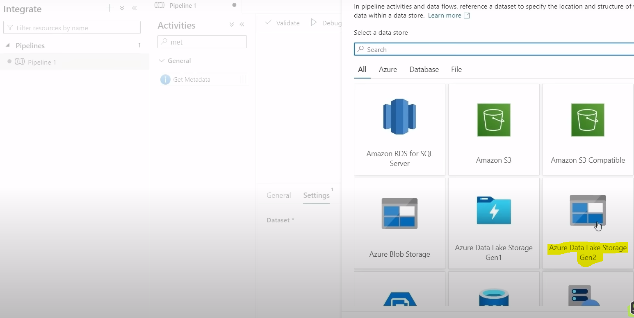

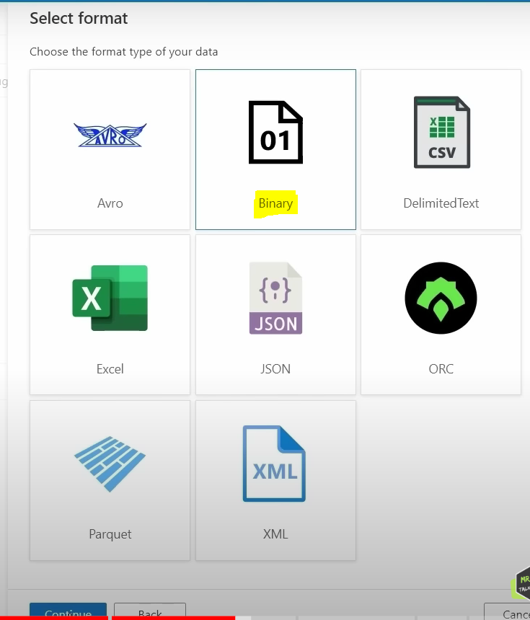

We are getting only table names so selecting binary file format. Click on continue.

Now we will give dataset name to goldtables

Linked Service we will select from drop down (synapse has direct connection to data lake). This is the default linked service connection to data lake and we will select file path of gold container.

Since we have specified gold container in get metadata activity so this will get all table names from the container, so for that we need to configure additional step.

In Field list, we will click on +,

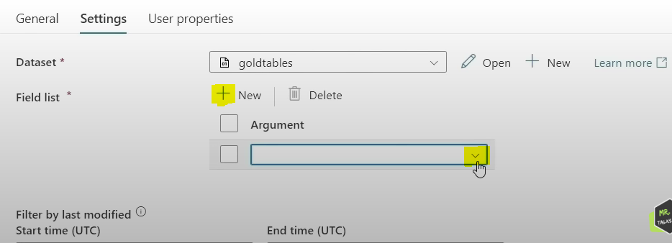

From field list drop down we will select child items . This child items will get all child items under salesLT folder. Once we run debug option, we can see activity succeeded or not. In output, we will get table name from name property as shown below. And we need to pass this name property to stored procedure to create views dynamically so for that we need to create for each activity to iterate through this list.

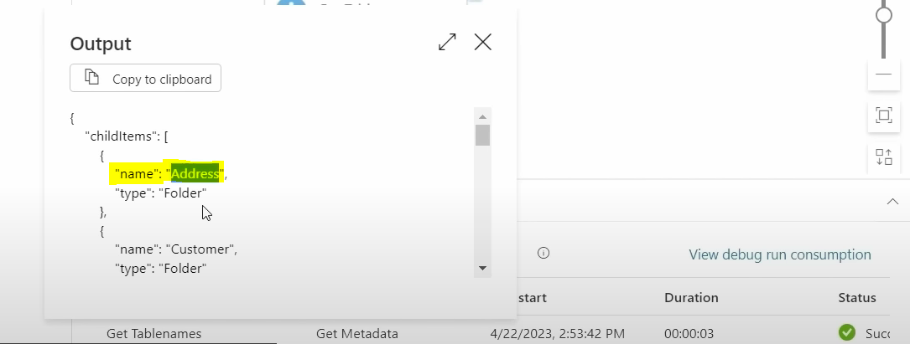

Now we will drag foreach activity to white space and give success of Get Metadata activity to foreach activity as shown below.

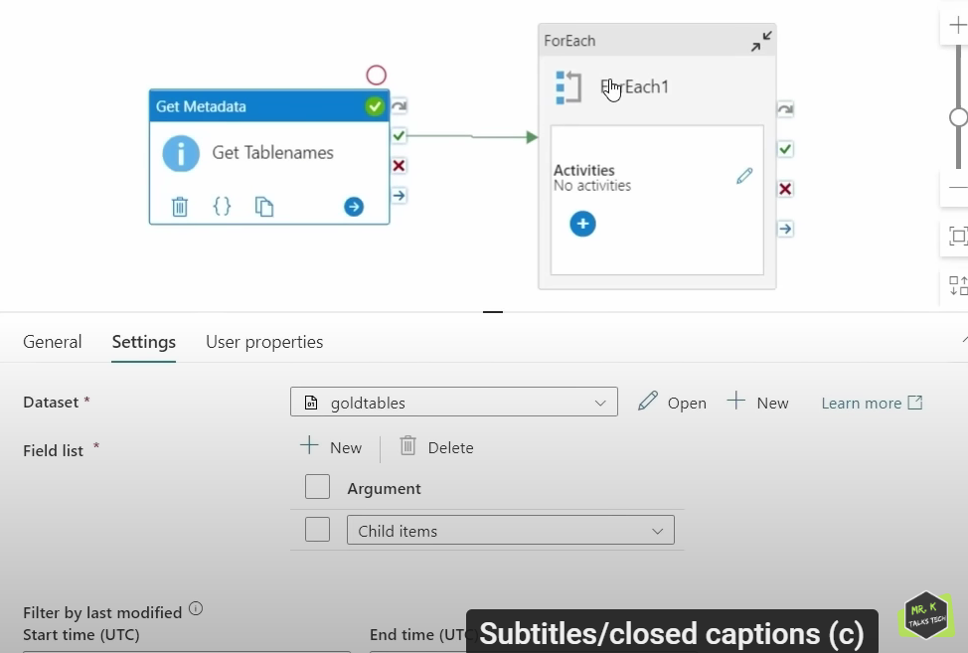

In General tab, we will change foreach activity name to For each table name and in settings tab in Items field, we will click on add dynamic content .

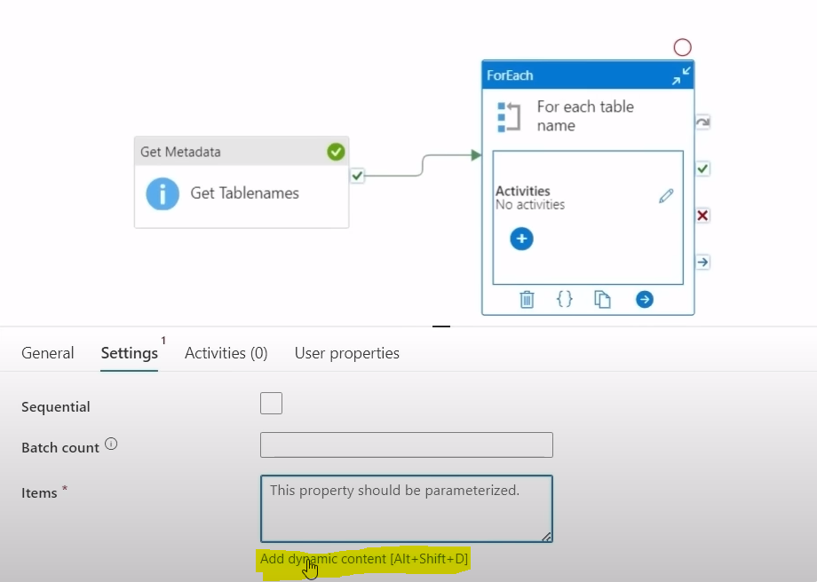

Here we need to select Get Tablenames activity output as shown below in activity outputs tab and after that .childItems will be written and click on OK.

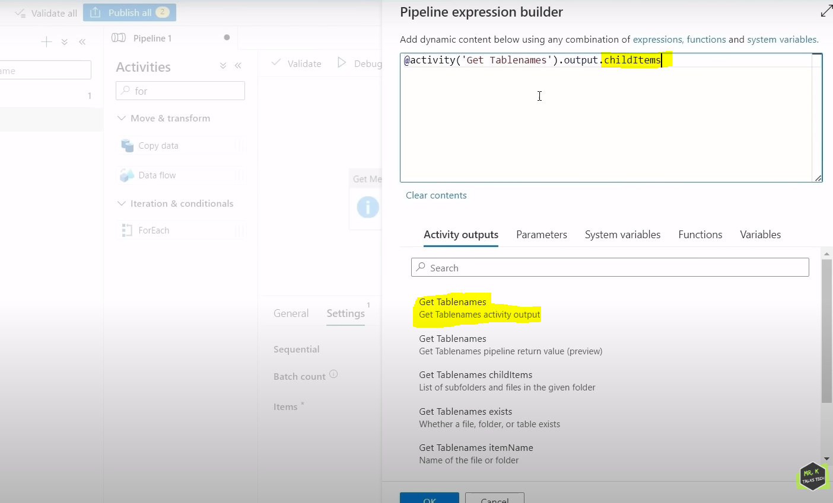

Now for each loop will iterate through list one by one and get table name from name property.

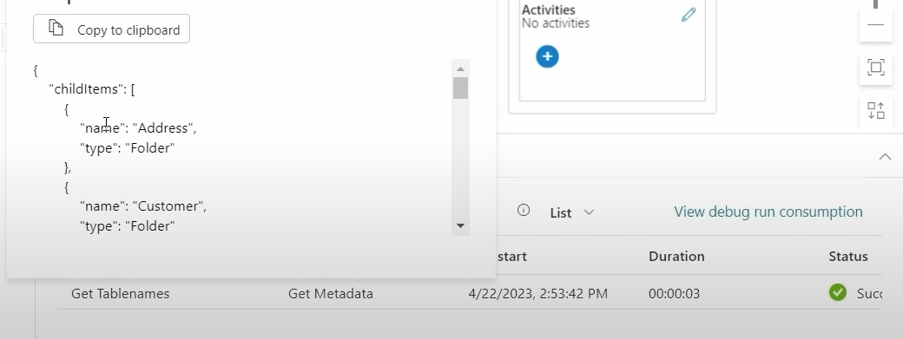

Now we can go to activity tab in for each activity or click on Pencil symbol . Now we will drag and drop Stored Procedure activity in white space .

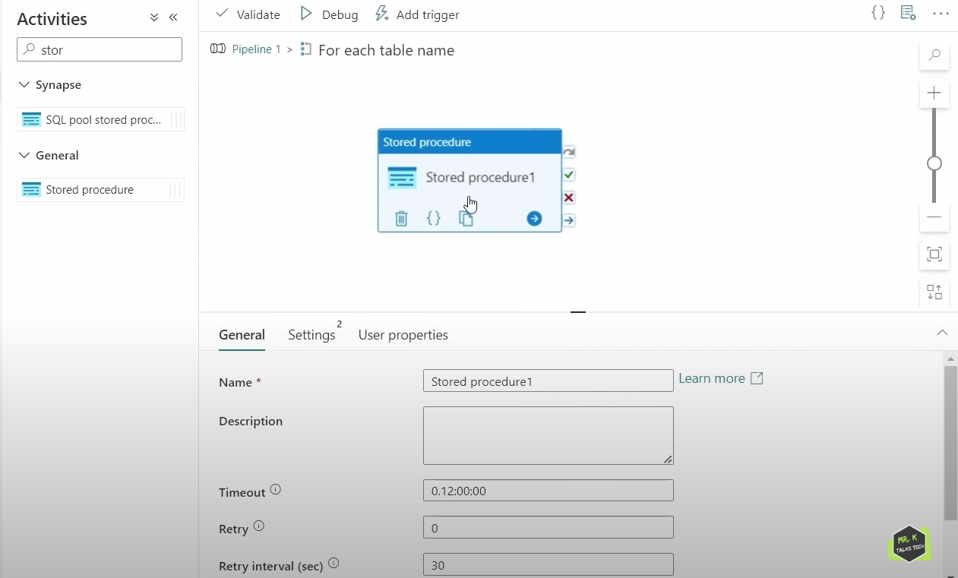

We already created stored procedure in serverless SQL database. So, we need to refer that stored procedure in this activity.

Now change stored procedure name in general tab. In settings tab, we will select linked service from drop down and select SP from drop down.

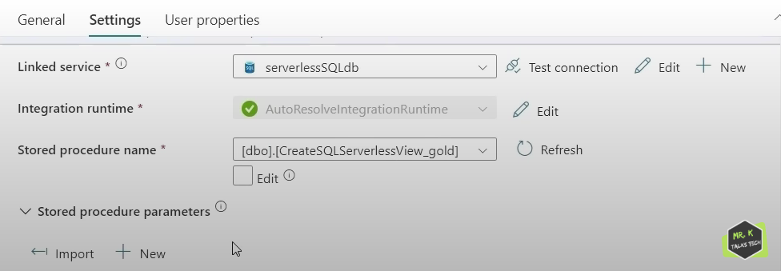

Now in Stored Procedure parameters field, we will select + New .

We will give ViewName because in SP , we declared parameters as ViewName and ViewName is String Type and we need to specify value , since we are inside this for each loop, we need to get table name from name property for every item.

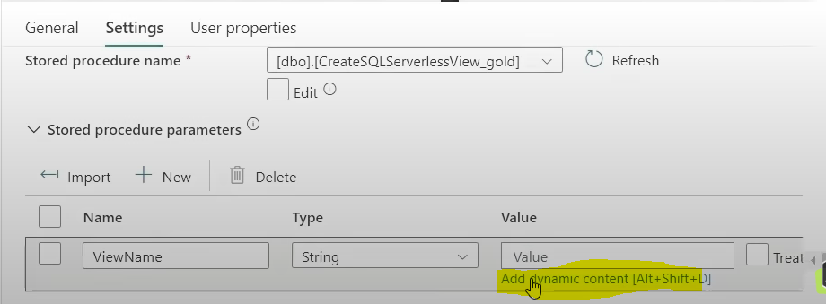

Here name is the property that holds table name.

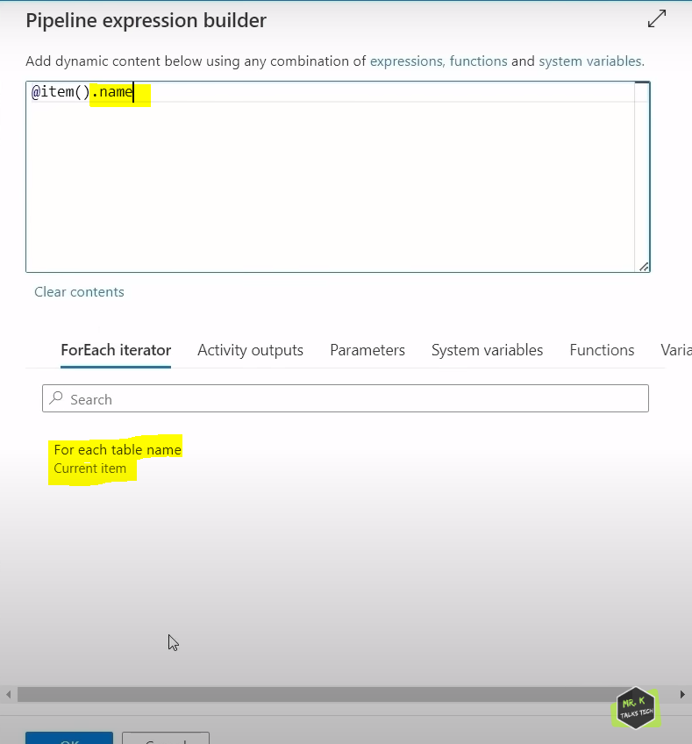

Click on OK.

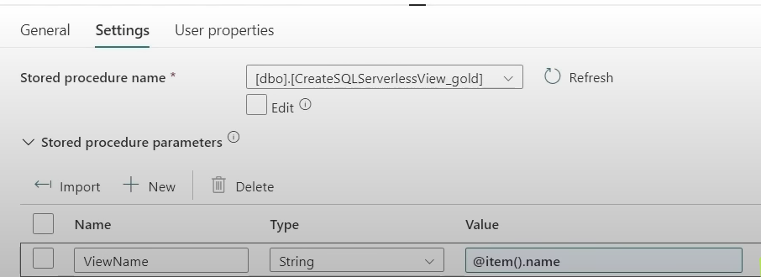

Now rename pipeline to create view pipeline.

Now click on publish all to save the pipeline changes. Now click on Add trigger 🡪 trigger now.

Now in monitor 🡪 pipeline runs 🡪 we can track status of pipeline activities.

Now once pipeline is succeeded, go to Data 🡪 workspace 🡪 Views folder 🡪 we can see views created for all tables.

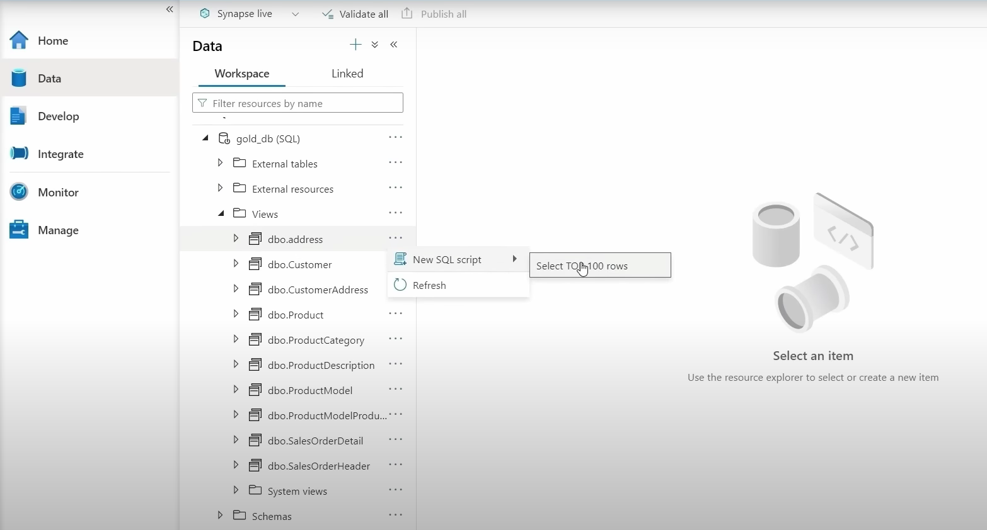

Let’s say, If schema changes in address table in the source, then we need to run create view pipeline to regenerate those views. Whenever data change happens in data source, then view will be automatically updated.

Now data loading is completed in ASA.

Now using power bi, we will get data from serverless SQL database and fetch all views exist in the database to create the reports.

Summary : In Data Loading section, in ASA, we have created a new database which is a serverless SQL data base and load the most curated form of data that exists in gold container as a form of views in the database. Now using data in the serverless SQL database , we will create report in powerbi.

POWER BI: Power BI is a business intelligence tool provided by Microsoft. Using power bi, we can create interactive dashboards and visuals.

Using power bi, we will get data from Azure Synapse Analytics .

Then it will ask to enter Server and Database name . Server name is serverless end point will get from properties tab of ASA. Data base name is what we created I ASA. There are 2 options in Data Connectivity mode import and DirectQuery. Difference between 2 modes is , in import mode, we will load data completely from serverless SQL data base to the powerbi and we can create reports on the loaded data. Whereas in directquery mode, data will still exist in the synapse database, we can use powerbi to query data directly from powerbi itself.

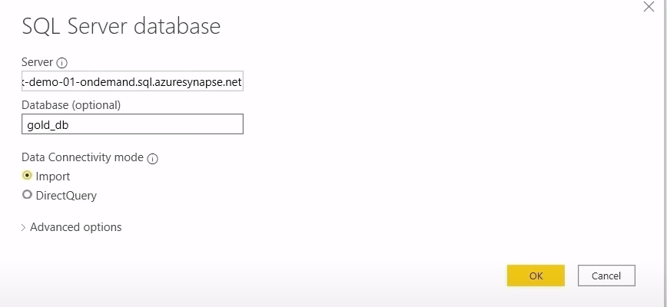

Once we click ok, it will ask authentication method to connect onto database.

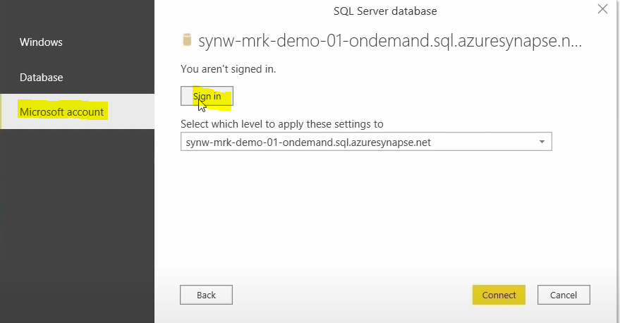

Now we will select sign in option, we will enter email and password who has Microsoft account access for ASA. Now we will click on connect option to connect onto database.

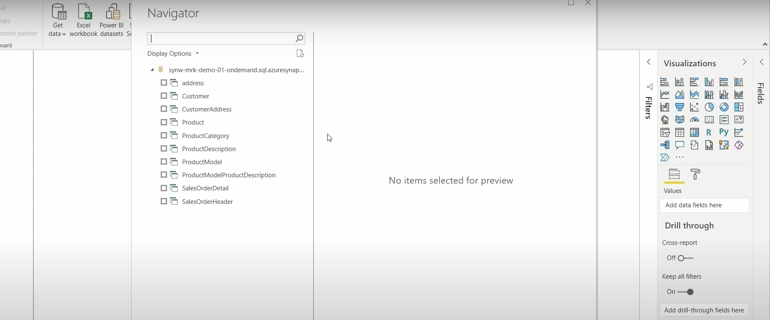

Now we can select views whatever we want,

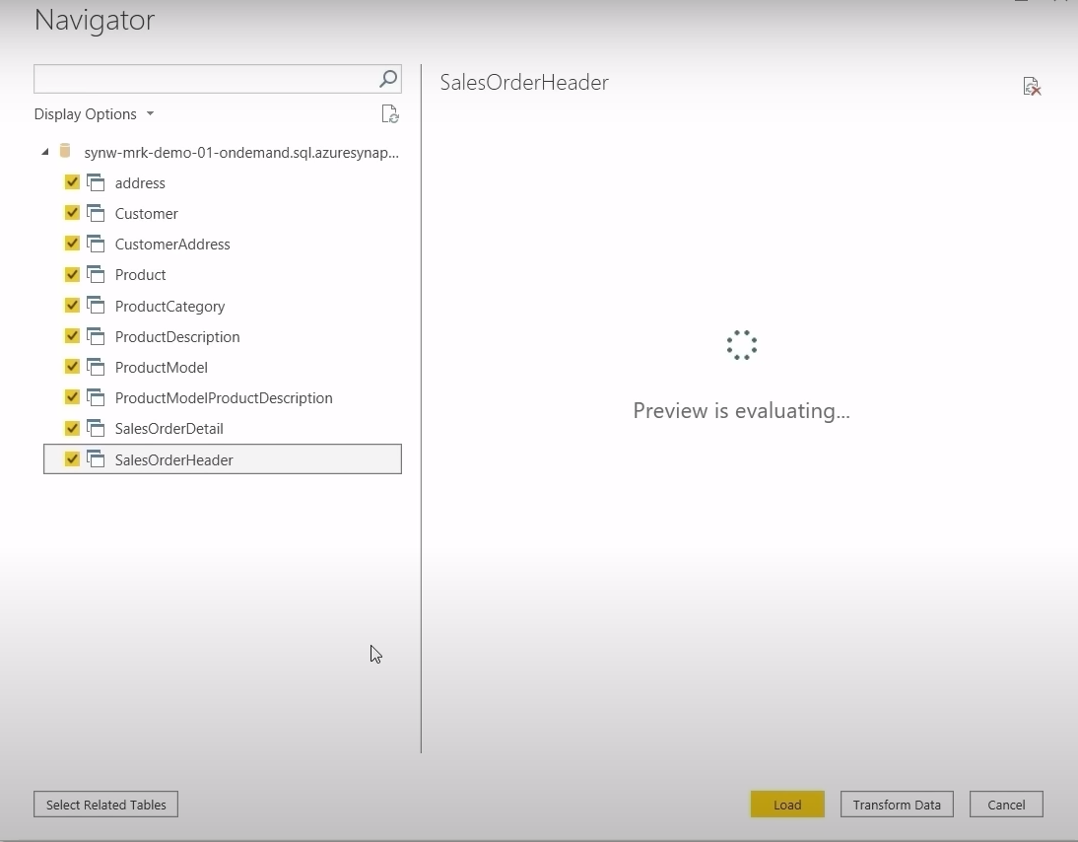

We have 2 options here, Load and Transform Data . If we click on load button, we can load all the data from gold container. If we want to perform further transformation on data before loading data into powerbi , we can click on transform data option to transform data . Data is already in cleaned fashion, so we will click on load option.

In left hand side, we have 3 tabs as shown below.

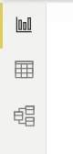1st one is visual/report tab, 2nd is data tab and 3rd one is modelling tab. Using model tab, we can establish connection between multiple tables and we can create data model, for e.g. we have imported views from serverless SQL database. Powerbi itself has automatically created this data modelling structure by establishing the relationship between multiple tables.so most of the time this relationship is not so accurate. The way powerbi uses to establish this connection is by using column names. Say for example , there is a table called product and another table called product detail. The way it has established relationship between 2 tables is If we just hover over line between these 2 tables is we can clearly see that column that has been used to make that connection is called name since both of these table have a column called name in it.so powerbi connects these 2 tables together. This is not so accurate. For example, we have 2 tables called customer and customeraddress table where powerbi could be able to establish connection. So, it is always good to make this data modelling by ourselves rather than relying on the powerbi .

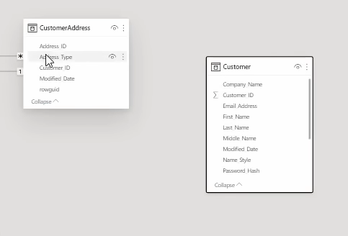

In order to establish connection between 2 tables, we need to select Customer table and go to manage relationship option

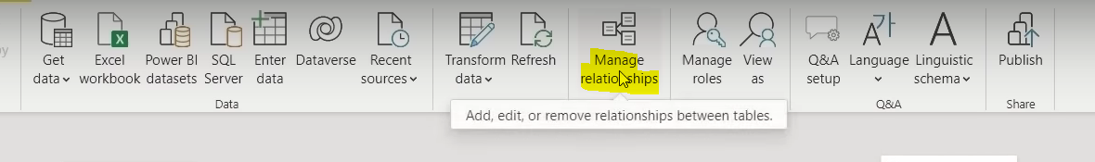

Once we click on manage relationship option, powerbi has automatically created for us as shown below.

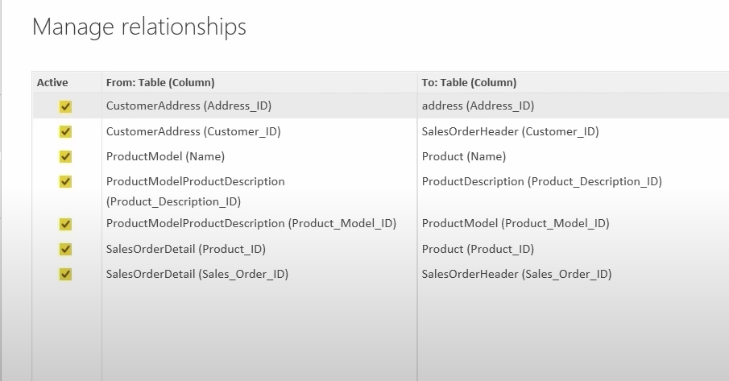

If we want to get new relationship , we will click on New button,

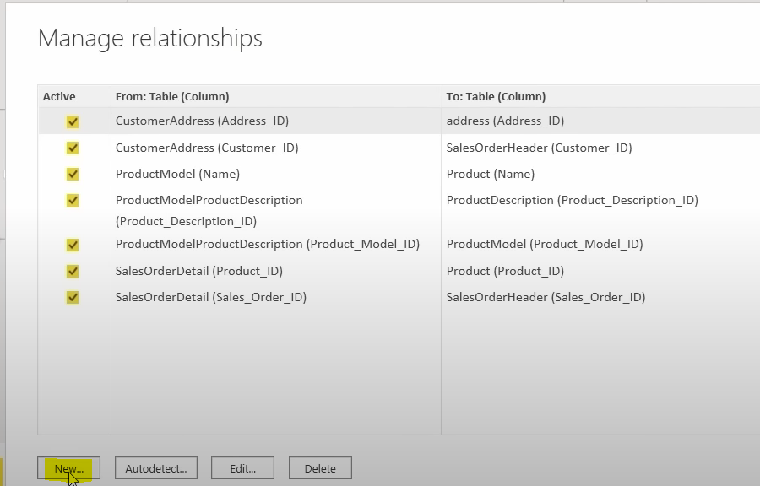

After clicking new, we need to choose first table as CustomerAddress table. In CustomerAddress table,we are clicking on customerid column to make that relationship > Once it is done, we need to choose 2nd table Customer table.

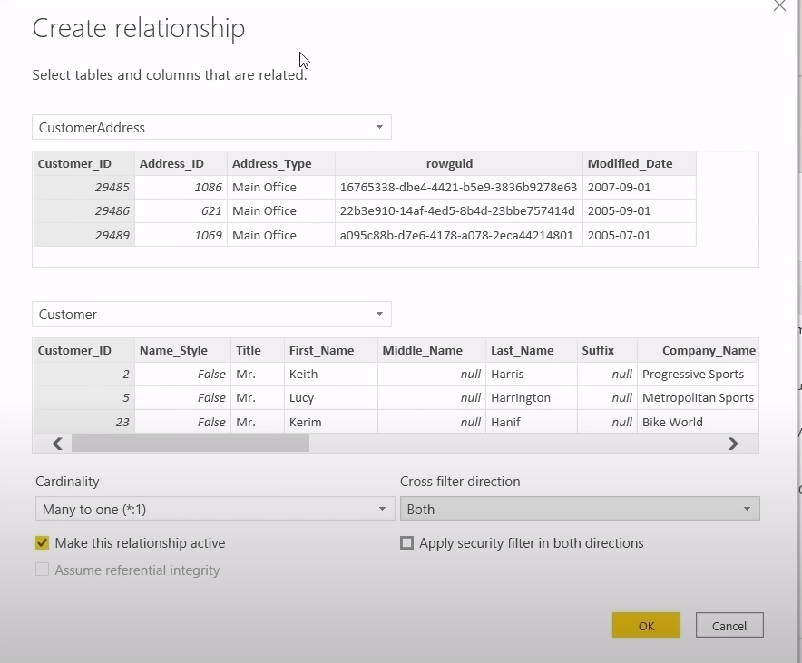

When we actually do any filtering on the customer address visual , automatically the visual that has been created using customer table will get reflected . In the same way, if we do any filtering on the customer table visual, automatically customer address will be getting reflected. So, this is possible only when cross filter direction option is configured as both. After configuring column, we will click on OK. Now we have established connection between CustomerAddress and Customer table.

SECURITY AND GOVERNANCE:

If we want to provide access to resource group level, we will go to Resource Group 🡪 Access Control(IAM) 🡪 Add Role Assignment 🡪 enter gmail id .

If we want to add multiple team members at a time , then above is not good approach . To resolve this complexity, what we can do is we can create a security group using Azure Active Directory and we can add all that team members to that security group and after that we can give resource group access to just security group and once that is done, all the members who belong to security group will have access to resource group. For example if a new employee joins as data engineer in an organization, we can add him to security group and automatically new user will get all the required access where the security group is given access to.

Home 🡪 AAD 🡪 Groups 🡪All Groups 🡪 New Group

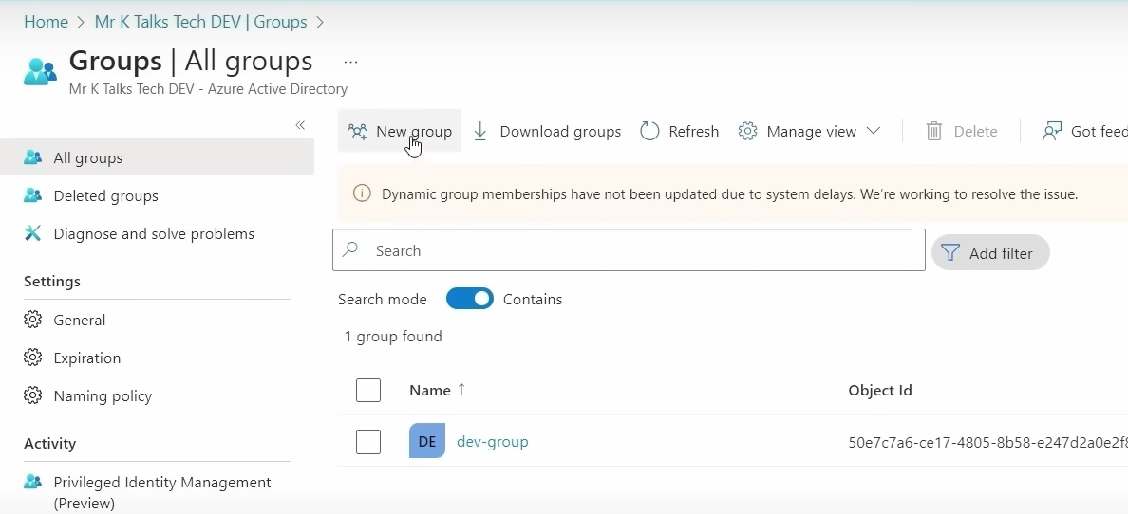

After clicking new group option from above screenshot, we will get below screen.

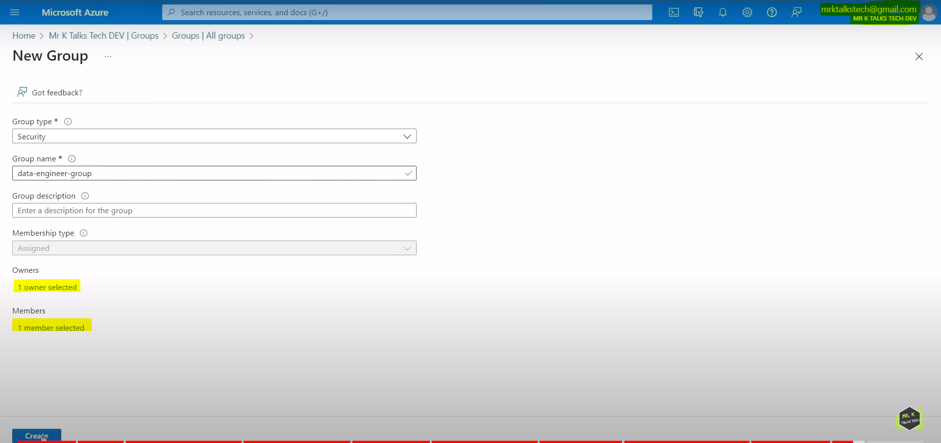

After selecting owner and members will click on create.

Now security group has created as shown below.

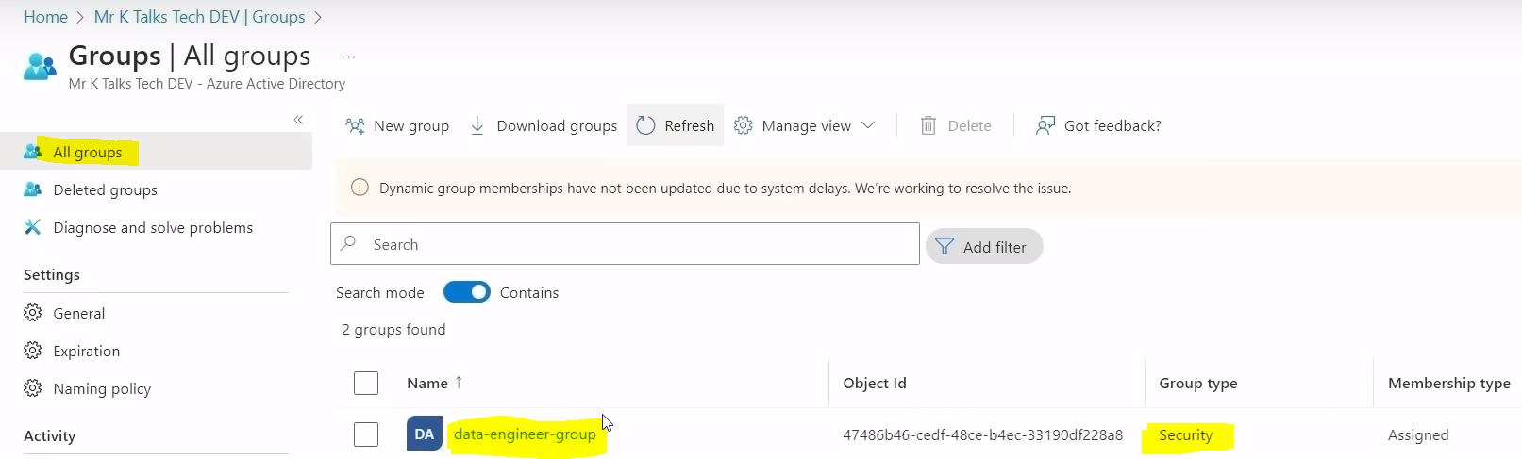

Now go to Resource Group 🡪 Access Control(IAM) from LHS 🡪 click on Add + button 🡪 click on Add role assignment, select contributor role and click on next.

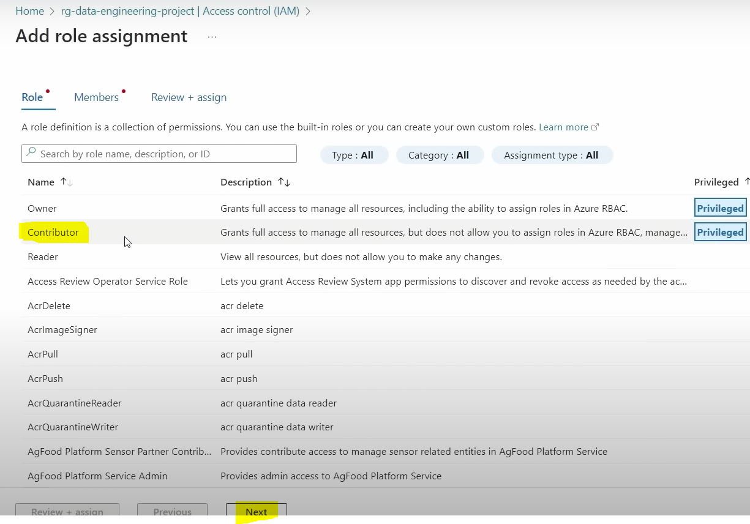

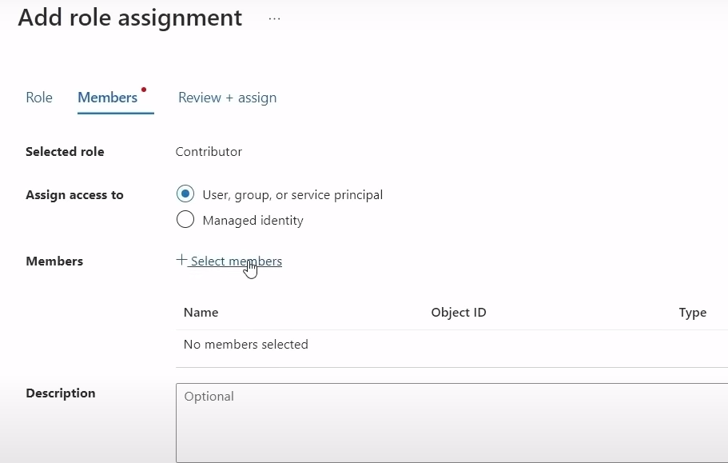

Now we will select Assign access to : Security group and we will select members . Members will select as security group which we created before as above.

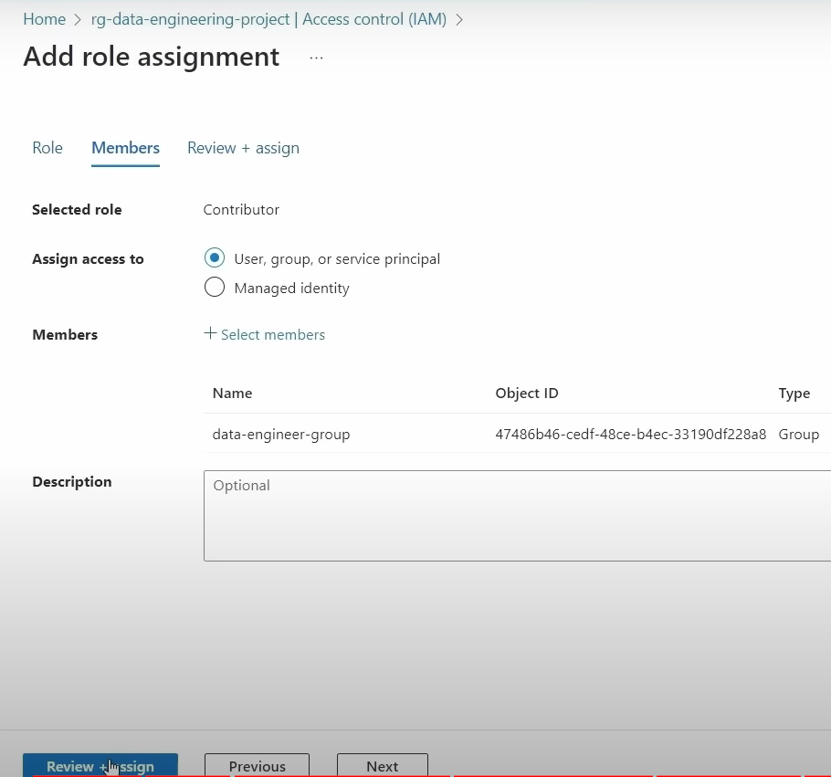

Now we will click on review and assign to assign contributor access to that security group. Now security group has contributor access to the resource group .

In real time projects, all the access should be managed via security group and not via individual user accounts. In this way it is easy to manage the user and the access .

**END TO END PIPELINE TESTING:**

Here our data source is on-premise SQL Server data base and after adding new row, if we run ADF pipelines what will happen is ADF will connect onto on-premise SQL Server database and it will copy all data including new row and put the data onto bronze layer in ADLS. Once it is done, ADB will fetch all the data from bronze layer, do 2 level of transformation and put transformed data into silver layer and finally into gold layer and after that final transformed data in gold layer will be loaded into data base in ASA. Once it is done power bi will integrate with ASA, get the latest data from data base and finally visuals that have been created using powerbi will be reflected with new row that has been added into source. Since these all components are integrated with each other , all these things will be performed automatically once we have run the ADF pipeline.

Now in ADF we will create triggers for the pipeline, After creating triggers , Lets add few rows in the data source tables and test the end to end pipelines.

In real time projects, we need to run pipeline in an automatic way. We can achieve by configuring a trigger in the pipelines. The trigger can be schedule trigger which runs pipeline on schedule basis or it can be event based trigger which runs pipeline automatically when a specific event occurs.

Now to run pipeline automatically, we will create schedule trigger.

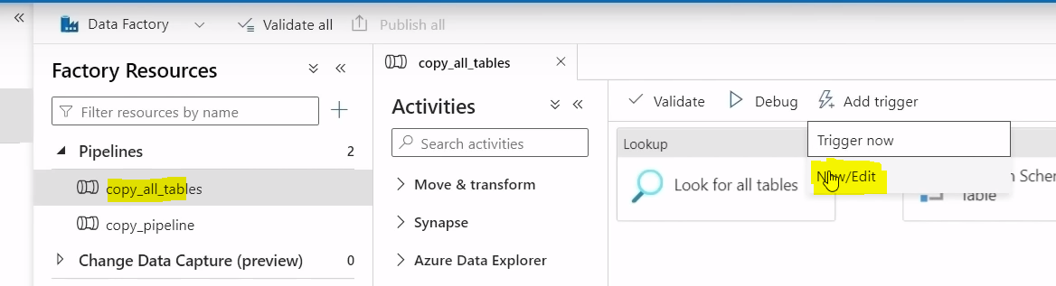

Click on New/Edit , click on +

Start date by default takes current time. Time zone, we will select time zone of the region that we are located. Recurrence field – This is used to specify frequency for the pipeline to run. Here default is running every 15 mins which means pipeline will run every 15 mins but what we can specify is this pipeline to run every day. This is the most used approach in real time environments to run a pipeline as a daily load.

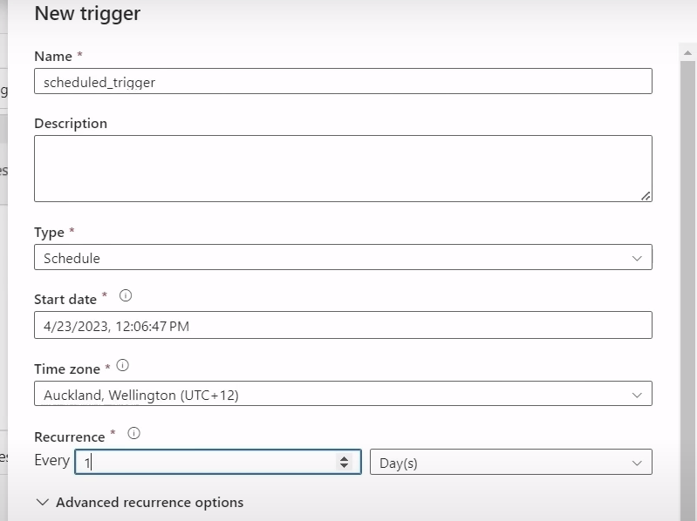

If we want to execute pipeline at 12:25 am , we will specify hours and minutes as below,

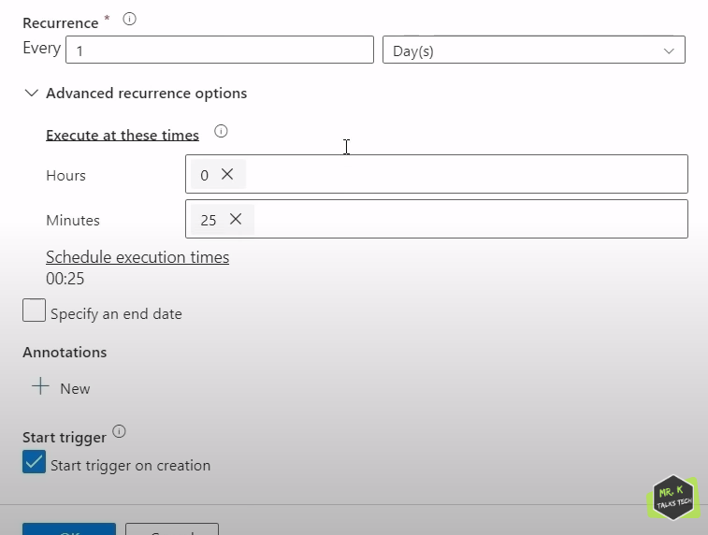

Now click on publish all to save the trigger changes . once publishing is done, pipeline will be triggered exactly at 12:25 am

Now in on-premise SQL server data base, 2 rows has been added, now when pipeline runs at 12:25 am, then in monitor 🡪 pipeline runs tab we can see pipeline has started running.

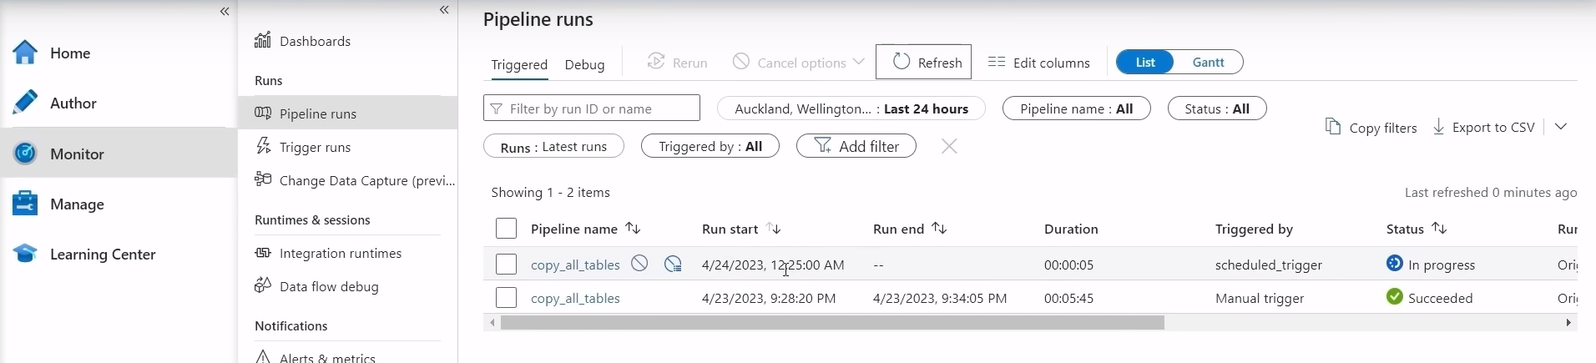

OLYMPIC DATA ANALYTICS PROJECT : DARSHIL PARMAR  
We will have 5 data sets Athletics, Coaches, EntriesGender, Medals and Teams 5 csv files.

We need to copy these 5 files from github repository to ADLS Gen2 container using ADF. In ADF data source is http because if we open 1 data set eg: Athletics.csv as shown below, if we click on raw the link is http and it is base URL. So in single pipeline we will copy all 5 datasets from github http URL to ADLS gen2 . In single pipeline, we will give in completion of 1 activity to 2nd activity, in completion of 2nd activity to 3rd activity etc.

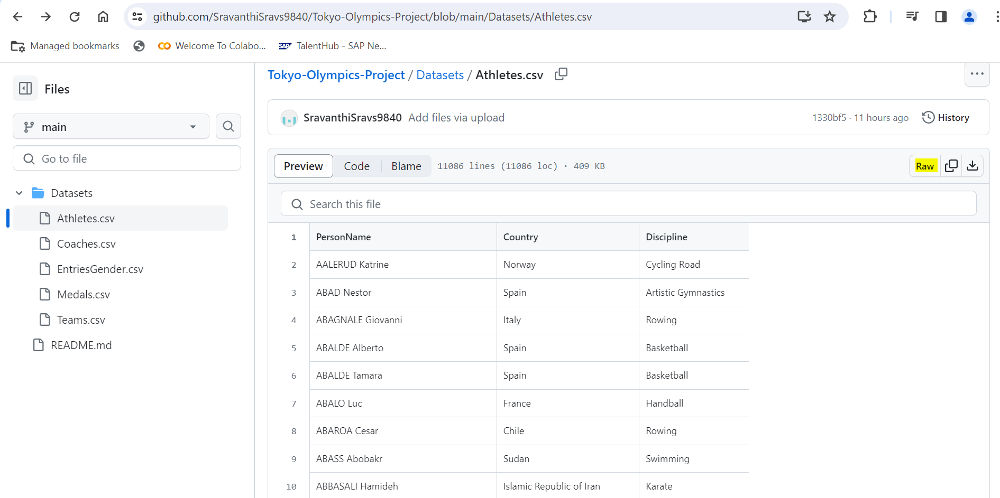

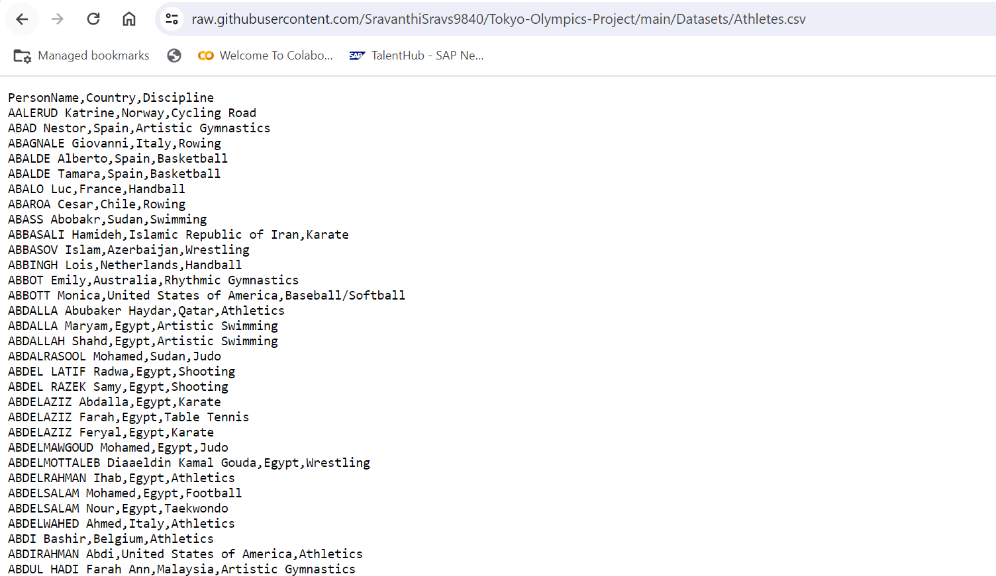

Once we get raw data into ADLS Gen2 container, we will first register ADB via App registration, from there we will get client id , tenant id. We will get secret value by going to certificates and secrets and create new client secret as shown below

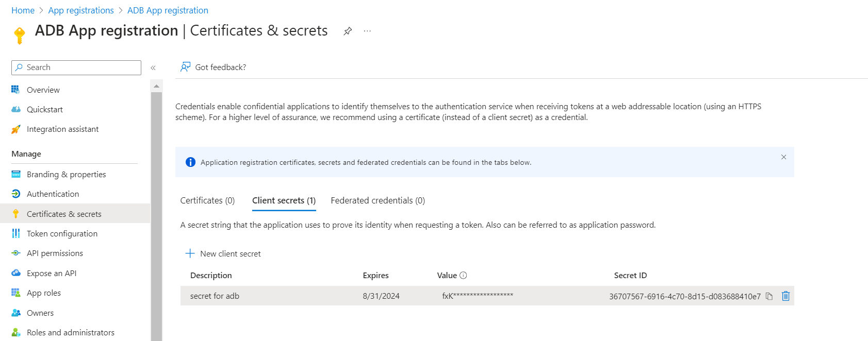

<https://github.com/darshilparmar/tokyo-olympic-azure-data-engineering-project/blob/main/Tokyo%20Olympic%20Transformation.ipynb>

link for adb notebook code is shown above.

Now in adb we will write below code, we will mention above copied client id, secret value and tenant id in below code and then we will mount(attach) ADLS to ADB

configs = {"fs.azure.account.auth.type": "OAuth",

"fs.azure.account.oauth.provider.type": "org.apache.hadoop.fs.azurebfs.oauth2.ClientCredsTokenProvider",

"fs.azure.account.oauth2.client.id": "",

"fs.azure.account.oauth2.client.secret": '',

"fs.azure.account.oauth2.client.endpoint": "https://login.microsoftonline.com/tanent_id/oauth2/token"}

dbutils.fs.mount(

source = "abfss://tokyo-olympic-data@tokyoolympicdata.dfs.core.windows.net", #container@storageac

mount_point = "/mnt/tokyoolymic",

extra_configs = configs)

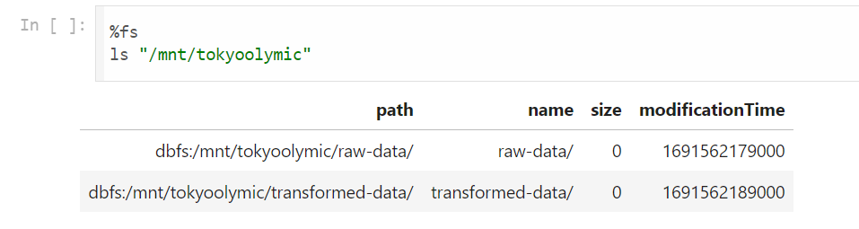

If we run above command %fs ls “/mnt/tokyoolymic” , sometimes we will get unauthorized access and no permission access, for that we will go to ADLS container , IAM(Access policies) 🡪 Add role as storage blob data contributor 🡪 and add App Registration name what we created above .

If we rerun above command %fs ls again, we will get data now.

Now after reading data frames for all 5 csv files from raw container, we will display data and can see data in tables and to see data types df.printSchema() and df.show() will default display 20 rows and display(df) will show us data in table format.

athletes = spark.read.format("csv").option("header","true").option("inferSchema","true").load("/mnt/tokyoolymic/raw-data/athletes.csv")

coaches = spark.read.format("csv").option("header","true").option("inferSchema","true").load("/mnt/tokyoolymic/raw-data/coaches.csv")

entriesgender = spark.read.format("csv").option("header","true").option("inferSchema","true").load("/mnt/tokyoolymic/raw-data/entriesgender.csv")

medals = spark.read.format("csv").option("header","true").option("inferSchema","true").load("/mnt/tokyoolymic/raw-data/medals.csv")

teams = spark.read.format("csv").option("header","true").option("inferSchema","true").load("/mnt/tokyoolymic/raw-data/teams.csv")

If we want to change data type of columns, we can do it via cast or inferSchema as shown above. inferSchema will infer schema by default which is coming from column data.

entriesgender = entriesgender.withColumn("Female",col("Female").cast(IntegerType()))\

.withColumn("Male",col("Male").cast(IntegerType()))\

.withColumn("Total",col("Total").cast(IntegerType()))

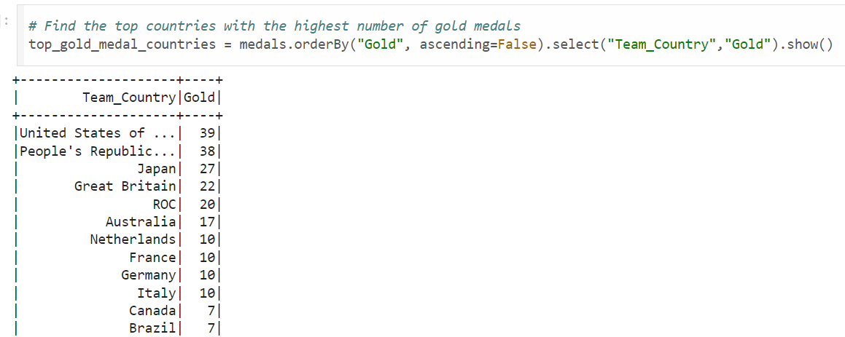

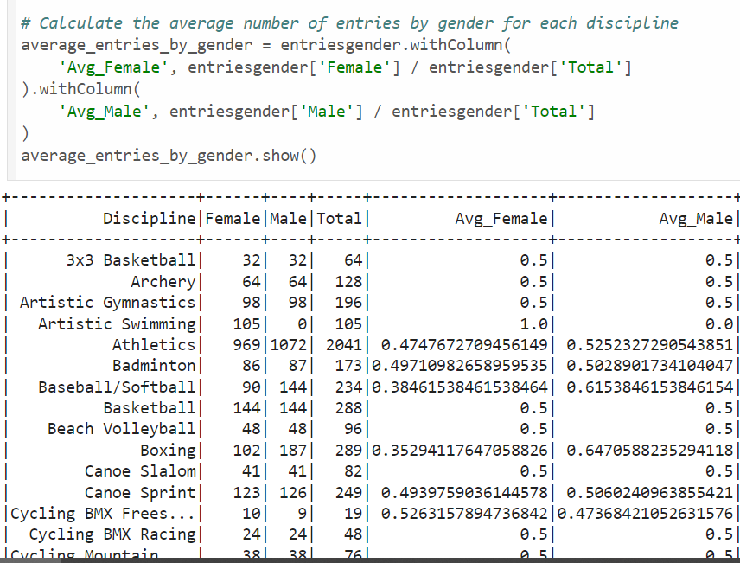

athletes.repartition(1).write.format(“csv”).mode("overwrite").option("header",'true').save("/mnt/tokyoolymic/transformed-data/athletes")

In this way we will save our data . repartition(3) means in transformed_data folder, athletes output data will be saved in 3 files. If we want to save our output data in single file only , we will mention as repartition(1) .

athletes.repartition(1).write.format(“csv”).mode("overwrite").option("header",'true').save("/mnt/tokyoolymic/transformed-data/athletes")

If we run this command 2 times, then output data will be overwritten and save it in one single file. but other started and committed files will be exist in 2 files as shown below.

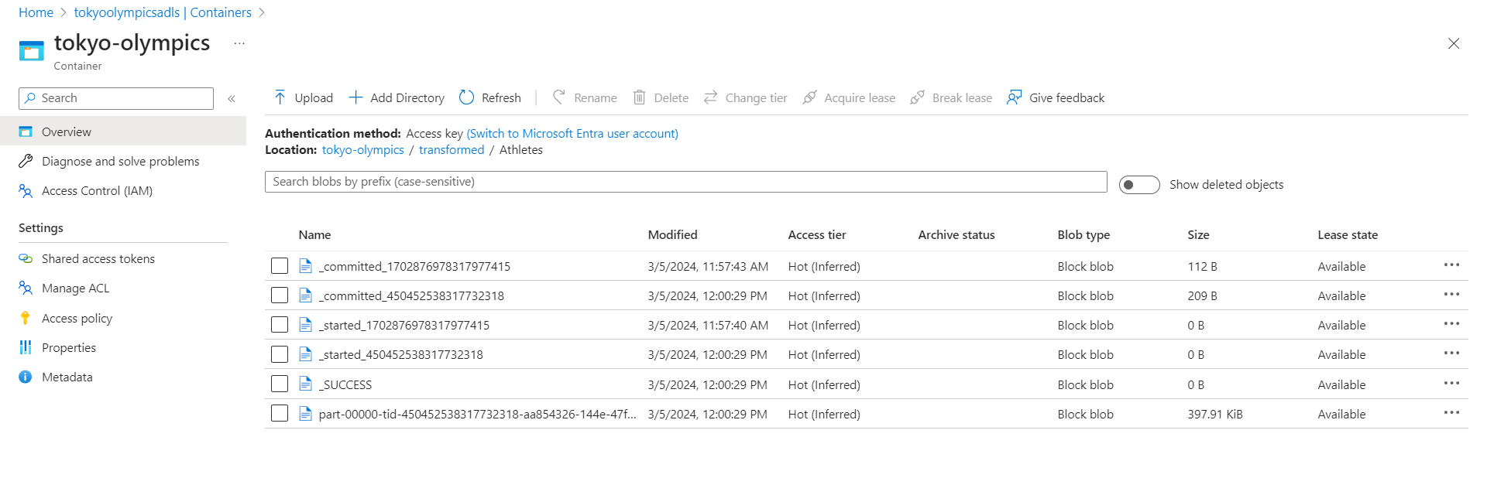

------

Now we go to Azure Synapse Analytics 🡪 go to Data 🡪 create Data Lake database.

Note: Once we entered data base name, we can change db name only before publishing. Once after publishing is done, we can’t change our db name.

Now we can create table name like shown below.

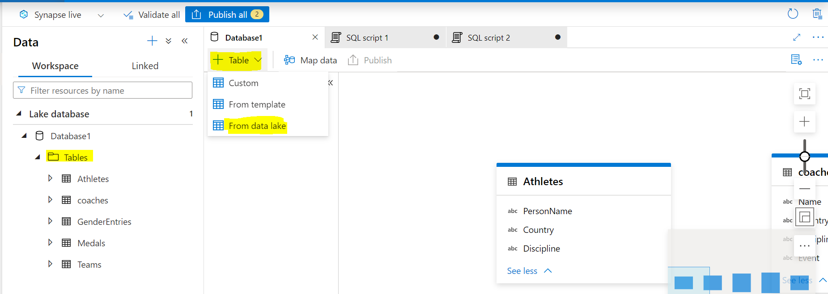

When we click on + Table 🡪 creating tables from data lake 🡪

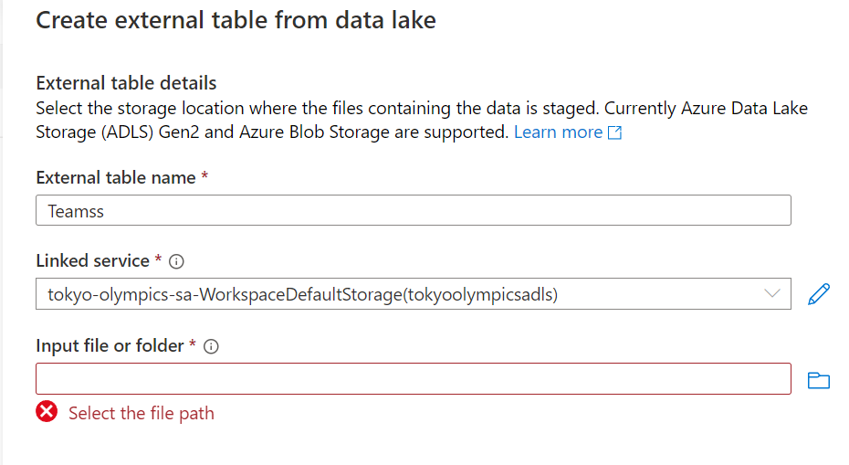

After specifying above, we will get below screen.

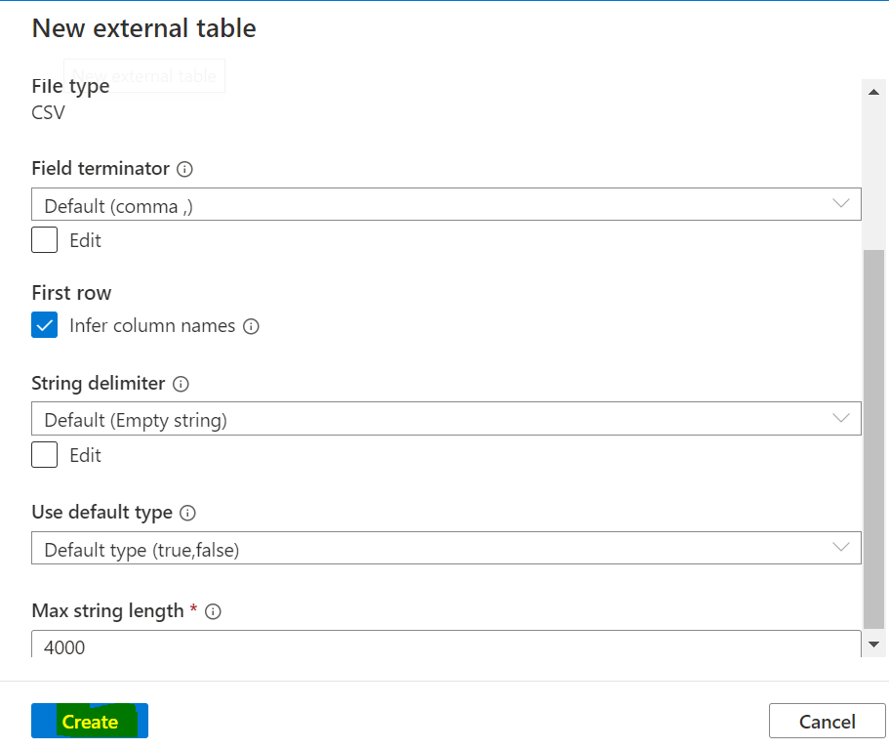

Once we click on create, tables will be created .

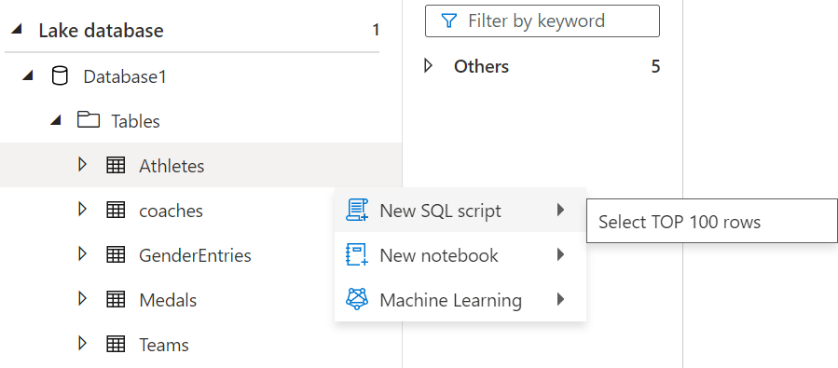

**--- Count number of athletes from each country**

 select Country ,count(*) as total_athletes from Athletes GROUP BY Country order by total_athletes desc;

**--- Calculate total medals won by each country**

 select Team_Country,SUM(Gold+Silver+Bronze) as total_medals from Medals group by Team_Country

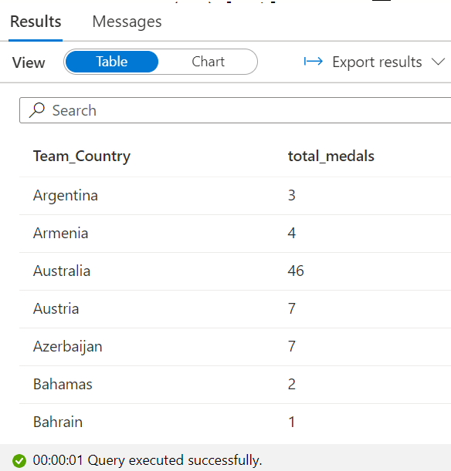

SELECT TOP (100) [Rank]

,[Team_Country]

,[Gold]

,[Silver]

,[Bronze]

,[Total]

,[Rank_by_Total]

 FROM [Database1].[dbo].[Medals]  order by [Team_Country]

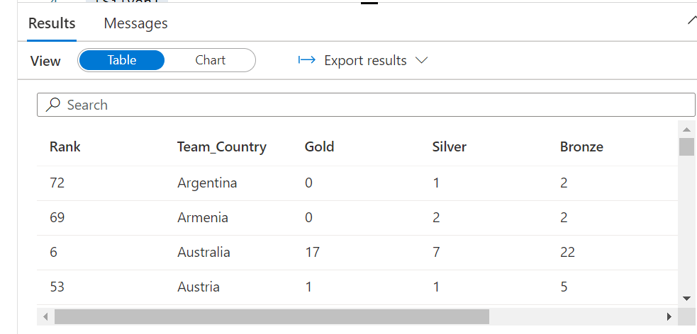

**#Calculate average number of entries by gender for each discipline**

select Discipline, AVG(Female) as female_avg, AVG(Male) as male  from GenderEntries group by Discipline